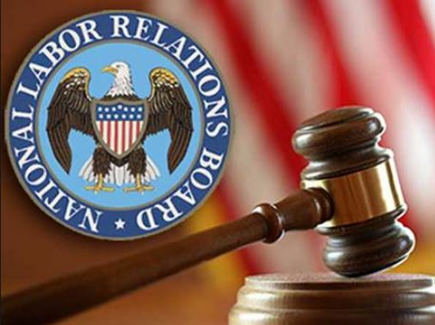

Employee Handbooks Audits in 2023 and 2024 by the NLRB! Employers Need to Make Changes to Be Compliant with Federal Policies or Risk Litigation!

Margie Faulk, PHR, SHRM-CP
October 2023
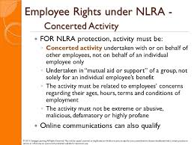
On August 2, 2023, the National Labor Relations Board (NLRB) adopted a new burden-shifting standard for evaluating whether work rules infringe upon employees' rights under Section 7 of the National Labor Relations Act (NLRA)—
Employers will need to think carefully about how to defend some of their corporate policies, such as ones about cameras at a worksite, social media use, and appropriate workplace conduct, in light of a recent decision by the National Labor Relations Board (NLRB).
The National Labor Relations Board is an independent agency of the United States federal government created in 1935 as part of the National Labor Relations Act. The Board consists of five presidentially appointed members, who are charged with overseeing union elections and hearing complaints of unfair labor practices under the NLRA.
Having in the Employee Handbook restrictions for employees to discuss their pay or their workplace conditions including their supervisor:
Current workplace regulations by the National Labor Relations Act (NLRA) who supervised the union and non-union environment.
The National Labor Relations Board (NLRB) is the enforcement arm of the NLRA which protects union and nonunion employees.
It is very clear under the “Concerted Activity” also called Section 7 regulations that all employees are protected from retaliation when discussing their work conditions including pay, management issues, confidentiality issues or social media discussions with same.

Employee rights under the NLRA
Section 7 of the NLRA guarantees employees the right to self-organization, to form and/or join a union, to bargain collectively, to engage in concerted activity, and the right to refrain from all such activities.
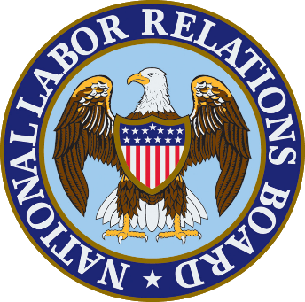
In Stericycle, an administrative law judge found that the employer violated the NLRA by maintaining certain policies for its employees that addressed personal conduct, conflicts of interest, and confidentiality of harassment complaints. The NLRB announced a new standard for whether work rules violate the NLRA and sent the case back to the judge to consider the ruling in light of the new standard.
Under that standard, if an employee could reasonably interpret the work rule to have a coercive meaning, the NLRB general counsel would have met her burden to prove that the rule has a reasonable tendency to chill employees from exercising their NLRA rights.
On August 2, 2023, the National Labor Relations Board (NLRB) adopted a new burden-shifting standard for evaluating whether work rules infringe upon employees' rights under Section 7 of the National Labor Relations Act (NLRA)—
Employers will need to think carefully about how to defend some of their corporate policies, such as ones about cameras at a worksite, social media use, and appropriate workplace conduct, in light of a recent decision by the National Labor Relations Board (NLRB).

In Stericycle, an administrative law judge found that the employer violated the NLRA by maintaining certain policies for its employees that addressed personal conduct, conflicts of interest, and confidentiality of harassment complaints. The NLRB announced a new standard for whether work rules violate the NLRA and sent the case back to the judge to consider the ruling in light of the new standard.
Under that standard, if an employee could reasonably interpret the work rule to have a coercive meaning, the NLRB general counsel would have met her burden to prove that the rule has a reasonable tendency to chill employees from exercising their NLRA rights.
A code of conduct or other Employee Handbook policies will certainly be impacted by this decision. Other impacted policies would be nondisclosure agreements, confidentiality agreements, any policies requiring respectful conduct, or policies regulating social media use.
Learn how Employers should review and make changes to their Employee Handbook policies to comply with the NLRB Rules and avoid allegations of violations of Concerted Activity Laws.
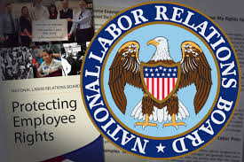
The NLRB enforces the National Labor Relations Act, which gives both unionized and non-union employees certain rights in the workplace. Find out how the changes at the NLRB may affect your company and why you might want to start making changes in your Employee Handbook now.
Employers should also "immediately review their policies and handbooks to determine if any of their existing policies could reasonably be interpreted by employees as chilling their right to engage in concerted activities and consider adding disclaimers that the policies are not intended to restrict employees' rights under the NLRA.
The new rule applies retroactively, so even those employee handbooks drafted and implemented before the Stericycle decision are subject to this heightened level of scrutiny.
The NLRA protects "concerted activities" that employees engage in to improve working conditions. What is Concerted Activity and Why Should Employers Care?
Protected Concerted Activity is a legal term used in labor policy to define employee protection against employer retaliation in the United States. The term defines the activities workers may partake in without fear of employer retaliation.
The Changes Based on the Current Administration and Previous Administration
With the return of Democrat control of the National Labor Relations Board, the pendulum is swinging back so fast, it might hit some employers on the chin.
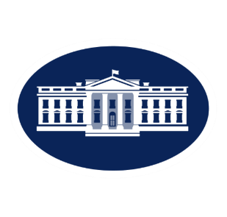
In particular, the NLRB is undoing many of the changes made by the Trump NLRB as to employee handbooks.
Before we get to the changes, let’s cover how things can change so fast. Most administrative bodies—such as OSHA, the EEOC, and the Department of Labor—can only change policy via rulemaking procedures under the Administrative Procedure Act.
The NLRB is different in that it not only makes rules, it also adjudicates them, meaning that it has an administrative court like system to try cases internally.
This means that, without actually re-writing the rules, the NLRB can effectively change how rules are implemented by making different decisions in individual NLRB cases.
The NLRA does not apply to federal or state governmental units, railroads or airlines.
Starbuck’s Employee Handbook vs NLRB
Employee rights under the NLRA Section 7 of the NLRA guarantees employees the right to self-organization, to form and/or join a union, to bargain collectively, to engage in concerted activity, and the right to refrain from all such activities.
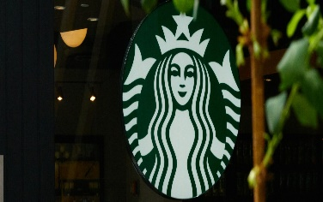
In early August, Starbucks was hit with a complaint for what most people would consider benign handbook language.
In the “How We Communicate” section of the company’s handbook, it states: “Partners are expected to communicate with other partners and customers in a professional and respectful manner at all times.
The use of vulgar or profane language is not acceptable.” The legal gymnastics required to argue that this language is illegal are impressive. Unfortunately, it leaves employers in a bind.
Employee Handbook Disclaimers Need to be Reviewed.
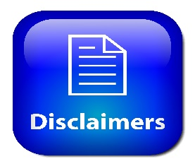
Disclaimers should be reviewed. Many employers will add a disclaimer to their handbook to note that the policies are not intended to interfere with employees’ Section 7 rights, but this alone may not be sufficient to avoid violating the new standard – particularly with respect to policies that are otherwise deemed to be coercive or overly broad.
Employers should therefore act now before they are subject to an unfair labor practice claim for the application of policies that may have passed muster under the Boeing decision.
What Laws Will Be Unlawful
Personal Conduct. Conduct that maliciously harms or intends to harm the Company’s business reputation will not be tolerated. You are expected to conduct yourself and behave in a manner conducive to efficient operations.
This policy is unlawful because it makes no exception for statements that would be protected by the NLRA, which would protect false or negative statements relating to Section 7 rights.
Conflict of Interest. The Company will not retain a team member who directly or indirectly engages in an activity that constitutes a conflict of interest or adversely reflects upon the integrity of the Company or its management.
Workplace investigations. …All parties involved in the investigation will fully keep complaints and the terms of their resolution confidential practicable.
Both policies are flawed because employees may understand them to prohibit them from engaging in activities protected under Section 7 of the Act.

So, what types of policies are now at risk of being overbroad? To name a few:
social media,
- audio/video recording,
- cell phone use (including cameras),
- personal conduct,
- conflicts of interest, and
- confidentiality of harassment complaints/investigation
Employers Should Review Their Policies & Handbooks
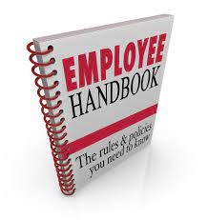
- Employers should also "immediately review their policies and handbooks to determine if any of their existing policies could reasonably be interpreted by employees as chilling their right to engage in concerted activities and consider adding disclaimers that the policies are not intended to restrict employees' rights under the NLRA.
- The new rule applies retroactively, so even those employee handbooks drafted and implemented before the Stericycle decision are subject to this heightened level of scrutiny.
- The NLRA protects "concerted activities" that employees engage in to improve working conditions. What is Concerted Activity and Why Should Employers Care?
- Protected Concerted Activity is a legal term used in labor policy to define employee protection against employer retaliation in the United States. The term defines the activities workers may partake in without fear of employer retaliation.

What Other Policies Are Being Scrutinized by the NLRB That Will Impact Employers
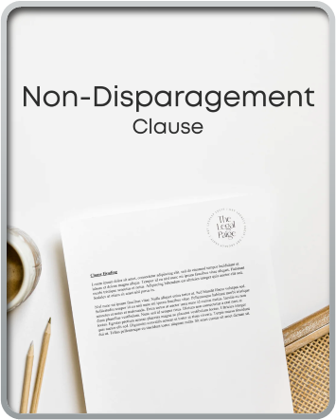
The National Labor Relations Board is promoting an array of employee friendly policies and positions under the Biden administration, taking aim at non-compete agreements, confidentiality and non-disparagement agreements tied to severance packages, the definition of independent contractors and other long-used business arrangements.

Businesses should be cognizant of several recent rulings and memoranda from the National Labor Relations Board (NLRB), several of which could impact operations and leave companies open to potential liabilities if not addressed.

Experts say companies should be paying particular attention to non-compete agreements, which are under scrutiny from the NLRB and a variety of other state and federal agencies and moving to update company policies to reflect the changing labor law landscape.

Non-Compete Agreements Can Be Unlawful
NLRB General Counsel released a May 30 memo stating that noncompete agreements violate the National Labor Relations Act (NLRA) in all but limited circumstances.
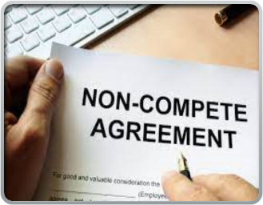
The General Counsel argued that overly broad noncompete agreements are unlawful in part because they prevent workers from seeking and accepting employment elsewhere to obtain a better working situation.

“Non-compete provisions reasonably tend to chill employees in the exercise of Section 7 (of the NLRA) rights when the provisions could reasonably be construed by employees to deny them the ability to quit or change jobs by cutting off their access to other employment opportunities that they are qualified for.

For more information on how the NLRB can impact Employers and how they can mitigate it, reach out to mfaulk@hrcompliance.net.

For more information about the impact of Workplace Compliance Regulations, please subscribe to my website at www.hrcompliance.biz and receive
compliance and regulatory updates

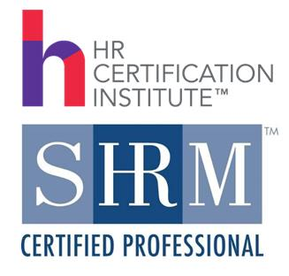

Margie Faulk, PHR, SHRM-CP
HR Compliance Advisor/Compliance E-Learning Trainer
mfaulk@hrcompliance.net
www.hrcompliance.biz

