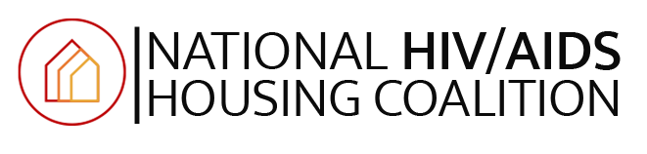

Fact Sheet: FY26 President’s HUD Budget Impact on People living with HIV

Stable housing is one of the most essential factors to any individual’s quality of life, but for people with HIV, stable housing is one of the strongest indicators of someone’s health and is associated with a 20% increased likelihood of being virally suppressed. Individuals who are virally suppressed cannot transmit HIV and are able to live healthy, full lives. Therefore, stable housing prevents new HIV transmissions and restores people to health.

In the United States there are an estimated 1.2 million people with HIV and about 10% of these experience homelessness each year (over 120,000 people). In 2021, The CDC found 27% of people with HIV needed housing assistance and 40% received no supports. The following year in 2022, the CDC Medical Monitoring Project reported that of in the past 12 months, 17% of PWH had been homeless or unstably housed. For 18-24 year-olds with HIV, 26% had experienced homelessness and/or unstable housing. Different jurisdictions report different rates of homelessness among PWH, as noted in Table 8 (below).

The Housing Opportunities for Persons with HIV/AIDS (HOPWA) program provided housing to about 46,000 households (~ 64,500 individuals) in 2022, and the Ryan White program was able to provide housing assistance to about 24,000 people. Low-income people with HIV can also be provided assistance through an array of mainstream federally-funded programs, including the Housing Choice Voucher program (formerly Section 8), Homeless Continuum of Care (CoC) assistance, the Youth Housing Demonstration Program (YHDP), and more. For many community-based organizations who implement housing programs, they stack these layers of funding together to provide assistance. Many clients are unaware of which funding source(s) assist with their housing. The entire spectrum of HUD-funding, including capital sources like CDBG and HOME, allow cities, states, and organizations to make their programs stretch and remain effective. Unfortunately, in nearly every jurisdiction in America, there is a waiting list for Housing Choice Vouchers, HOPWA, and other HUD programs.
In 2024, HUD estimated that 372,177 low-income people living with HIV in the United States are eligible for, but not currently accessing services under the HOPWA program.

President Trump’s FY26 Budget reduces the HUD budget by 44%, including a proposal to eliminate the HOPWA program. The justification for this decision reads as follows,

“The Budget does not provide funding for the Housing Opportunities for Persons
With AIDS (HOPWA) program which funds housing and supportive service interventions for low-income people living with HIV/AIDS and their families. Individuals living with HIV/AIDS who are homeless or at-risk of homelessness may be served through the expanded emergency solutions grant program, which provides emergency, short, and medium-term housing assistance.”

This proposed solution is short-sighted and dangerous, as only 34% of HOPWA funding is emergency, short, or medium-term assistance. 64% of HOPWA households are in permanent supportive housing or served by the TBRA (tenant based rental assistance) program that has no time limit. Further, “expanded emergency solutions grant program” which the administration is proposing, is also supposed to absorb the following accounts: Continuum of Care, New Permanent Supportive Housing, Construction Awards (for populations under 2,500,000), Victims of Domestic Violence, National Homeless Data Analysis Project, Youth Homelessness Demo and Youth Homelessness System Improvement Grant and Technical Assistance. To fund this collapse of programs, the Administration is actually decreasing the total award by $532 Million, $27 Million from “Homeless Assistance – Emergency Solutions Grants” line items and $505M from elimination of HOPWA.

HUD rental assistance programs, in totality, would be reduced by $26.72 billion from the previous year and restructure housing programs into a State Rental Assistance Block Grant (SRABG) program, combining the HCV program (Section 8), Public Housing, Project-Based Rental Assistance (PBRA), Section 202 Housing for the Elderly (Section 202), and Section 811 Housing for Persons with Disabilities (Section 811) programs.

In summary, NHAHC estimates that if this budget was implemented, well over 50,000 low-income people with HIV would lose housing assistance, adding to the existing 120,000 people with HIV who experience homelessness each year. This would, without doubt, create a new crisis in the ongoing HIV epidemic.

For more information, please contact:
Lauren Banks
Executive Director
National HIV/AIDS Housing Coalition
lauren@nhahc.org
Table 8

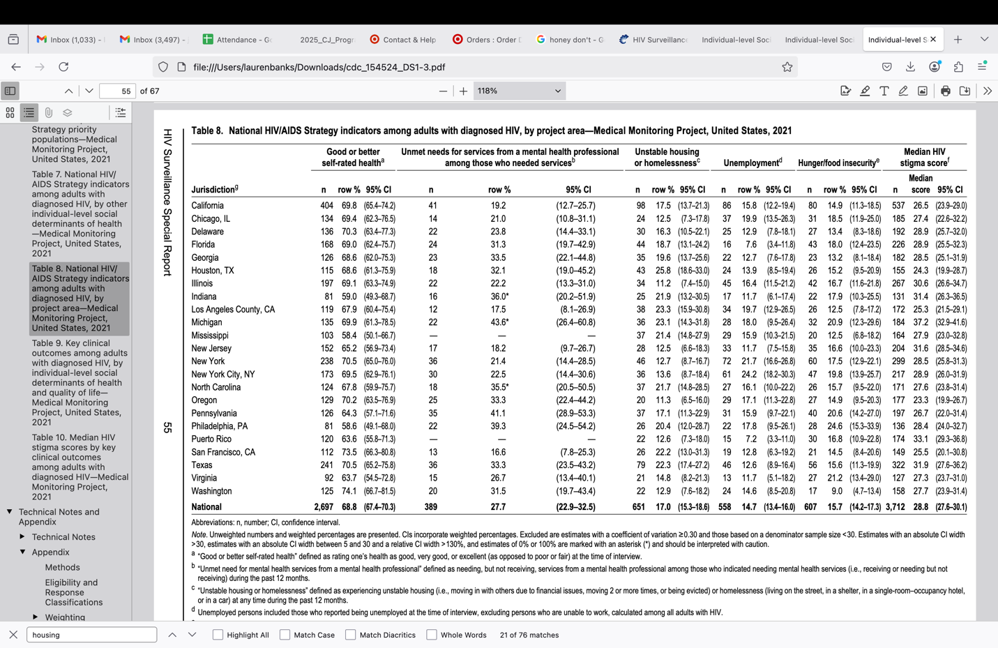
Title : HIV Surveillance Special Report: Individual-level Social Determinants of Health and Quality of Life Among Persons With Diagnosed HIV Infection Medical Monitoring Project, United States, 2021 Data Cycle (June 2021–May 2022). Published Date : 04/26/2024.URL : https://stacks.cdc.gov/view/cdc/154524

Dasgupta, S., Beer, L., Lu, J. F., Weiser, J., Yuan, X., Nair, P., Banks, L., & Marcus, R. (2023). Needs for shelter or housing assistance among people with diagnosed HIV by jurisdiction: United States, 2015-2020. AIDS (London, England), 37(3), 535–540. https://doi.org/10.1097/QAD.0000000000003460
“Unstable housing or homelessness” defined as experiencing unstable housing (i.e., moving in with others due to financial issues, moving 2 or more times, or being evicted) or homelessness (living on the street, in a shelter, in a single-room–occupancy hotel, or in a car) at any time during the past 12 months.
https://archives.hud.gov/budget/fy25/2025_CJ_Program_-_HOPWA.pdf
“https://www.whitehouse.gov/wp-content/uploads/2025/05/appendix_fy2026.pdf

