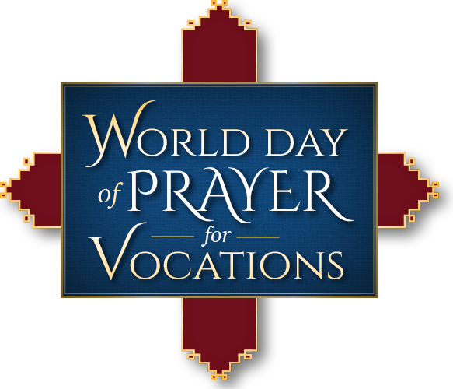
YOUR CHURCH NAME

LOCATION
DATE
TIME

Opening Hymn: The Summons, #384
Opening Prayer: Leader
Exposition of the Blessed Sacrament (Please Kneel)
0 Saving Victim (Organ Music Only)
Incensing the Blessed Sacrament
Scripture reading: Luke 10:1-9
General Intercessions (Response: Lord hear our prayer)
That all priests, deacons, and religious sisters and brothers receive your peace and continued strength in their vocations…
That deceased priests, deacons, religious sisters and brothers be granted eternal rest…
That all seminarians, and those in religious formation, receive the needed wisdom as they discern the Lord’s call…
That all married couples continue to keep God at the center of their marriage…
That those who work with youth will encourage them to listen carefully for God’s call…
For those that are having difficulty discerning their vocation, that the Holy Spirit give them wisdom and peace…
For all the intentions we hold in the silence of our hearts, (pause)….
Recitation of the Rosary: The Glorious Mysteries

Meditation/Reflection

Benediction
Divine Praises
Reposition of Jesus

Closing Hymn: Glory and Praise to Our God, #564

