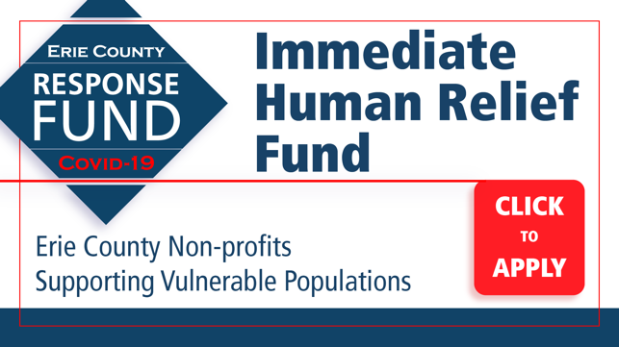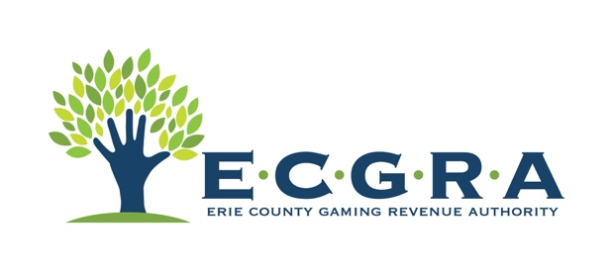

NEWS***NEWS***NEWS***NEWS***NEWS***NEWS***NEWS***

Erie County COVID-19 Response Fund Opens Project Face Shield to Non-Profits
Seven new grants awarded to help Erie’s Most Vulnerable Residents

CONTACT: Kate Philips
philips@parkerphilips.com
215.850.4647 | mobile

Erie, PA (April 29, 2020) – The Erie County Gaming Revenue Authority (ECGRA) authorized the purchase of an additional 500 face shields, which are now available at no cost to Erie County non-profits. ECGRA already provided an initial investment to support local police and fire with a purchase of 500 face shields. Now, the program has been extended to start equipping local non-profit organizations.

Non-profits can request face shields here: https://www.ecgra.org/covid-19-face-shield-form

“As local non-profits consider the cost and logistics to the myriad challenges on the horizon, providing them with PPE for their staffs will eliminate at least one hurdle ahead of opening their doors post-shutdown,” said Perry Wood, Executive Director, ECGRA. “We are all in this together, and ECGRA is proud to support the Erie County #MaskUp efforts, per state and county health guidelines.”

The Erie County COVID-19 Human Relief Fund was created by ECGRA and Erie County Council to support those in need throughout Erie County. As part of the latest round of grants, the ECGRA Board of Directors awarded seven additional grants (FULL LIST BELOW), including several grants to support local food banks. A total of $551,904 has been awarded since the launch of the Erie County COVID-19 Response Fund on March 19.

Grant #26: Corry Salvation Army
Amount: $9,500
Project: Refrigerator, hygiene, sanitization related things

Grant #27: Penn State Behrend
Amount: $10,121
Project: Mental Health Mobile Application

Grant #28: Christian Cupboard (Girard)
Amount: $3,000
Project: food pantry supplies

Grant #29: Ellan Cochran Food Pantry of Harborcreek
Amount: $1,000
Project: food pantry supplies

Grant #30: Northwestern Food Pantry (Albion)
Amount: $5,000
Project: food pantry supplies

Grant #31: Union City Food Pantry
Amount: $2,000
Project: food pantry supplies

Grant #32: Waterford Food Pantry
Amount: $5,000
Project: food pantry supplies

Organizations can apply for grants on the ECGRA online application system: https://www.ecgra.org/covid-19-response-fund

IMMEDIATE HUMAN RELIEF GRANTS AWARDED TO DATE

Grant #1: Second Harvest Food Bank of NWPA
Amount: $168,000
Project: Purchase life-sustaining food for Erie County families facing food insecurities

Grant #2: Emergency Shelter System
Amount: $12,500
Project: Emergency shelter funding for the homeless

Grant #3: North East Community Food Pantry
Amount: $1,000
Project: Funds to supplement additional need during time of crisis

Grant #4: Erie Family Center
Amount: $7,500
Project: Diaper Depot for those in need

Grant #5: YMCA of Greater Erie
Amount: $16,000
Project: Childcare Center for Life Sustaining Personnel

Grant #6: Mercy Center for Women
Amount: $9,525
Project: Emergency homeless shelter-related costs due to COVID-19 regulations

Grant #7: The Upper Room
Amount: $5,000
Project: Costs associated with increased regulations due to COVID-19

Grant #8: Metro-Erie Meals on Wheels
Amount: $2,000
Project: Transportation costs related to food distribution for homebound elderly

Grant #9: Penn State Behrend
Amount: $6,700
Project: Face Shields for medical professionals and first responders

Grant #10: Community Shelter Services
Amount: $30,750
Project: Emergency sheltering increase due to COVID-19

Grant #11: Saint Patrick’s Haven
Amount: $2,500
Project: Men’s shelter costs

Grant #12: Erie City Mission
Amount: $39,085
Project: Homeless shelter and kitchen

Grant #13: Safe Journey
Amount: $9,000
Project: Women’s shelter for domestic abuse victims

Grant #14: Erie DAWN
Amount: $10,000
Project: City of Erie domestic violence safe house provider

Grant #15: Gannon University
Amount: $23,000
Project: 3D printed face shields for distribution in Erie County

Grant #16: Sarah A Reed Children’s Center
Amount: $11,000
Project: Technology costs related to social distancing/remote therapy

Grant #17: HVA Senior Living Alliance
Amount: $6,800
Project: Technology costs related to telemedicine for seniors

Grant #18: Erie United Methodist Alliance
Amount: $2,365
Project: Homeless shelter-related costs

Grant #19: St. Martin’s Center
Amount: $7,300
Project: Childcare center preparation costs

Grant #20: Bethany Outreach Center
Amount: $7,600
Project: Emergency hygiene and food distribution

Grant #21: MECA Senior Care
Amount: $3,850
Project: Sanitizing the Senior Center for future opening

Grant #22: Penn State Behrend
Amount: $46,500
Project: Expansion of face shield project and N95 level face shields

Grant #23: Sisters of St. Joseph Neighborhood Network
Amount: $25,400
Project: Staff costs due to lost volunteer base

Grant #24: Millcreek Counseling & Mental Health Advocacy Partnership
Amount: $2,500
Project: Telemedicine

Grant #25: Urban Erie Community Development Corporation (UECDC)
Amount: $56,408
Project: Temporary supplemental food box preparation and delivery to Housing Authority residents

Grant #26: Corry Salvation Army
Amount: $9,500
Project: Refrigerator, hygiene, sanitization related things

Grant #27: Penn State Behrend
Amount: $10,121
Project: Mental Health Mobile Application

Grant #28: Christian Cupboard (Girard)
Amount: $3,000
Project: food pantry supplies

Grant #29: Ellan Cochran Food Pantry of Harborcreek
Amount: $1,000
Project: food pantry supplies

Grant #30: Northwestern Food Pantry (Albion)
Amount: $5,000
Project: food pantry supplies

Grant #31: Union City Food Pantry
Amount: $2,000
Project: food pantry supplies

Grant #32: Waterford Food Pantry
Amount: $5,000
Project: food pantry supplies

####

