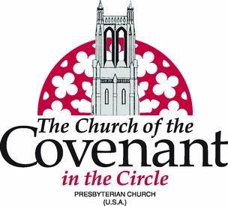
Amy Starr Redwine, M Div, Senior Pastor and Head of Staff
Melanie Marsh Baum, M. Div, Associate Pastor

January 6, 2019
Dear Members and Friends,

This morning at a congregational meeting, the First Presbyterian Church of Richmond, Virginia elected me as their new senior pastor and head of staff. I met with the Church of the Covenant session today, and they have called a congregational meeting for 9:15 am on Sunday, January 27 in the Dowd Commons for the purposes of dissolving my pastoral relationship with Covenant and receiving a motion from the Nominating Committee to elect a new slate of officers.

In our time together, we have navigated several challenging transitions, including the retirements of three long-term pastors and the restructuring of governance and staff, all while deepening the vibrant mission and ministry that is a hallmark of this church. I am convinced that God brought us together so that we could learn from and grow with one another. I will be forever grateful for the grace and patience you have shown me.

Just as God called me to Covenant, I feel God is now calling me to First Presbyterian to serve another vibrant and historic congregation and to be closer to my siblings and Derek’s sister and parents. My excitement for this new opportunity is tempered by my sadness at leaving two wonderful church communities in Covenant and Fairmount as well as the many other benefits of our family’s life in Cleveland. I trust that the work we have done together at Covenant has laid a strong foundation on which new pastoral leadership can build. I am especially and profoundly grateful for Covenant’s staff and session, and I know that, with God’s help, they will continue to lead with energy, enthusiasm, creativity, and love. The session is already working faithfully to determine next steps and will communicate these plans to you in the coming days.

In the next few weeks, there will be time for other words and expressions of leave-taking. Please know it has been a privilege to be your pastor, sharing in your joys and sorrows and journeying with you on the path of discipleship. I will hold you in my prayers as you uphold your vision to be a welcoming spiritual home, live God’s inclusive love, express Christ’s compassion, and do justice in the world.

With deep gratitude,
Amy Starr Redwine, Pastor and Head of Staff

