JULIE MORGENSTERN, Greenfield Class of 1971
New York Times Best-Selling Author and Organizing Guru

TIME TO PARENT
Organizing Your Life to Bring Out The Best in Your Child and You
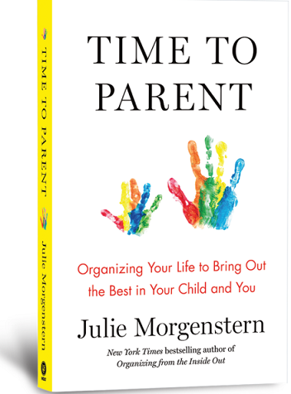
Designed for parents with children of all ages and at all stages, TIME TO PARENT: Organizing Your Life To Bring Out The Best In Your Child And You is the ultimate instruction manual that time-stretched parents have been craving for generations. Bringing together nearly three decades of work coaching parents internationally, Julie Morgenstern’s extensive research in the field of human development, and her own experience as a single Mom, gives parents a revolutionary way of organizing their time that is liberating, doable and helps parents achieve more presence in each thing they do.

Thursday, March 28, 2019
7:00 – 8:00 PM | Talk and Q&A
8:00 – 8:30 PM |Book Purchase* and Signing
(*Accepted Payment: Venmo, Cash or Check)

Albert M. Greenfield School | Auditorium
2200 Chestnut Street

Julie Morgenstern is the author of five previous books, including the New York Times bestsellers Organizing from the Inside Out and Time Management from the Inside Out, and an internationally renowned organization consultant who has shared her expertise on countless TV and radio outlets, including The Oprah Winfrey Show, The Today Show, and NPR. She is quoted and featured regularly in a wide variety of publications, including The New York Times, Time Magazine, USA Today, Business Week, The Wall Street Journal, Best Life, Martha Stewart Living, Glamour, Fitness Magazine and Men's Health.

