Decision Stepper with Student Account

Please see below for the steps to access your child’s middle school or high school application results. Your child should know his/her ID and password, but please e-mail me at jestern@philasd.org if you need this information.

- Go to: www.philasd.org
- Click ‘Login’ in the upper right hand corner
- Enter your child’s ID number (Username) and Password
- Click on the drop down arrow next to ‘Student’ in the black box

- Click on Portal

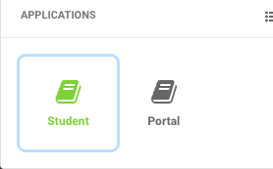

- Select ‘School Selection’ out of the list of icons on the right

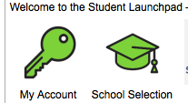

7) Your child’s application will appear with the results of the application process for each school that he/she applied to. Instructions will be listed for how to make school selections.
*Students can choose to remain on a waiting list while simultaneously accepting a school offer. If space becomes available, students can be called up to the end of the first marking period of the following school year. At that point, all wait lists will be dissolved and students will have to reapply the following year.
**You can make your selection at any time between Friday, January 11th at 5:00 pm and Tuesday, January 22nd at midnight.
***You can accept the offer of admission at ONE school only. You must select “Accept the Approval” at the chosen school and you must select “Decline the Approval” at all other schools that your child was accepted to.
****Even if your child was only accepted to one school and you would like to select it, you still need to select “Accept the Approval” for this school.

