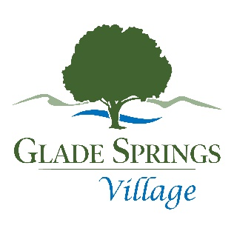**Nomination Form**

For the

Glade Spring Village Property Owners Association, Inc.

Board of Directors 2025

All nomination forms must be completed in their entirety (please attach answers to the questions in typed form except for the signatures). All nominations **MUST** be **received at the POA office by** **4:00 p.m.,** **March 20, 2025,** by email or paper copy to be considered by the Nomination Committee. In addition, we would request that you attach a color photo (in a PDF file or hard copy) with this form when returning it to the Nomination Committee. Completed forms must be returned to:

Glade Springs Village Property Owners Association, Inc.

Attention: Nomination Committee

P. O. Box 90

Daniels, WV 25832

Board Members are required to attend monthly and special board meetings and actively participate in GSVPOA business. Officer positions (President, Vice President, Treasurer, and Secretary) will be determined after the election of the newly elected Board of Directors. Please note that there are some duties that will require time and effort beyond the scope of the monthly meetings.

Public Information (this information will be distributed with the election ballot)

Full Name:

Address:

Phone:

E-Mail:

Please answer in a clear and concise manner:

1. How long have you owned property in Glade Springs Village:

2. Why do you want to be a leader in the GSVPOA as a member of the Board of Directors?

3. What do you consider to be your qualifications to serve in this capacity?

4. What other gifts do you bring with your service on the Board of Directors?

5. When elected to serve as a Board member, what specific issues would invite your focus and attention?

6. What is your vision for Glade Springs Village?

7. What do you consider to be the mission of the Board of Directors?

8. What are your personal core values by which you live your daily life?

A viable candidate for the Board of Directors is required to be over 18 years of age, a member in good standing which is defined as a person with no outstanding or past due monthly assessments during the current fiscal year (2024/2025), no fines or penalties that are more than 30 days past due, and of sound mind. I certify that I fulfill all the above requirements and that I am eligible to be a member of the Board of Directors. Further, when elected I will attend regular meetings and perform the duties assigned to me as a director to the best of my ability.

Candidate’s Signature: _________________________________ Date: ________________________

**To be filled out by the POA:**

Date received: ___________________________

Received by: _____________________________

Date Saved to the Shared Drive: _______________