**Abandoned Cart**

<https://support.yourdocket.com/hc/en-us/articles/27886704058509-Abandoned-Cart-Email-Rules>

To enable the Abandoned Cart function, follow these steps:

Online Booking → Sessions → Active View drop-down change to Notification Management

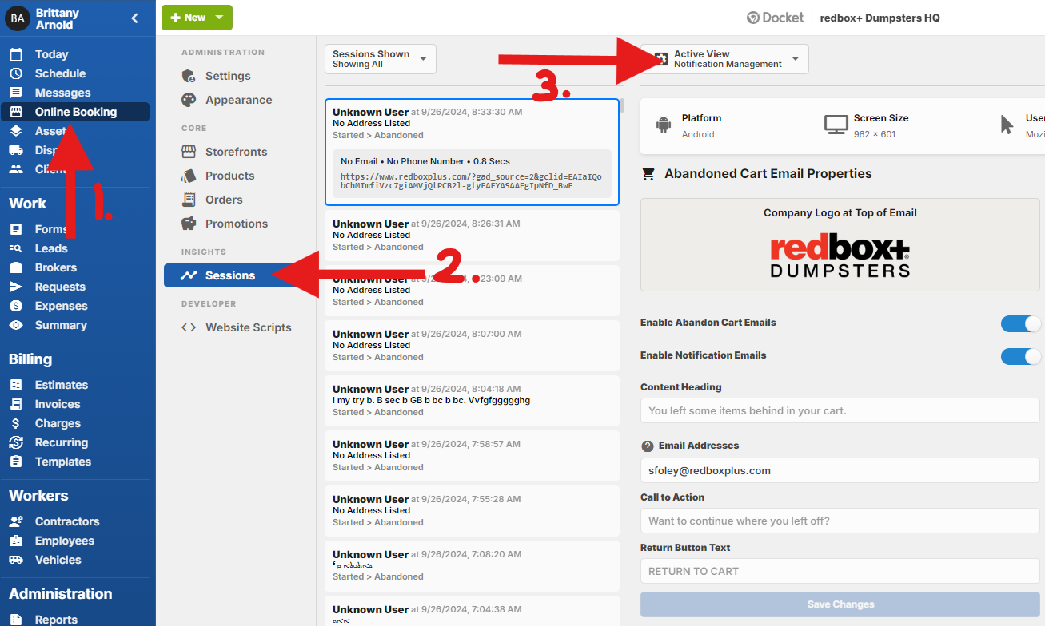

You’ll need to enable the cart notifications in order for this feature to work. There are two options to toggle for this.

1. **Enable Abandon Cart Emails** - This toggle lets your *customers* receive the notification.
2. **Enable Notification Emails** - This toggle allows the *internal team* to receive the notification.

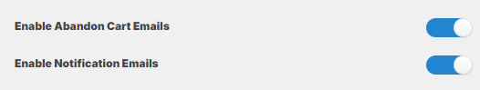

You’ll then need to add the flavor of the abandoned cart and who the internal notification should be sent to. (Example below.)

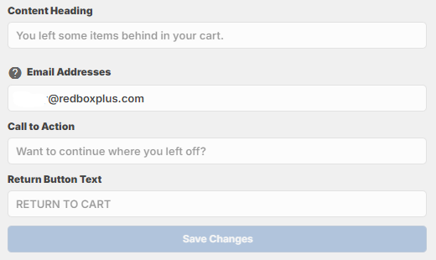

You do have the option to add multiple e-mail addresses to be sent *internally*. You can do this by separating the e-mail addresses with commas. DO NOT add any spaces.

Example: emailone@email.com,emailtwo@email.com,emailthree@email.com

E-mails to the internal team get sent out at the same time that the customer e-mail addresses do. The Docket server checks for abandoned carts every 10 minutes, so customers will receive an abandoned cart e-mail within a **maximum** of 20 minutes after abandoning their cart.

E-mails *to the customer* are sent out based on the following criteria:

1. **Inactivity:** The customer has not interacted with their session for over 10 minutes.
2. **Daily Limit:** Only one abandoned cart email is sent to a customer per day, regardless of how many times they abandon carts.
3. **Item in Cart:** There was an item in the customer's cart when they abandoned the session.
4. **No System Errors:** The session was not associated with a system error.
5. **No Order Submission:** The session was not associated with an order submission.