

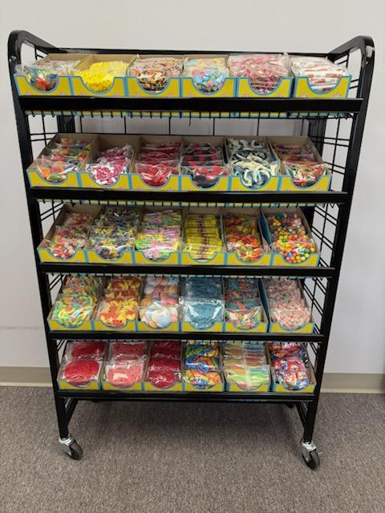
The Penny Candy Rack program
Order a minimum of 30 SKU's and the cost for the rack is $400.00
The shelves can be angled down which looks the best with our candy.
Dimensions: 36"W X 13"D X 52"H

