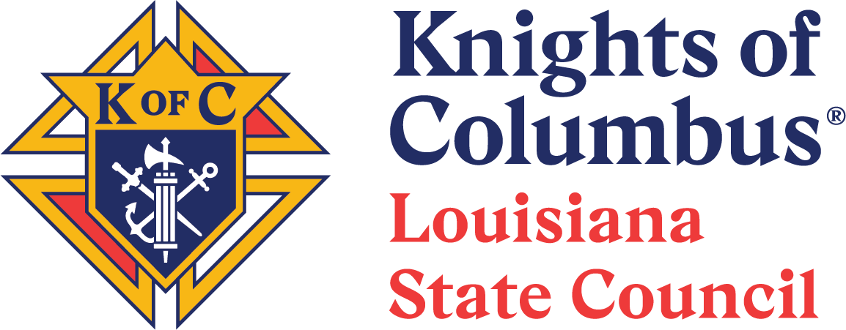

2024-2025 Louisiana State Deputy Award

Councils that satisfy the criteria set by the State Council will be eligible for the Louisiana State Deputy Award. The State Deputy Award showcases and honors those Councils and members who work to achieve the required goals.

1. Criteria and Deadlines.

Reporting Period: July 1, 2024, to June 15, 2025.

Administrative Criteria and Other Deadlines.
Refer to the deadlines, criteria, and guidance stated herein.

2. Method to determine 2024-2025 State Deputy Award recipients.

A council that meets the attached requirements qualifies for the Louisiana State Deputy Award. Every council in Louisiana can earn the Louisiana State Deputy Award.

3. Objective.

The objectives of the award criteria are to:

(1) Focus on the activities that are important to the Louisiana State Council and Louisiana Knights; and

(2) Focus on the requirements needed to earn Star Council.

Vivat Jesus!

Vince Whittington
State Deputy

To earn the award, the Council must fully satisfy each mandatory requirement by the deadline and fully satisfy at least 6 of the 11 elective requirements.
Action | Mandatory Requirements | Due Date
KCLS | At least two (2) council members must attend KCLS.  (The requested members are Grand Knight, Membership Director, Program Director, and Financial Secretary.) | July 20 or 21, 2024
Grand Knights Day | At least two (2) council members must attend Grand Knights Day.  (The requested members are Grand Knight, Membership Director, Program Director, and Financial Secretary.) | January 25 or 26, 2025
Form 185 | Submit Form 185 (Officers). | September 1, 2024
Form 365 | Submit Form 365 (Directors). This form ensures that all applicable positions are included in the Safe Environment training. | September 1, 2024
Safe Environment | The council must be fully safe environment compliant. (The Grand Knight, Program Director, Community Director, and Family Director are required to take the Safe Environment Training. The Community Director and the Family Director must also provide consent for a background screening.) | June 1, 2025
Form 1295 | Submit Form 1295 (Semiannual Council Audit). | August 15, 2024
Form 1295 | Submit Form 1295 (Semiannual Council Audit). | February 15, 2025
Form 1728 | Submit Form 1728 (Fraternal Survey). | January 31, 2025
Per Capita | All State Per Capita payments must be paid in full. (Both billing dates.) | April 30, 2025
Convention | At least two (2) voting delegates from your council must attend the State Convention. | May 3, 2025
Membership | Must recruit at least three (3) new members. | June 15, 2025
FBN | Must earn the Founders’ Award.  - Founders’ Award Criteria  - Founders’ Award — Form #11077 — Due Within 7 Days of Seminar  - Host / promote at least two Fraternal Benefit Events — By June 15  - The required sum total attendance of members, or member eligible men, at these events must equal or exceed:  - 10 for councils with 99 or fewer members  - 14 for councils with 100 or more members | June 15, 2025

None of the following are specifically required by the State Deputy, but your Council must achieve at least 6 of the following items. Your Council has to decide which 6 to achieve.

Action | Any 6 of the 11 Electives are required | Due Date
CPID | A donation of any size must be made to St. Mary's Residential Training School or Holy Angels Residential Facility and reported using the State Form. | June 15, 2025
Special Olympics | Special Olympics Report must be submitted to Supreme by January 31 and must reflect a donation or volunteer hours of any size or amount. Donation or volunteer hours are for Calendar Year 2024. Fill out Form #10784 by January 31, 2025. | January 31, 2025
CYLA | At least one (1) CYLA application must be submitted to the Diocesan Event Chairman. | February 7, 2025
SMF | Sell at least $250 worth of tickets (50 Tickets) to the Seminary Mission Fund. | May 3, 2025
YEP | Donate 100% of the council’s (YEP) Youth Expansion Program quota. | June 15, 2025
Retreat | At least one (1) council member must attend the State Retreat. | February 21-23, 2025
Golf | At least one (1) council member must participate in the State Golf Tournament. | October 5, 6, 7, 2024
Cornhole | At least one (1) council member must participate in the State Cornhole Tournament. | February 1, 2025
Horseshoe | At least one (1) council team must participate in the State Horseshoe Tournament. | October 19, 2024
Gumbo | At least one (1) council team must participate in the Diocesan Gumbo Cook Off.  (The dates and places for the Gumbo Cook Offs will be determined by the Diocesan Event Chairman.) | December 31, 2023
Bowling | At least one (1) council member must participate in the State Bowling Tournament | January 11-12, or January 18-19, 2025
BONUS | If all four (4) requested members attend KCLS AND Grand Knights Day, your council can achieve a bonus check mark to use. | July 20 or 21, 2024  January 25 or 26, 2025

