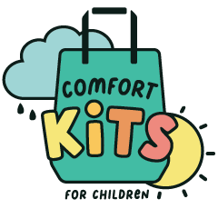

- Box of crayons
- Small coloring or activity book
- Small notebook
- Playdough
- Bubbles
- Stress Ball or similar fidget
- Hand sanitizer
- Small plush toy

These are packed in a plastic container the size of a shoe box. However, if mailing multiples, please include items in a gallon size Ziploc bag (plush stuffie can be separate) for ease of mailing. Plastic containers can then be stacked together or sent separately.

- Box of crayons
- Small coloring or activity book
- Small notebook
- Playdough
- Bubbles
- Stress Ball or similar fidget
- Hand sanitizer
- Small plush toy

These are packed in a plastic container the size of a shoe box. However, if mailing multiples, please include items in a gallon size Ziploc bag (plush stuffie can be separate) for ease of mailing. Plastic containers can then be stacked together or sent separately.

