Hello from the Trainee Affairs Committee!

The 51st Annual Meeting is less than a month away in the charming city of New Orleans! We hope that you have submitted your best work and have applied to Trainee awards and grants that were available for the meeting. The TAC has put together a number of Trainee-specific events (detailed below) for you to take full advantage of all that the meeting has to offer.

Meeting Registration

Trainee registration is highly subsidized by SSR and we strongly suggest you take advantage of the opportunities the Annual Meeting offers. Online and onsite registration is available.

Trainee Volunteers needed

You can help make SSR 2018 a success! We are currently looking for trainees to volunteer their time at the 2018 meeting to work behind-the-scenes and help with the day-to-day running of the meeting! Volunteering is a great way to expand your personal and professional networks, enhance your soft skills, and learn about the inner workings of the Society. There is a volunteer activity to suit everyone, including (but not limited to):
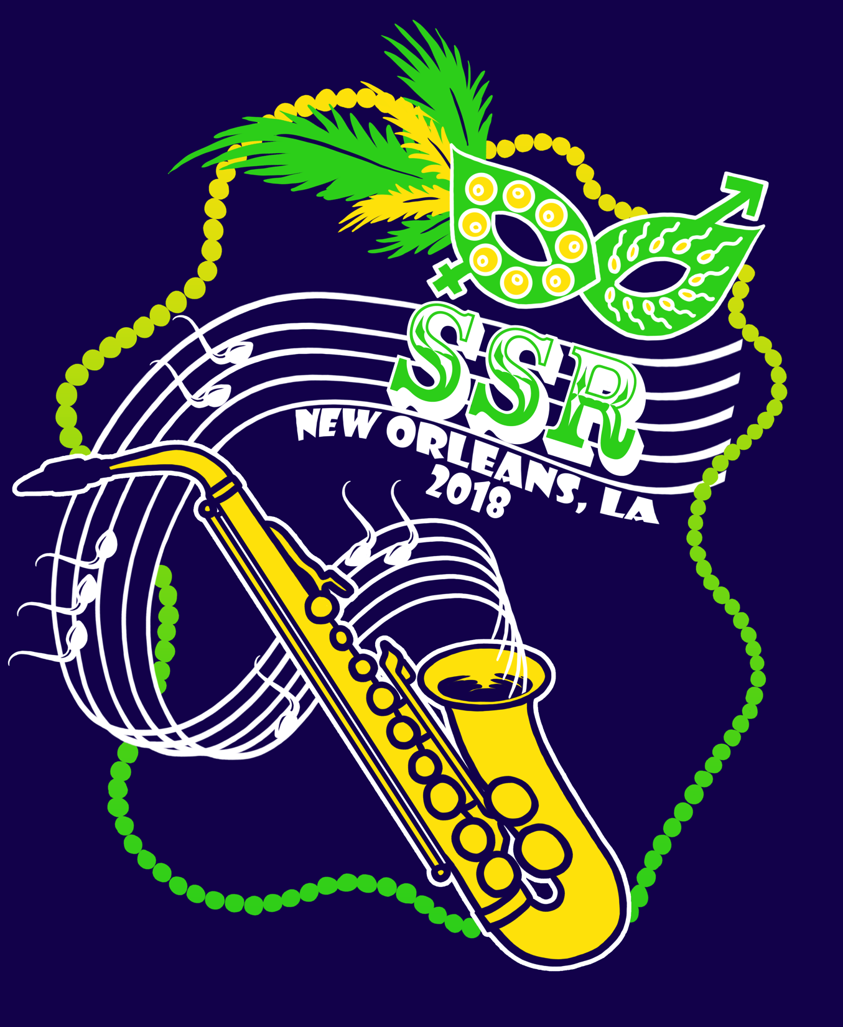
1) Greeting meeting attendees at the registration desk
2) Collecting tickets at special events
3) Helping presenters upload their presentations
4) Placing signage around the meeting venue

It is a very rewarding experience, but don’t take our word for it; read the testimonials from last year's volunteers on our webpage! To top it off, all volunteers will receive a free SSR 2018 t-shirt, designed by our own talented Trainee, Katie Chiang! Interested trainees should check the ‘Volunteer’ box on their registration form, or if you have already registered, please contact the Trainee Volunteer Subcommittee Co-Chairs, Pei-Chih Lee and Brittany Foster. Pei-Chih and Brittany will contact you closer to the meeting to choose the specific volunteer tasks you would like to be involved in!

Election held for the 2018-2019 Junior Trainee Representative
The elections for the incoming 2018-20 Trainee Representative to the Board were recently held and the results will be announced soon. This year, we had four highly qualified candidates ready-and-willing to serve the SSR Trainees:

1) Ashley George (5th Year Graduate Student at Rutgers University – Dr. Carol Bagnell)
2) Matthew Dean (Postdoc at University of Illinois, Chicago – Dr. Joanna Burdette)
3) Rolando Pasquariello (Postdoc at Colorado State University – Dr. Rebecca Krisher lab)
4) Megan Sheridan (5th Year Graduate Student at University of Missouri, Columbia - Dr. R. Michael Roberts lab)

Fun Run 5k

Don’t forget to sign up for the Fun Run 5k along the scenic Mississippi Riverside! The TAC has set up a fundraising webpage to support Trainee Travel – you do not need to run to donate! Should we reach our fundraising goal of $500, your dedicated Senior Trainee Rep, Jitu George, will wear a banana suit while he cheers on the runners.

- When? Friday July 13 from 6:30 am - 8:00 am
- Where? Hilton New Orleans Riverside
- How much? Registration is $30
What do I get? Registration includes a T-shirt and the endless personal satisfaction of completing an athletic feat.

Trainee Forum

The Trainee Forum is scheduled on July 10, from 10:15 am -11:45 and will discuss “Treading thoughtfully through the career transitional path: Navigating successfully from graduate student to postdoc to academia or industry”. Our speakers for the forum are:

1. Dr. Francesca Duncan (Northwestern University),
2. Dr. John Bromfield (University of Florida),
3. Dr. Tracy Clement (Texas A&M University)
4. Dr. Gaurang Daftary (Ferring Pharmaceuticals)

Mock Grant Review

The Mock Grant Review study section will be held on July 10, from 1:30pm- 3:00pm to help demystify the grant review process. Drs. Susan Taymans, Stuart Moss, and Mark Mirando will help understand the NIH/USDA grant review process using the K99/R00 grant as a platform. This event will be available for all meeting attendees and there is a $10 registration fee to cover refreshments. Drs. Taymans and Moss are Program Directors at NICHD, and Dr. Moss formerly served as a Scientific Review Officer at NIH. Dr. Mark Mirando is the National Program Leader of Animal Nutrition, Growth and Reproduction at the National Institute of Food and Agriculture where he provides leadership for competitive grant and capacity programs in animal reproduction. We look forward to seeing you at this event!

Trainee Mentor Luncheon
The Trainee-Mentor Luncheon coordinator, Dr. Jeremy Egbert (UConn Health), has selected 31 Regular member mentors for you to engage in an informal setting. The TML will be run on July 12 from 12:00 pm-1:30 pm. We have capped the number of trainees at 150, to enable each table at the luncheon to have a lower trainee to mentor ratio and encourage productive discussions. This event is an excellent way to network with your fellow trainees and regular members in a casual setting. Please remember to sign up for the event when you register for the meeting! If you have not signed up during registration, please contact Lorna Valle at membership@ssr.org. Tickets for the luncheon are $30. For more information about the event and Mentor biographies visit the Trainee webpage and fill the mentor choice form.
Career Consultation Center
This year’s CCC coordinator is Katie Chiang (University of Illinois) and she has put together a diverse and impressive list of mentors with expertise in research, science policy, industry and publication! The CCC will be run concurrent with the poster sessions from July 11-13, 8:00am-9:45am. Interested trainees must complete the Google Form to reserve an appointment. Space is limited. Get in early to secure your spot!

Roommate Referral Service

The RRS coordinator is Rosalina Villalon Landeros (University of Wisconsin-Madison) and she will help identify potential roommates. please fill out the Roommate Referral Application Form and email to roommate@ssr.org. Deadline was June 8, 2018.

It has been an honor!

This is Jitu’s last newsletter as the Chair of the Trainee Affairs Committee. The last two years were a lot of fun and a highly rewarding experience. He has had a wonderful time working with Drs. Patrick Hannon and Erica Schoeller, all the members of the Trainee Affairs Committee, the SSR Business office, Board of Directors and Trainee members of various committees of the Society. He has learnt a lot about the inner workings of a scientific society and highly recommends Trainees to be involved in SSR. SSR prizes and engages its Trainees and provides numerous opportunities for Trainee growth within the Society. The TAC is always looking for enthusiastic Trainees to be involved in the society and interested Trainees should contact Erica Schoeller at trainees@ssr.org.

We look forward to seeing you in New Orleans for an outstanding meeting.

—Drs. Jitu George and Erica Schoeller, Co-Chairs 2018 Trainee Representatives and Trainee Affairs Committee trainees@ssr.org

