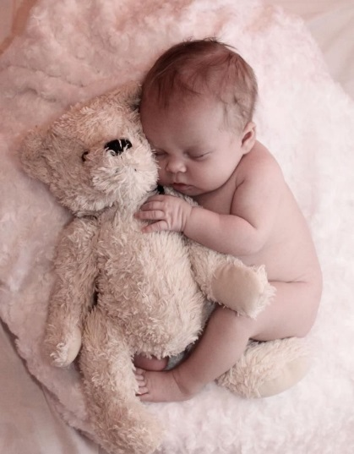

**Please Help Give Central Florida Newborns**

**Jammies and Joy**

***Itty-bitty babies need itty-bitty pajamas now!***

Little ones born into foster care urgently need cozy little items of sleepwear for their trip from the hospital to their new homes. Park Maitland 5th Grader Ainsley Giorgio and her mom, Raquel, are collecting brand new pajamas for these local infants in need.

For those who wish to donate, please bring in *brand new* pajamas to fit newborns and babies up to 6 month-olds and send them home with Ainsley Giorgio, 5-Blue. We plan to deliver collected items on November 20th to:



2265 Lee Rd, Suite 203, Winter Park, FL 32789

[www.foundationforfosterchildren.org](http://www.foundationforfosterchildren.org/); P: [407-422-4615](tel:407-422-4615)

The Foundation for Foster Children serves the over 2,000 children in foster care ages 0-23 in the Orange, Osceola and Seminole counties. Their mission is to enhance the lives of children in foster care through support and advocacy to create opportunities for a brighter future.

In support of the Foundation for Foster Children’s Safe Space & Supplies program, we’re collecting pajamas for local children in need.