CONGO RIVER GOLF FUN RAISING EVENT.
The money raised will help Park Maitland package 25,000 meals on February 14th through FEEDING CHILDREN EVERYWHERE. The meals will be sent to people in need in Puerto Rico.

Wednesday, January 31st,
5:30 p.m. to 7:30 p.m.
Congo River Golf in Altamonte Springs

Each ticket provides 20 meals for people in need.
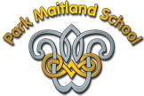
TICKETS AVAILABLE NOW. But supplies are limited.

$10.00 per ticket.

Tickets can be ordered through January 31st.
Get yours now!
If you can’t make it on our date, don’t worry! Your tickets are good for any Congo River location and they do not expire.
_ _ _ _ _ _ _ _ _ _ _ _ _ _ _ _ _ _ _ _ _ _ _ _ _ _ _ _ _ _ _ _ _ _ _ _ _ _ _ _ _
Name_____________________________________________
Grade/Color_______________________________________
# of tickets needed _________ X $10.00 = $_________.

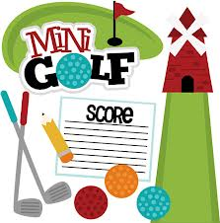
Please make checks payable to
Park Maitland School.

For $35.00 you, your class, or your local business can sponsor a hole. If you wish to sponsor a hole, please write your name and contact information below. A representative will contact you in the next few days with more information regarding this excellent opportunity. Hole sponsors can advertise their business, cause, or class with a sign on one of the holes and receive two free raffle tickets for our door prizes.

Name:_____________________________________________________________

Email:___________________________________Phone:____________________
Pizza, drinks, and chips will be sold during the event. There will be 3 grand prizes raffled off at 7:00 during the event. You can get a raffle ticket for a donation of $2.00, or you can get 5 raffle tickets for a donation of $6.00. Prizes TBA.

