

ABOUT US
ProMaster Security Gate and Door Expert is New York’s top team of technical professionals. We are the premier commercial garage door, roll-up gate and fence company focused on keeping your business safe and secure. We provide all the best personalized solutions for your security needs.
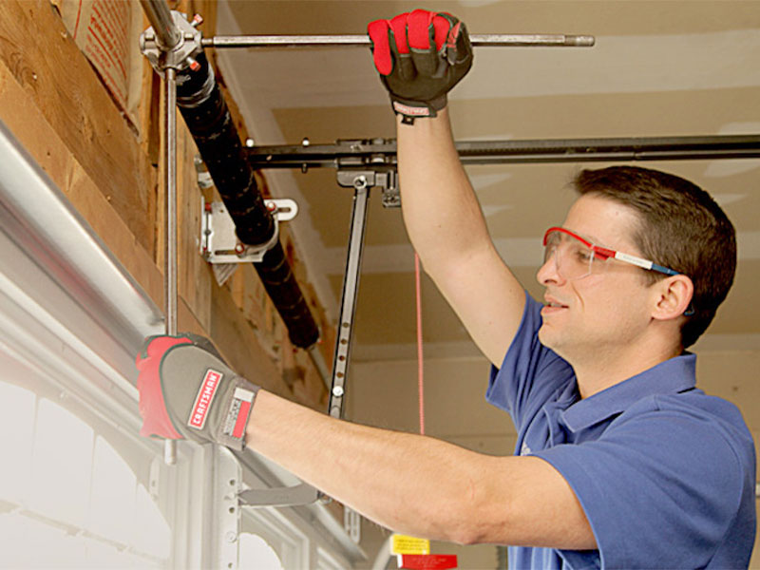
Our purpose is to help you find the best solutions to your safety and security needs. We do that by installing the right products based on your personal situation. We evaluate your property needs and give you the solutions to protect and secure it. Based in New York City we provide expert garage door repair, gate repair and roll up gate repair. Same-day service calls get the job done fast and done right.
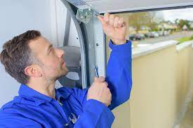
We provide repair and installation services to clients who are looking for a strong, secure, reliable, and beautiful garage door or storefront roll up gate. Our professional repair teams are responsive to all garage door repair emergency calls.
Each garage door repair technician comes fully prepared to get the job done fast and done right. We carry a large selection of garage doors, rolling gates, storefront roll up gates, garage door openers, commercial garage doors and fences.
We offer all types of gate replacement parts and a full line of garage door opener accessories. All garage door repairs and rolling gate repairs are done same day.

OUR PROMISES
- Provide a simple and cost- effective solution to your immediate problem.
- Provide a permanent handling to your problem that will last long into the future.
- Provide you with excellent service and a 1 year warranty on all new installations.
Our Goal
We are a supplier and installer of the best brands of commercial doors and gates. We are trained, hard-working and professional. Our business is customer-focused. We are here to solve the real problems and needs of our customers.

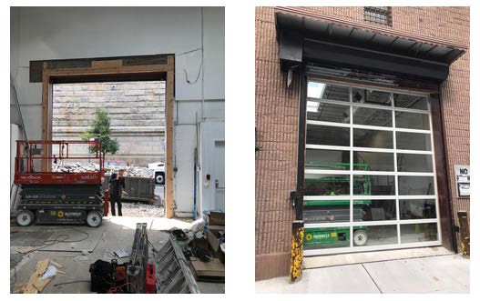
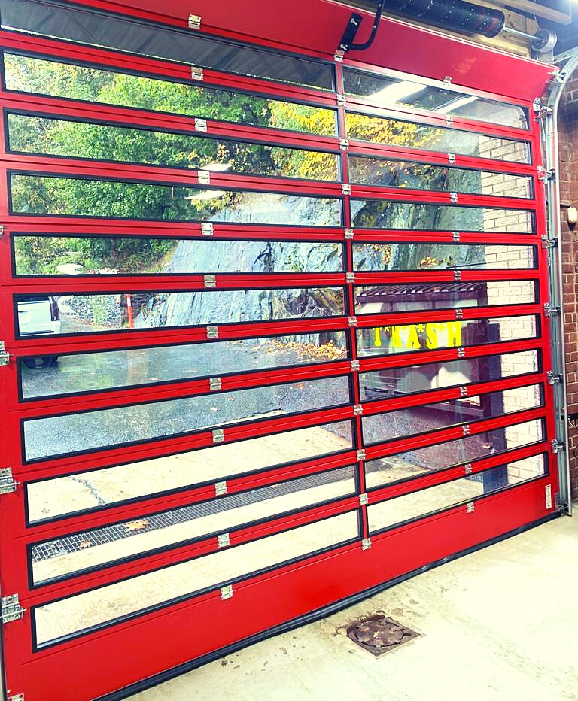

CORE VALUES
1. ProMaster Security Gate and Door Expert aims to service our customers’ security needs in for the next 100 years. That means we give you confidence in the security of your space.
2. We aim to give you confidence by providing you with gates and garage doors that are fully- functional and will last many years into the future.
What Our Customers say...
"My experiences with ProMaster was excellent. The response turnaround time was great, and the technician sent was very timely, and professional. The tech knew all about the problem I was having with my garage, was able to explain it so I can understand, and did an excellent job and fixing the jam and also installing a new lock. Felt the pricing was honest as well at the business. Definitely would recommend them and look forward to doing more business with them." - Kyra Groves

"The technician was very helpful, great service, went above and Beyond what was expected to help me get what I wanted done. Definitely recommend!" - A.D

"Great all-around experience. They are very professional and service-oriented!! Definitely will use them again if the need arises." – JV

Call Now! 1-855-333-4884

