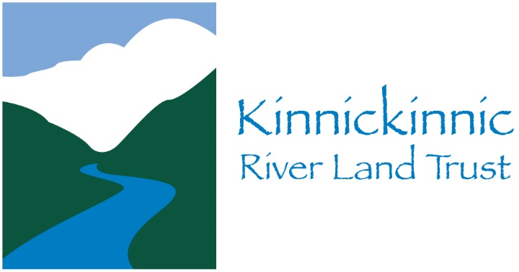

Volunteer Release and Acknowledgement of Risk and Photo Release

KinniRiverCleanUp, April 27, 2019, River Falls, Wisconsin

Please complete the following, printing legibly:

Name of Volunteer: __________________________________________________________

Address: ___________________________________________________________________

City: State: Zip: ______________________________________________________________

Phone: _____________________________________________________________________

Email: ______________________________________________________________________

Date/Location of Volunteer Activity: Saturday, April 27, 2019, River Falls, Wisconsin

Organizer: Kinnickinnic River Land Trust, Inc.

This document must be signed by all volunteers. If the volunteer is under the age of 18, this document must be signed by his or her legal guardian.

Volunteer Activity: I am donating my time and services without any compensation and shall at no time be considered an employee or independent contractor of the Kinnickinnic River Land Trust, Inc., or the KinniRiverCleanUp event. I understand that no organization is providing insurance coverage for me.

Release from Liability: In consideration for being allowed to participate in KinniRiverCleanUp as a volunteer, I, binding my heirs, executors, administrators, and assigns, hereby fully and forever release, waive, discharge, acquit and exonerate Kinnickinnic River Land Trust, Inc., the organizer of KinniRiverCleanUp in which I am participating, from any and all claims, actions, remedies and complaints of any kind, except for claims for gross negligence or willful misconduct, which I have or may have, whether known or unknown, arising out of or relating to the KinniRiverCleanUp or my volunteer work for this event, including specifically all claims for personal injury, paralysis, wrongful death, property damage and any other injury I may sustain.

Continue and Sign on back side.
Assumption of Risk: I assume all risks of participating in KinniRiverCleanUp and full responsibility for my conduct and actions, including any injury to myself or others or damage to property that may result while volunteering. I understand that the Kinnickinnic River Land Trust, Inc. is not responsible for conditions I create for myself or those created by other volunteers or participants. I am aware that the KinniRiverCleanUp activities may be hazardous, involving risk of serious bodily injury, death, or property damage. I am voluntarily participating in these activities with knowledge of the risks. These risks include, but are not limited to, slips, falls, exposure to hazardous materials, object or persons falling on persons, equipment failure, injury from sharp equipment, improperly administered first aid, lightning strikes, hypothermia, and/or drowning.

I know of no reason, medical or otherwise, that would prevent me from performing the tasks required to participate in this volunteer activity. I will be personally responsible for my own safety during these activities and assume all risks and accept full and complete responsibility for any and all damages and personal injury of any kind, including death. I recognize Kinnickinnic River Land Trust, Inc., its agents, volunteers and affiliates make no representations whatsoever as to whether the Kinnickinnic River, its tributaries, and any other land or water area included in the KinniRiverCleanUp are safe or as to whether the safety recommendations provided are comprehensive or adequate.

I grant to Kinnickinnic River Land Trust, Inc., its representatives and employees the right to take photographs at this event of me and of any minor participants for which I am the parent or guardian. I authorize Kinnickinnic River Land Trust, Inc., its assigns and transferees to use such photographs, with or without names, for any lawful purpose, including for example such purposes as publicity, illustration, advertising, and Web content, and to copyright, use and publish the same in print and/or electronically.

My signature below affirms that I have read and understood the above document and that I voluntarily, freely and without duress agree to its terms:

Participant Name: _______________________________

Signature: _____________________________________ Legal Parent/Guardian

Date: _________________________________________ Signature: ___________________________

I am 18 years of age or older Print Name: _________________________

If you are under 18 years of age, you MUST have Date: ______________________________
a parent or guardian signature

EMERGENCY INFORMATION: In case of emergency, please call:

Name: __________________________________ Phone:__________________________

Allergies: ________________________________________________________________________

Current Medications: _______________________________________________________________

