Welcome to our Sunday Worship
The Feast of the Resurrection, Year C
Easter Sunday April 20, 2025 10:00 a.m. Rite II

PRELUDE: Alleluia Mozart

SURELY THE PRESENCE WORSHIP Worship #131

PROCESSIONAL HYMN: At the Lamb’s high feast we sing Hymnal #174

OPENING ACCLAMATION

Celebrant Alleluia. Christ is risen.
People The Lord is risen indeed. Alleluia.

Celebrant Alleluia. Christ is risen.
People The Lord is risen indeed. Alleluia,

Celebrant Alleluia. Christ is risen.
People The Lord is risen indeed. Alleluia.

Almighty God, to you all hearts are open, all desires known, and from you no secrets are hid: Cleanse the thoughts of our hearts by the inspiration of your Holy Spirit, that we may perfectly love you, and worthily magnify your holy Name; through Christ our Lord. Amen.

GLORIA Hymnal S-280
Glory to God in the highest, and peace to his people on earth.

Lord God, heavenly King, almighty God and Father, we worship you, we give you thanks, we praise you for your glory.

Lord Jesus Christ, only Son of the Father, Lord God, Lamb of God, you take away the sin of the world: have mercy on us; you are seated at the right hand of the Father: receive our prayer.

For you alone are the Holy One, you alone are the Lord, you alone are the Most High, Jesus Christ, with the Holy Spirit, in the glory of God the Father. Amen.

Celebrant The Lord be with you.
People And also with you.
Let us pray
O God, who for our redemption gave your only-begotten Son to the death of the cross, and by his glorious resurrection delivered us from the power of our enemy: Grant us so to die daily to sin, that we may evermore live with him in the joy of his resurrection; through Jesus Christ your Son our Lord, who lives and reigns with you and the Holy Spirit, one God, now and for ever. Amen.

FIRST READING: Acts 10.34-43
The setting, the people to whom this Good News was proclaimed, and the linking of gospel to Old Testament prophecies, underline the universality of Peter's message that we read this morning. The point of Peter's message is that the resurrection of Jesus confirmed for all people, and all time, that he is Lord.

Then Peter began to speak to them: "I truly understand that God shows no partiality, but in every nation anyone who fears him and does what is right is acceptable to him. You know the message he sent to the people of Israel, preaching peace by Jesus Christ--he is Lord of all. That message spread throughout Judea, beginning in Galilee after the baptism that John announced: how God anointed Jesus of Nazareth with the Holy Spirit and with power; how he went about doing good and healing all who were oppressed by the devil, for God was with him. We are witnesses to all that he did both in Judea and in Jerusalem. They put him to death by hanging him on a tree; but God raised him on the third day and allowed him to appear, not to all the people but to us who were chosen by God as witnesses, and who ate and drank with him after he rose from the dead. He commanded us to preach to the people and to testify that he is the one ordained by God as judge of the living and the dead. All the prophets testify about him that everyone who believes in him receives forgiveness of sins through his name."

Reader Hear what the Spirit is saying to God’s people.
People Thanks be to God.

from Psalm 118
This song of victory may have been composed to celebrate a military triumph. In later Jewish rituals it served as a special litany for festive occasions. Centuries later, it was a favorite of Martin Luther who said that it had helped him out of grave distress.

1 Give thanks to the LORD, for he is good; *
his mercy endures for ever.
2 Let Israel now proclaim, *
“His mercy endures for ever.”
14 The LORD is my strength and my song, *
and he has become my salvation.
15 There is a sound of exultation and victory *
in the tents of the righteous:
16 “The right hand of the LORD has triumphed! *
the right hand of the LORD is exalted! the right hand of the LORD has triumphed!”
17 I shall not die, but live, *
and declare the works of the LORD.
18 The LORD has punished me sorely, *
but he did not hand me over to death.
19 Open for me the gates of righteousness; *
I will enter them; I will offer thanks to the LORD.
20 “This is the gate of the LORD; *
he who is righteous may enter.”
21 I will give thanks to you, for you answered me *
and have become my salvation.
22 The same stone which the builders rejected *
has become the chief cornerstone.
23 This is the LORD’s doing, *
and it is marvelous in our eyes.
24 On this day the LORD has acted; *
we will rejoice and be glad in it.

SECOND READING: 1 Corinthians 15.19-26
This passage contains the earliest description of the resurrection. It was written by Paul no more than twenty years after the actual event.

If for this life only we have hoped in Christ, we are of all people most to be pitied. But in fact Christ has been raised from the dead, the first fruits of those who have died. For since death came through a human being, the resurrection of the dead has also come through a human being; for as all die in Adam, so all will be made alive in Christ. But each in his own order: Christ the first fruits, then at his coming those who belong to Christ. Then comes the end, when he hands over the kingdom to God the Father, after he has destroyed every ruler and every authority and power. For he must reign until he has put all his enemies under his feet. The last enemy to be destroyed is death.

Reader Hear what the Spirit is saying to God’s people.
People Thanks be to God.

SEQUENCE HYMN: Alleluia, Alleluia Hymnal #178

GOSPEL: John 20.1-18
The story of the resurrection and its astounding excitement is told in a frenetic pace that only heightens the intensity the disciples must have felt on that first Easter Sunday.

Celebrant The Holy Gospel of our Lord Jesus Christ according to John.
People Glory to you, Lord Christ.

Early on the first day of the week, while it was still dark, Mary Magdalene came to the tomb and saw that the stone had been removed from the tomb. So she ran and went to Simon Peter and the other disciple, the one whom Jesus loved, and said to them, "They have taken the Lord out of the tomb, and we do not know where they have laid him." Then Peter and the other disciple set out and went toward the tomb. The two were running together, but the other disciple outran Peter and reached the tomb first. He bent down to look in and saw the linen wrappings lying there, but he did not go in. Then Simon Peter came, following him, and went into the tomb. He saw the linen wrappings lying there, and the cloth that had been on Jesus' head, not lying with the linen wrappings but rolled up in a place by itself. Then the other disciple, who reached the tomb first, also went in, and he saw and believed; for as yet they did not understand the scripture, that he must rise from the dead. Then the disciples returned to their homes. But Mary stood weeping outside the tomb. As she wept, she bent over to look into the tomb; and she saw two angels in white, sitting where the body of Jesus had been lying, one at the head and the other at the feet. They said to her, "Woman, why are you weeping?" She said to them, "They have taken away my Lord, and I do not know where they have laid him." When she had said this, she turned around and saw Jesus standing there, but she did not know that it was Jesus. Jesus said to her, "Woman, why are you weeping? Whom are you looking for?" Supposing him to be the gardener, she said to him, "Sir, if you have carried him away, tell me where you have laid him, and I will take him away." Jesus said to her, "Mary!" She turned and said to him in Hebrew, "Rabbouni!" (which means Teacher). Jesus said to her, "Do not hold on to me, because I have not yet ascended to the Father. But go to my brothers and say to them, 'I am ascending to my Father and your Father, to my God and your God.'" Mary Magdalene went and announced to the disciples, "I have seen the Lord"; and she told them that he had said these things to her.

Celebrant The Gospel of the Lord.
People Praise to you, Lord Christ.
SEQUENCE HYMN: Alleluia, Alleluia Hymnal #178

THE SERMON

THE RENEWAL OF BAPTISMAL VOWS
Celebrant
Do you believe in God the Father?
People
I believe in God, the Father almighty, creator of heaven and earth.

Celebrant
Do you believe in Jesus Christ, the Son of God?
People
I believe in Jesus Christ, his only Son, our Lord, He was conceived by the power of the Holy Spirit and born of the Virgin Mary. He suffered under Pontius Pilate, was crucified, died, and was buried. He descended to the dead. On the third day he rose again. He ascended into heaven, and is seated at the right hand of the Father. He will come again to judge the living and the dead.

Celebrant
Do you believe in God the Holy Spirit?
People
I believe in the Holy Spirit, the holy catholic Church, the communion of saints, the forgiveness of sins, the resurrection of the body, and the life everlasting.

Celebrant
Will you continue in the apostles’ teaching and fellowship, in the breaking of the bread, and in the prayers?
People
I will, with God’s help.

Celebrant
Will you persevere in resisting evil, and, whenever you fall into sin, repent and return to the Lord?
People
I will, with God’s help.

Celebrant
Will you proclaim by word and example the Good News of God in Christ?
People
I will, with God’s help.

Celebrant
Will you seek and serve Christ in all persons, loving your neighbor as yourself?
People
I will, with God’s help.

Celebrant
Will you strive for justice and peace among all people, and respect the dignity of every human being?
People
I will, with God’s help.

Celebrant
May Almighty God, the Father of our Lord Jesus Christ, who has given us a new birth by water and the Holy Spirit, and bestowed upon us the forgiveness of sins, keep us in eternal life by his grace, in Christ Jesus our Lord. Amen.

THE PRAYERS OF THE PEOPLE
In peace, we pray to you, Lord God.

For all people in their daily life and work;
For our families, friends, and neighbors, and for those who are alone.

For this community, the nation, and the world;
For all who work for justice, freedom, and peace.

For the just and proper use of your creation;
For the victims of hunger, fear, injustice, and oppression.

For all who are in danger, sorrow, or any kind of trouble;
For those who minister to the sick, the friendless, and the needy.

For the peace and unity of the Church of God;
For all who proclaim the Gospel, and all who seek the Truth.

For Sean. our Presiding Bishop; Doug, our Bishop; Tom, our Rector; Mary, our Deacon; and for all bishops and other ministers;
For all who serve God in his Church.

For the special needs and concerns of this congregation.
The People may add their own petitions

Hear us, Lord;
For your mercy is great.

We thank you, Lord, for all the blessings of this life. We offer thanksgiving for those celebrating the anniversary of their birth, especially Diane Augustus. We offer thanksgiving for those celebrating the anniversary of their marriage, especially Michael and Mary Grindstaff, George and Sandra McGowan, and Edward and Diane Lebida.
The People may add their own thanksgivings

We will exalt you, O God our King;
And praise your Name for ever and ever.

We pray for all who have died, that they may have a place in your eternal kingdom.
The People may add their own petitions

Lord, let your loving-kindness be upon them;
Who put their trust in you.

Almighty God, who created us in your own image: Grant us grace fearlessly to contend against evil and to make no peace with oppression; and, that we may reverently use our freedom, help us to employ it in the maintenance of justice in our communities and among the nations, and nurture victims of violence and warfare throughout your world, to the glory of your Name, through Jesus Christ our Lord, who lives and reigns with you and the Holy Spirit, one God, now and for ever. Amen.

THE PEACE
Celebrant The peace of there Lord be always with you.
People And also with you.

Announcements

The Holy Communion

OFFERTORY ANTHEM: Let the Earth Rejoice Kosche

THE FLOWERING OF THE CROSS

DOXOLOGY: Praise God from whom all blessings flow Old 100th

THE GREAT THANKSGIVING

Celebrant The Lord be with you.
People And also with you.
Celebrant Lift up your hearts.
People We lift them to the Lord.
Celebrant Let us give thanks to the Lord our God.
People It is right to give him thanks and praise.

It is truly right to glorify you, Father, and to give you thanks; for you alone are God, living and true, dwelling in light inaccessible from before time and for ever.

Fountain of life and source of all goodness, you made all things and fill them with your blessing; you created them to rejoice in the splendor of your radiance. Countless throngs of angels stand before you to serve you night and day; and, beholding the glory of your presence, they offer you unceasing praise. Joining with them, and giving voice to every creature under heaven, we acclaim you, and glorify your Name, as we say,

SANCTUS
Holy, holy, holy--- Holy, holy, holy
Lord God of power and might---- Lord God of power and might
Heaven, heaven and Earth------ Heaven, heaven and Earth
Are full of Your glory-------- Are full of Your glory

Refrain
Sing Hosanna--- Sing Hosanna
Sing Hosanna---- Sing Hosanna
Sing Hosanna----- Sing Hosanna
Sing Alleluia----- Sing Alleluia

Blessed, blessed is He---- Blessed, blessed is He
Who comes in the name of the Lord----- Who comes in the name of the Lord

Refrain

We acclaim you, holy Lord, glorious in power. Your mighty works reveal your wisdom and love. You formed us in your own image, giving the whole world into our care, so that, in obedience to you, our Creator, we might rule and serve all your creatures. When our disobedience took us far from you, you did not abandon us to the power of death. In your mercy you came to our help, so that in seeking you we might find you. Again and again you called us into covenant with you, and through the prophets you taught us to hope for salvation.

Father, you loved the world so much that in the fullness of time you sent your only Son to be our Savior. Incarnate by the Holy Spirit, born of the Virgin Mary, he lived as one of us, yet without sin. To the poor he proclaimed the good news of salvation; to prisoners, freedom; to the sorrowful, joy. To fulfill your purpose he gave himself up to death; and, rising from the grave, destroyed death, and made the whole creation new.

And, that we might live no longer for ourselves, but for him who died and rose for us, he sent the Holy Spirit, his own first gift for those who believe, to complete his work in the world, and to bring to fulfillment the sanctification of all.

When the hour had come for him to be glorified by you, his heavenly Father, having loved his own who were in the world, he loved them to the end; at supper with them he took bread, and when he had given thanks to you, he broke it, and gave it to his disciples, and said, “Take, eat: This is my Body, which is given for you. Do this for the remembrance of me.”

After supper he took the cup of wine; and when he had given thanks, he gave it to them, and said, “Drink this, all of you. This is my Blood of the new Covenant, which is shed for you and for many for the forgiveness of sins. Whenever you drink it, do this for the remembrance of me.”

Father, we now celebrate this memorial of our redemption. Recalling Christ’s death and his descent among the dead, proclaiming his resurrection and ascension to your right hand, awaiting his coming in glory; and offering to you, from the gifts you have given us, this bread and this cup, we praise you and we bless you.

We praise you, we bless you, we give thanks to you, and we pray to you, Lord our God.

Lord, we pray that in your goodness and mercy your Holy Spirit may descend upon us, and upon these gifts, sanctifying them and showing them to be holy gifts for your holy people, the bread of life and the cup of salvation, the Body and Blood of your Son Jesus Christ.

Grant that all who share this bread and cup may become one body and one spirit, a living sacrifice in Christ, to the praise of your Name.

And grant that we may find our inheritance with the Blessed Virgin Mary, Blessed Joseph, Blessed Paul, with patriarchs, prophets, apostles, and martyrs, and all the saints who have found favor with you in ages past. We praise you in union with them and give you glory through your Son Jesus Christ our Lord.

Through Christ, and with Christ, and in Christ, all honor and glory are yours, Almighty God and Father, in the unity of the Holy Spirit, for ever and ever. AMEN.

THE LORD’S PRAYER: Worship #740

DISTRIBUTION OF THE HOLY COMMUNION

COMMUNION HYMN: O sons and daughters Hymnal #203

POST-COMMUNION PRAYER
Let us pray.

Eternal God, heavenly Father, you have graciously accepted us as living members of your Son our Savior Jesus Christ, and you have fed us with spiritual food in the Sacrament of his Body and Blood. Send us now into the world in peace, and grant us strength and courage to love and serve you with gladness and singleness of heart; through Christ our Lord.Amen.

BLESSING

POST-COMMUNION HYMN: Welcome happy morning Hymnal #179

Let us pray.
Almighty and everlasting God, make our parish of St Paul's truly a community of prayer and belonging. Raise up in our midst the resources and leadership which will enable us to act upon what you would have us do, in this place and in a ministry of love and concern for others. Open my mind and heart to discern what you would have me do; through Jesus Christ our Lord. Amen.

DISMISSAL
People Thanks be to God. Alleluia. Alleluia.

Welcome visitors!
We are glad you have joined us for worship today. Please join us for coffee and fellowship in Trinity Hall after the service.

Celebrant and Preacher The Rev. Dr. Tom Thoeni
Eucharistic Minister(s) Rich Shea, Steve Carnell
Lector Lynne LaMarca
Intercessor Mary Ellen Wieber
Usher(s) Barb & Dave Abernathy

Active Altar Guild Members: Judy Allen, Lee Barron, Rose Porembo, Nancy Smith, Mia Tajawandee, Cindy Tysiak.
Honorary Altar Guild Members: Linda Condon, Melene and Ray Davila, Joan Menslage, Carol O’Connell, Tootie Steineger.

Rector The Rev Dr Thomas Thoeni
Deacon The Rev Dr Mary Abrams, seasonal
Administrative Assistant Betty Hernandez
Sexton Gary Dickerson
Music Director Jacquie Scaduto

Senior Warden Diane Augustus Junior Warden Julio Albino
Clerk Charlene Connolly
Treasurer Rose Porembo
Vestry: Tom Connolly, Mary Lou Dogoloff, Jack LaRose, Paul Nelson, Jennie Smith, Murray Smith.

3901 Davis Blvd. Naples, FL 34104
239 643-0197 welcome@saintpaulsnaples.org
www.saintpaulsnaples.org

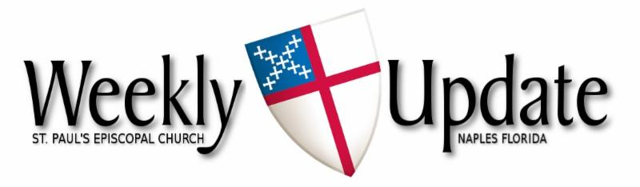
April 20, 2025
Easter Sunday


Aumbry Candle
In April, the aumbrey candle burns in loving memory of
- of my parents, Millie & Roy Olsen from Doug & Philip..
- our good friend Connie Middleton-Hope from Rob & Wendy Lindsay
- our friend William Harcourt Woods, Jr. from Lloyd Williams and Alice King
If you would like to reserve the candle for a loved one, or in memory of a loved one, please call the office at 239-643-0197.

THANK YOU.
For the donation of port wine in loving memory of her parents Bud & Lois from Carolyn Hale.

🎶 Wanted: Choir singers (male and female) 🎶
Do you like to sing? We would love to have you join us on Sunday mornings.
You are welcome to come even if you are here for a short time. Our weekly choir practice is held on Monday morning from 11am-12 noon, and we come for rehearsal on Sunday morning at 9:30.
If you would like to join us, please speak to our Music Director, Jacquie Scaduto, at coffee hour, or email her at jacquilt123@gmail.com. Or you can speak to a choir member.
We look forward to seeing new members.

Farmers’ Market
The market and stores are now closed for the summer.
They will reopen in the fall. See you soon


Easter flower memorial envelopes are now available for your use. The dedications will be published on Easter Sunday’s bulletin.

TAX STATEMENTS:
St. Paul’s Church will be providing quarterly gift statements beginning April 20th. If you are interested in receiving your paperwork quarterly, please contact the office and the document will be mailed to your current mailing address posted in the directory.


This Photo by Unknown Author is licensed under CC BY

The food donations ministry led by Judy Martin is requesting donations of pet food for the months, of April, May and June. She will be distributing the donations among the various animal groups in the area. Please contact Judy at 239-784-8485 if you have any questions or particular needs.


Prayer List
Please pray for Peter Lund, Joan Cacchio, Barbara Dean, Lani Jenkins, Nikki Wall, Martha Wallace Richard Broszeit, Lynne LaMarca, Martha Waddell-Gill, Don Kleer, Joyce & Barry Deems and Madeline Fotovich.

*The church received notification of the passing of Nancy Smith in Freeport, Illinois from Lisa Lind. She is requesting our prayers for Nancy’s peaceful passing,*

To add someone to the prayer list, email the office at welcome@saintpaulsnaples.org or call the office at (239) 643-0197.

Yoga sessions
Ann Marina will be holding classes on Wednesdays & Fridays January through the end of April.
Yoga 9-10 am;

Laundry Love
We encourage you to consider donating to the Laundry Love initiative by contributing to the container in the Narthex. This wonderful program, now led by Steve Augustus, offers a unique opportunity to extend kindness to those in need right here in Naples. If you want to volunteer or have questions, call Steve at 860-490-3178 or email: saugustus@sbcglobal.net. Thank you for your generosity.


Please sign up to bring snacks to fellowship after Sunday Services. Sign up sheets are in Trinity Hall. Thanks!


April Birthdays
Doug Olsen 4/3, Pauline Suss 4/10, Mia Tajawandee 4/12, Bruce MacGregor 4/14, Jonathan Blundell 4/16, Diane Augustus 4/22, Lee Perry 4/29, Tom Holman 4/30, Lynne Kennedy 4/30, Lee Wieber 4/30


April Wedding Anniversaries
Mathilde Anesca 4/10, Dave & Judy Hall 4/18,
Mike & Mary Grindstaff 4/21, George & Sandra McGowan 4/23, Diane & Edward Lebida 4/24.
Justin’s Place
In the narthex, you will find a dedicated box for donations
Vestry
Sr. Warden – Diane Augustus
Jr. Warden – Julio Albino
Clerk – Charlene Connolly
Treasurer – Rose Porembo
Tom Connolly, Mary Lou Dogoloff, Jack LaRose, Paul Nelson, Jeannie Smith and Murray Smith

Pastoral Emergency:
Fr. Tom’s cell phone: (813) 763-0441

Pastoral Care:
The Rev. Dr. Thomas Thoeni, Rector

Sick? Facing surgery? Recuperating? Please notify the church office for yourself or others.

Office: Betty Hernandez (M-F 9 am-1 pm)
Administrative Assistant (239) 643-0197

Readings for April 27th
First Reading: Acts 5: 27-32
Psalm/Canticle:150
Second Reading: Revelation 1: 4-8
Please go to St. Paul’s Website (www.saintpaulsnaples.org) for links to our online Sunday Services, zoom meetings, and the Sunday bulletin.

St. Paul’s is grateful for your support
You may mail checks to the church, donate via our website: saintpaulsnaples.org, or drop donations on the offering plate on Sunday, or you can scan the QR code to donate to the church.

Scan to donate
Pledge Cards
Pledge cards for 2025 are on the table in the Narthex

Schedule during the week:

4/21 OFFICE IS CLOSED
4/23 9:00 a.m. Yoga (TH)
10:30 a.m. Reflect & Connect (L)
6:30 p.m. Bible Study (L)
4/24 8:00 a.m. God’s Gardeners (TH)
4/25 9:00 am Yoga (TH) last day
4/27 8:00 am Eucharistic service
10:00 am Eucharistic service / fellowship follows (TH)
4/30 10:30 am Reflect & Connect (L)
6:30 pm Bible study (L)
5/1 8:00 am God’s Gardeners (TH)
3:00 pm Circle of Sisters (TH)
Monthly Events and Repeated Gatherings
- Holy Eucharist 8 am & 10 am Sundays

- Bible Study 6:30 pm Wednesdays
- Choir Practice 11:00 am Mondays
- Circle of Sisters 3:00 pm 1st Thursday of the month
- Farmer’s Market 8 am- 12 pm Resumes in November
- God’s Gardeners 8:00 am every Thursday (Nov-April)
- Men’s Meetings 10:00 am every Monday
- Parish Luncheon 11:30 am 2nd Tuesday of the month
- Potluck Dinners 5:30 pm 3rd Thursday of the month
- Reflect & Connect 10:30 am every Wednesday
- Vestry Meeting 6:30 pm 1st Monday of the month
- Wine Time 6:00 pm Resumes in November
- Yoga/Tai Chi 9:00 am Resumes in November



Thu April 24: 5:30 pm potluck dinner (TH)

NOTE: Beginning Sunday May 4th, there will be a single Sunday service at 9 am.

MEMORABLE MOMENTS:
Palm Sunday's surprise celebrant was Fr. Stephen Gerth.
Fr Gerth was a supply celebrant at St Paul's in May 2023.

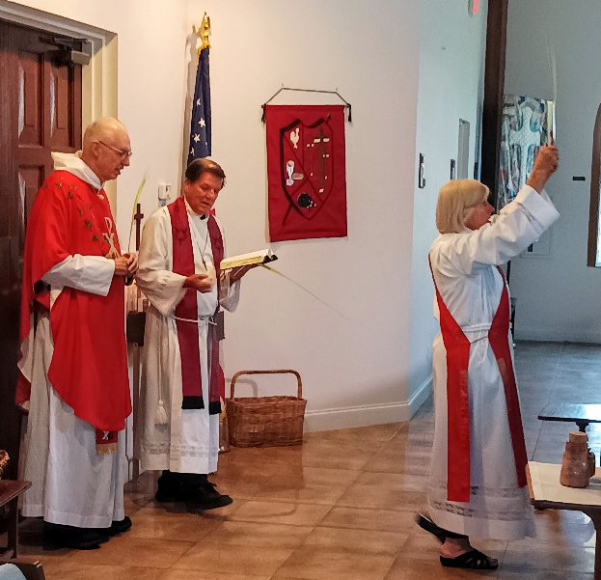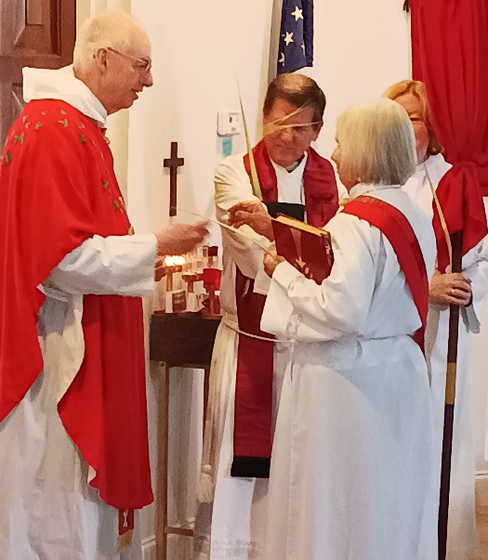

Gail Cooper's daughter, Lydia Toperzer, sang on Palm Sunday with the choir
and sang The Holy City by Weatherly/Adams. Thank you Lydia.
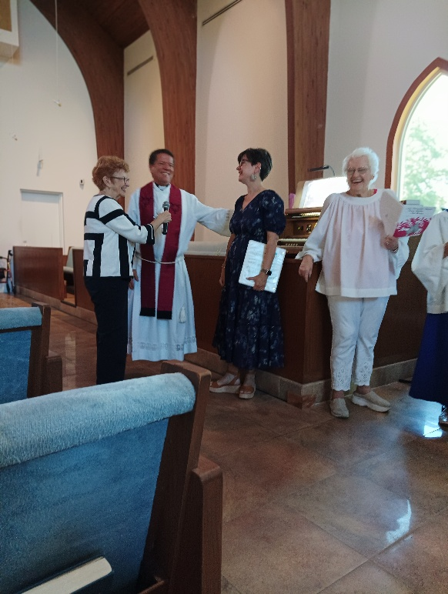
St Paul's Knit and Crochet Group asked Fr Tom to bless kitty blankets and prayer shawls. The blankets go with newly adopted kittens and the prayer shawls are gifted to people experiencing difficult days.

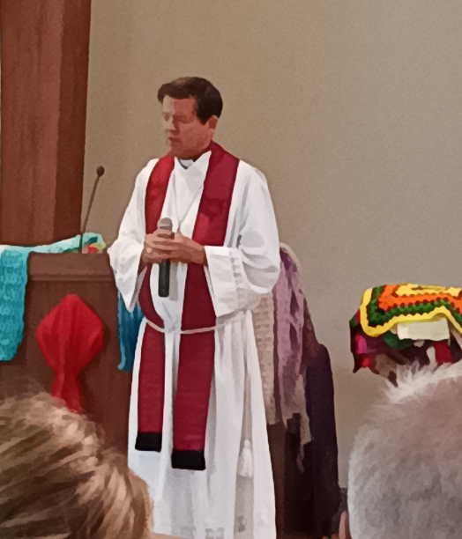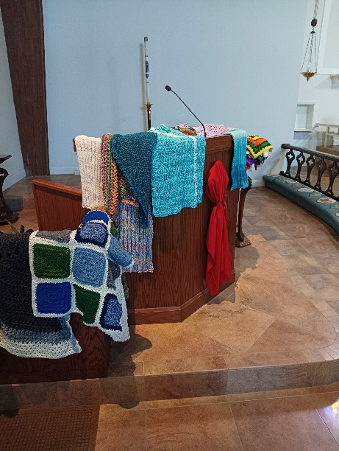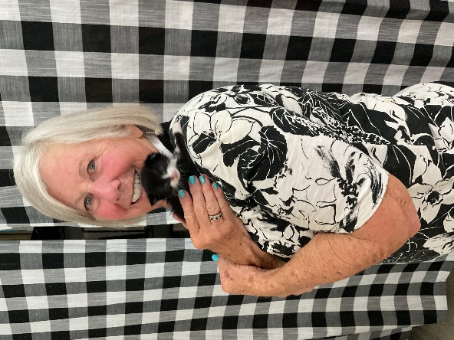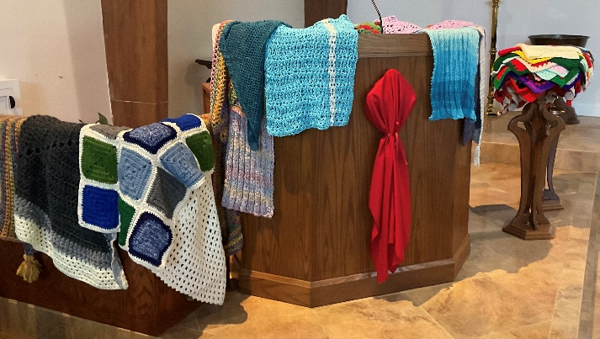

John 3:16: "For God so loved the world that he gave his one and only Son,
that whoever believes in him shall not perish but have eternal life"

EASTER FLOWER DONATIONS & OFFERINGS
- In loving memory of Dorothy Binder from Roberta Holt.
- In loving memory of Russell Perry from Lee & Marilyn Perry.
- In loving memory of Charles & Florence Augustus from Steve & Diane Augustus.
- In loving memory of Robert & Esther Davies from Steve & Diane Augustus.
- In loving memory of Melissa and David from Marcia Entner.
- In loving memory of my husband Jack and my brother Bill from Carolyn Hale.
- In loving memory of Bob & Joan Shaffer from Gene & Susie Bartley.
- In loving memory of Vera & Anthony Bartley from Gene & Susie Bartley.
- In loving memory of my parents, Emilio & Yolanda Hospital from Betty Hernandez.
- In loving memory of my daughter-in-law, Nona Deuschle, from Judy Martin.
- In loving memory of my mom, Cecelia Markol lovingly Gina Markol-Mansfield.
- In loving memory of our daughter, Stacie Blakeley, from Mark & Mary Grindstaff.
- In loving memory of Chery Griffith Edney and Francis Sullivan from the Griffiths.
- In loving memory of Hilde, Eva and Munchkin from Philip & Doug Olsen.
- In loving memory of my mom, Joan Bradbury, from Toni Rovedo.
- In loving memory of Bill DeFrancis from Barbara DeFrancis.
- In loving memory of Suzanne Williams from Jack.
- In loving memory of Verne Kwiatkowski from Joan Allison.
- In loving memory of past family members Andrews & Jennings from Pat & Steve Andrew.
- In loving memory of my husband Cliff Blanchard from Sara Blanchard.

John 3:16: "For God so loved the world that he gave his one and only Son,
that whoever believes in him shall not perish but have eternal life"

- In loving memory of Anthony Cimaglia, Larry and Catherine DiCecco, Diane and Butch DiCecco from Judy Cimaglia.
- In loving memory of Craig Guensch, Mark Guensch, and AJ Johnson from Charles & Connie Guensch.
- In loving memory of Don Neapolitan from Elizabeth Neapolitan.

