Welcome to our Sunday Worship
Trinity Sunday, Year C
June 15, 2025 9:00 a.m. "Enriching Our Worship”

PRELUDE: Phantasy on the hymn "Holy, Holy, Holy": Inleiding en Koraal Piet Post

Post (1919–1979) was a Dutch organist and teacher, and a consultant to organ builders. He served as organist of the Great Jacobin Church of Leeuwarden (Friesland) from 1949 until his death. The glorious hymn Nicaea [362 in the blue hymnal] was written by the English bishop Reginald Heber (1783–1826) and set to music in 1861 by John Bacchus Dykes (1823–1876). It paraphrases the Sanctus of the Mass as well as verses from Isaiah and Revelation. The Inleiding [Introduction] of this fantasy (1961) starts with a declamatory introduction interspersed with a statement of the tune.

SURELY THE PRESENCE Worship #131

OPENING ACCLAMATION
Celebrant Blessed be God: Father, Son, and Holy Spirit
People And blessed be his kingdom, now and forever. Amen.

THE COLLECT FOR PURITY
Almighty God, to you all hearts are open, all desires known, and from you no secrets are hid: Cleanse the thoughts of our hearts by the inspiration of your Holy Spirit, that we may perfectly love you, and worthily magnify your holy Name; through Christ our Lord. Amen.

SONG OF PRAISE: KYRIE Hymnal S-96
Lord, have mercy. Lord, have mercy.
Christ, have mercy. Christ, have mercy.
Lord, have mercy. Lord, have mercy.
Lord, have mercy, have mercy.

Celebrant The Lord be with you
People And also with you.
Celebrant Let us pray.

Almighty and everlasting God, you have given to us your servants grace, by the confession of a true faith, to acknowledge the glory of the eternal Trinity, and in the power of your divine Majesty to worship the Unity: Keep us steadfast in this faith and worship, and bring us at last to see you in your one and eternal glory, O Father; who with the Son and the Holy Spirit live and reign, one God, for ever and ever. Amen.

FIRST READING: Proverbs 8:1-4, 22-31

The Book of Proverbs comes from a type of writing known in biblical studies as Wisdom Literature. This name comes from the way in which religious teachings are presented as ancient, inherited wisdom to guide the morally and spiritually inexperienced. The Books of Job, Song of Songs, Ecclesiastes and some of the psalms also belong to this genre.

Does not wisdom call, and does not understanding raise her voice? On the heights, beside the way, at the crossroads she takes her stand; beside the gates in front of the town, at the entrance of the portals she cries out: "To you, O people, I call, and my cry is to all that live. The LORD created me at the beginning of his work, the first of his acts of long ago. Ages ago I was set up, at the first, before the beginning of the earth. When there were no depths I was brought forth, when there were no springs abounding with water. Before the mountains had been shaped, before the hills, I was brought forth--when he had not yet made earth and fields, or the world's first bits of soil. When he established the heavens, I was there, when he drew a circle on the face of the deep, when he made firm the skies above, when he established the fountains of the deep, when he assigned to the sea its limit, so that the waters might not transgress his command, when he marked out the foundations of the earth, then I was beside him, like a master worker; and I was daily his delight, rejoicing before him always, rejoicing in his inhabited world and delighting in the human race.

Reader Hear what the Spirit is saying to God’s people.
People Thanks be to God.

Psalm 8 (from the Book of Common Prayer)
Through contemplating God’s creation, the psalmist teaches us that humans are partners with God in the care of all that God has created.

1 O LORD our Governor, *
how exalted is your Name in all the world!
2 Out of the mouths of infants and children *
your majesty is praised above the heavens.
3 You have set up a stronghold against your adversaries, *
to quell the enemy and the avenger.
4 When I consider your heavens, the work of your fingers, *
the moon and the stars you have set in their courses,
5 What is man that you should be mindful of him? *
the son of man that you should seek him out?
6 You have made him but little lower than the angels; *
you adorn him with glory and honor;
7 You give him mastery over the works of your hands; *
you put all things under his feet:
8 All sheep and oxen, *
even the wild beasts of the field,
9 The birds of the air, the fish of the sea, *
and whatsoever walks in the paths of the sea.
10 O LORD our Governor, *
how exalted is your Name in all the world!

SECOND READING: Romans 5.1-5

Two of the most important doctrines of our faith had their roots in this passage: justification, and sanctification. The good news of this passage is that, through Christ we have been rendered innocent, or justified. Through the gift of the Spirit we are given the hope and strength to live new lives in Christ. We have been sanctified, or set apart as God’s own.

Therefore, since we are justified by faith, we have peace with God through our Lord Jesus Christ, through whom we have obtained access to this grace in which we stand; and we boast in our hope of sharing the glory of God. And not only that, but we also boast in our sufferings, knowing that suffering produces endurance, and endurance produces character, and character produces hope, and hope does not disappoint us, because God's love has been poured into our hearts through the Holy Spirit that has been given to us.

Reader Hear what the Spirit is saying to God’s people.
People Thanks be to God.

SEQUENCE HYMN: Let all mortal flesh keep silence Hymnal #324 v1

GOSPEL: John 16.12-15

The doctrine of the Trinity is implicit in this passage. The revelation which Jesus Christ brought is from the Father, and it is the function of the Spirit to take that revelation and make it meaningful to each succeeding generation. The Spirit does not convey new, independent revelations (“on his own authority”), but constantly updates our understanding of the once and for all revelation of God in Christ.

Gospeler The Holy Gospel of our Lord Jesus Christ according to John.
People Glory to you, Lord Christ.

[Jesus said,] "I still have many things to say to you, but you cannot bear them now. When the Spirit of truth comes, he will guide you into all the truth; for he will not speak on his own, but will speak whatever he hears, and he will declare to you the things that are to come. He will glorify me, because he will take what is mine and declare it to you. All that the Father has is mine. For this reason I said that he will take what is mine and declare it to you.”

Gospeler The Gospel of the Lord.
People Praise to you, Lord Christ.

SEQUENCE HYMN: Let all mortal flesh keep silence Hymnal #324 v4

THE SERMON

THE NICENE CREED
We believe in one God, the Father, the Almighty, maker of heaven and earth, of all that is, seen and unseen.

We believe in one Lord, Jesus Christ, the only Son of God, eternally begotten of the Father, God from God, Light from Light, true God from true God, begotten, not made, of one Being with the Father. Through him all things were made. For us and for our salvation he came down from heaven: by the power of the Holy Spirit he became incarnate from the Virgin Mary, and was made man. For our sake he was crucified under Pontius Pilate; he suffered death and was buried. On the third day he rose again in accordance with the Scriptures; he ascended into heaven and is seated at the right hand of the Father. He will come again in glory to judge the living and the dead, and his kingdom will have no end.

We believe in the Holy Spirit, the Lord, the giver of life, who proceeds from the Father and the Son. With the Father and the Son he is worshiped and glorified. He has spoken through the Prophets. We believe in one holy catholic and apostolic Church. We acknowledge one baptism for the forgiveness of sins. We look for the resurrection of the dead, and the life of the world to come. Amen.

THE PRAYERS OF THE PEOPLE
Father, we pray for your holy catholic Church;
That we all may be one.

Remembering the The Anglican Church of Mexico, grant that every member of the Church may truly and humbly serve you;
That your Name may be glorified by all people.

We pray for all Sean, our Presiding Bishop; Doug, our Bishop; Tom, our Rector; and Mary, our Deacon. We pray for all bishops, priests, and deacons;
That they may be faithful ministers of your Word and Sacraments.

We pray for all who govern and hold authority in the nations of the world;
That there may be justice and peace on the earth.

Give us grace to do your will in all that we undertake;
That our works may find favor in your sight.

Have compassion on those who suffer from any grief or trouble;
That they may be delivered from their distress.

Give to the departed eternal rest;
Let light perpetual shine upon them.

We praise you for your saints who have entered into joy;
May we also come to share in your heavenly kingdom.

Let us pray for our own needs and those of others.

We offer thanksgiving for those celebrating the anniversary of their birth, especially Jim Crosby; and for those celebrating the anniversary of their marriage, especially Paul and Shelly Nelson, Jack and Dawn Powell, and Warren Adams.

Grant us grace fearlessly to contend against evil and to make no peace with oppression; and, that we may reverently use our freedom, help us to employ it in the maintenance of justice in our communities and among the nations, and nurture victims of violence and warfare throughout your world, to the glory of your Name, through Jesus Christ our Lord, who lives and reigns with you and the Holy Spirit, one God, now and for ever. Amen.

CONFESSION AND ABSOLUTION
Let us confess our sins against God and our neighbor.

Most merciful God, we confess that we have sinned against you in thought, word, and deed, by what we have done, and by what we have left undone. We have not loved you with our whole heart; we have not loved our neighbors as ourselves. We are truly sorry and we humbly repent. For the sake of your Son Jesus Christ, have mercy on us and forgive us; that we may delight in your will, and walk in your ways, to the glory of your Name. Amen.

THE PEACE
Celebrant The peace of the Lord be always with you.
People And also with you.

ANNOUNCEMENTS

The Holy Communion

OFFERTORY ANTHEM: Lento in C major from Heures Mystiques Léon Boëllmann

Boëllmann (1862–1897) was a French composer of Alsatian origin, best known for his organ pieces. His promising career was cut short by his death from tuberculosis at age 35. His compositions were popular in his lifetime, and he was also successful as a performer and a critic. Heures mystiques ("Divine Hours", 1896) is a collection of 100 versets, or short pieces for the Mass. This selection is a quiet meditation on a short melodic fragment.

DOXOLOGY: Praise God from whom all blessings flow Old 100th

THE GREAT THANKSGIVING: Enriching Our Worship, Prayer 2

Celebrant The Lord be with you.
People And also with you.
Celebrant Lift up your hearts.
People We lift them to the Lord.
Celebrant Let us give thanks to the Lord.
People It is right to give our thanks and praise.

We praise you and we bless you, holy and gracious God, source of life abundant. From before time you made ready the creation. Your Spirit moved over the deep and brought all things into being: sun, moon, and stars; earth, winds, and waters; and every living thing.

You made us in your image, and taught us to walk in your ways. But we rebelled against you, and wandered far away; and yet, as a mother cares for her children, you would not forget us.Time and again you called us to live in the fullness of your love.

And so this day we join with Saints and Angels in the chorus of praise that rings through eternity,
lifting our voices to magnify you as we sing (say):

SANCTUS Hymnal S-130
Holy, holy, holy Lord, God of power and might,
Holy, holy, holy Lord, God of power and might,
heaven and earth are full, full of your glory.
Hosanna in the highest. Hosanna in the highest.
Blessed is he who comes in the name of the Lord.
Hosanna in the highest. Hosanna in the highest.

Glory and honor and praise to you, holy and living God. To deliver us from the power of sin and death
and to reveal the riches of your grace, you looked with favor upon Mary, your willing servant, that she might conceive and bear a son, Jesus the holy child of God. Living among us, Jesus loved us. He broke bread with outcasts and sinners, healed the sick, and proclaimed good news to the poor. He yearned to draw all the world to himself yet we were heedless of his call to walk in love. Then, the time came for him to complete upon the cross the sacrifice of his life, and to be glorified by you.

On the night before he died for us, Jesus was at table with his friends. He took bread, gave thanks to you, broke it, and gave it to them, and said: “Take, eat: This is my Body, which is given for you. Do this for the remembrance of me.”

As supper was ending, Jesus took the cup of wine. Again, he gave thanks to you, gave it to them, and said: “Drink this, all of you: This is my Blood of the new Covenant, which is poured out for you and for all for the forgiveness of sins. Whenever you drink it, do this for the remembrance of me.”

Now gathered at your table, O God of all creation, and remembering Christ, crucified and risen, who was and is and is to come, we offer to you our gifts of bread and wine, and ourselves, a living sacrifice.

Pour out your Spirit upon these gifts that they may be the Body and Blood of Christ. Breathe your Spirit over the whole earth and make us your new creation, the Body of Christ given for the world you have made.

In the fullness of time bring us, with the Blessed Virgin Mary, Blessed Joseph, Blessed Paul, and all your saints, from every tribe and language and people and nation, to feast at the banquet prepared from the foundation of the world.

Through Christ and with Christ and in Christ, in the unity of the Holy Spirit, to you be honor, glory, and praise, for ever and ever. AMEN.

THE LORD’S PRAYER

FRACTION ANTHEM: Come, thou almighty King Hymnal #365 v1

DISTRIBUTION OF THE HOLY COMMUNION

COMMUNION HYMN: Holy God, we praise thy Name Hymnal #366 v1,4,5

POST-COMMUNION PRAYER
God of abundance, you have fed us with the bread of life and cup of salvation; you have united us with Christ and one another; and you have made us one with all your people in heaven and on earth. Now send us forth in the power of your Spirit, that we may proclaim your redeeming love to the world and continue for ever in the risen life of Christ our Savior. Amen.

BLESSING
And finally my brothers and sisters, live in harmony and with compassion. Show kindness and humility. Return no evil nor slander, but return blessings to all. Bless and do not curse for such is your call in Christ Jesus our Lord. And the blessing of God Almighty, Father, Son, and Holy Spirit shall be with you this day and all the days of your life. Amen.

POST-COMMUNION HYMN: Holy, holy, holy! Hymnal #362 v1,2,4

Let us pray.

Almighty and everlasting God, make our parish of St Paul's truly a community of prayer and belonging. Raise up in our midst the resources and leadership which will enable us to act upon what you would have us do, in this place and in a ministry of love and concern for others. Open my mind and heart to discern what you would have me do; through Jesus Christ our Lord. Amen..

DISMISSAL
People Thanks be to God.

Welcome visitors!
We are glad you have joined us for worship today. Please join us for coffee and fellowship in Trinity Hall after the service.

Celebrant and Preacher The Rev. Dr. Tom Thoeni
Deacon The Rev. Dr. Mary Abrams
Eucharistic Minister(s) Linda Connelly, Philip Lindquist
Lector Tom Connolly
Intercessor Tom Connolly
Usher(s) Barb & Dave Abernethy

Active Altar Guild Members: Judy Allen, Joan Allison, Diane Augustus, Rose Porembo, Mia Tajawandee, & Cindy Tysiak.

Rector The Rev. Dr. Thomas Thoeni
Deacon The Rev. Dr. Mary Abrams, seasonal
Administrative Assistant Betty Hernandez
Sexton Gary Dickerson
Music Director Jacquie Scaduto (Gordon Brown – acting organist)

Vestry
Senior Warden Diane Augustus Junior Warden Julio Albino
Clerk Charlene Connolly Treasurer Rose Porembo
Members: Tom Connolly, Mary Lou Dogoloff, Paul Nelson, Jeannie Smith, Murray Smith, Jack LaRose.

3901 Davis Blvd. Naples, FL 34104
239 643-0197 welcome@saintpaulsnaples.org
www.saintpaulsnaples.org

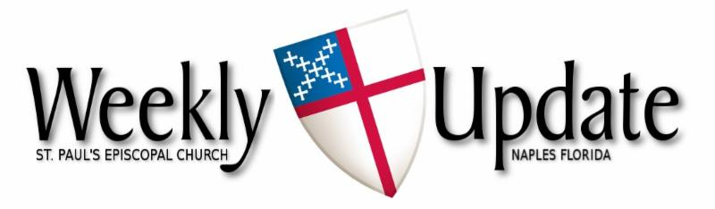
June 15, 2025
The First Sunday after Pentecost


Aumbry Candle
Throughout June, the aumbrey candle burns

- In loving memory of Millie Olsen & Claire Linquist from Doug & Philip.

If you would like to reserve the candle for a loved one, or in memory of a loved one, please call the office at 239-643-0197.

🎶 Wanted: Choir singers (male and female) 🎶
Do you like to sing? We would love to have you join us on Sunday mornings.
You are welcome to come even if you are here for a short time. Our weekly choir practice is held on Monday morning from 11am-12 noon, and we come for rehearsal on Sunday morning at 9:30.
If you would like to join us, please speak to our Music Director, Jacquie Scaduto, at coffee hour, or email her at jacquilt123@gmail.com. Or you can speak to a choir member.
We look forward to seeing new members.

Prayer List
Please pray for Joan Cacchio, Lani Jenkins, Nikki Wall, Richard Broszeit, Lynne LaMarca, Martha Waddell-Gill, Don Kleer, Joyce & Barry Deems, Madeline Fotovich, Mary Grindstaff, Patty Linde, Barry Stone, Barbara Metcalfe and the Kiehl family

Farmers’ Market
The market and stores are now closed for the summer.
They will reopen in the fall. See you soon

Thank you for the pet food donations. Judy Martin will be distributing the donations among the various animal groups in the area.



*Outreach Committee*
Judy Martin and Jack LaRose are heading up the St. Paul's Outreach Committee. They are in need of 2-3 more people to join them. The committee meets right after church 2 to 3 times per year. They review submissions from the charitable organizations that have reached out to St Paul's for support and decide which ones to contribute to. This is a commitment that does not require a lot of time yet it is very rewarding. Please contact Judy at (239) 784-8485 for more information.

The O.C. is providing a wishlist for school supply donations to be distributed for the new school year. They are asking for:
- Filler paper
- Composition books (wide ruled)
- Spiral notebooks (wide ruled)
- Tissue boxes small sizes
- Hand sanitizers (individual size)
- Yellow highlighters
- 1” binders and
- Index cards

If you would like to add someone to the prayer list, email the office at welcome@saintpaulsnaples.org or call the office at (239) 643-0197.

Lunch with the Bunch
Effective in July, Norma Pappalardo will be coordinating the monthly parish luncheons on the second Tuesday of the month at 11:30. This is a most enjoyable ministry as all are welcome, and no one needs to cook or clean-up. Suggestions for meeting locations are always welcome – email: nbpapp@aol.com

Laundry Love
We encourage you to consider donating to the Laundry Love initiative by contributing to the container in the Narthex. This wonderful program, now led by Steve Augustus, offers a unique opportunity to extend kindness to those in need right here in Naples. If you want to volunteer or have questions, call Steve at 860-490-3178 or email: saugustus@sbcglobal.net. Thank you for your generosity.


Please sign up to bring snacks to fellowship after Sunday Services. Sign up sheets are in Trinity Hall.
Great ideas to bring are breakfast casseroles, bowl of fruit or gluten free foods
Thanks!


June Birthdays

Betty Smith 6/9; Richard Seller 6/9; Joan Allison 6/11; Sharron Crosby 6/13; Jim Crosby 6/19; Al Pike 6/26; Geroge Lower 6/26; Peter Kanarian 6/29; Dave Hall 6/30; and Tom Connolly 6/30.

Wishing you a year filled with peace, joy, health and new beginnings.


June Wedding Anniversaries

Gary & Rosemary Porembo 6/5; Jim & Carolyn Kells 6/10; Sally Blanchard 6/11; Paul & Shelly Nelson 6/15; Jack & Dawn Powell 6/17; Warren Adams 6/17; Carolyn Hale 6/25; Gene & Susie Bartley 6/26; George & Rosanna Lower 6/26; Steven & Diane Augustus 6/28; Dave & Barbara Abernethy 6/28; and John & Avery Jones 6/29.

May your bond continue to strengthen with each passing year.

Readings for June 22nd
First Reading: Isaiah 65:1-9
Psalm/Canticle: 22: 18-27
Second Reading: Galatians 3: 23-29

Justin’s Place
In the narthex, you will find a dedicated box for donations.

Vestry
Sr. Warden – Diane Augustus
Jr. Warden – Julio Albino
Clerk – Charlene Connolly
Treasurer – Rose Porembo
Tom Connolly, Mary Lou Dogoloff, Jack LaRose, Paul Nelson, Jeannie Smith and Murray Smith

Pastoral Emergency:
Fr. Tom’s cell phone: (813) 763-0441

Pastoral Care:
The Rev. Dr. Thomas Thoeni, Rector

Sick? Facing surgery? Recuperating? Please notify the church office for yourself or others.

Office: Betty Hernandez (M-F 9 am-1 pm)
Administrative Assistant (239) 643-0197
Email: welcome@saintpaulsnaples.org

 Scan to donate

Please go to St. Paul’s Website (www.saintpaulsnaples.org) for links to our online Sunday Services, zoom meetings, and the Sunday bulletin.

St. Paul’s is grateful for your support
You may mail checks to the church, donate via our website: saintpaulsnaples.org, or drop donations on the offering plate on Sunday, or you can scan the QR code to donate to the church.

Pledge Cards
Pledge cards for 2025 are on the table in the Narthex

Schedule during the week:

MON 6/16 10:00 am Men’s club meeting (LR)
6:30 pm Vestry meeting (L)
TUE 6/17 11:30 am Parish luncheon (Texas Tony’s)
WED 6/18 10:30 am Reflect & Connect (L)
6:30 pm Bible Study (L)
THU 6/19 8:00 am God’s Gardeners (TH)
5:30 pm Potluck Dinner (TH) BBQ Bash

Monthly Events and Repeated Gatherings
- Holy Eucharist 9 am Sunday through the summer months

- Bible Study 6:30 pm Wednesdays
- God’s Gardeners 8:00 am every Thursday
- Men’s Meetings 10:00 am every Monday
- Circle of Sisters 3:00 pm 1st Thursday of the month
- Reflect & Connect 10:30 am every Wednesday
- Parish Luncheon 11:30 am 2nd Tuesday of the month
- Potluck Dinners 5:30 pm 3rd Thursday of the month
- Vestry Meeting 6:30 pm 3rd Monday of the month
- Wine Time 6:00-7:00 pm Thursdays except on vestry week
On summer break
- Choir Practice 11:00 am Mondays resumes soon
- Farmer’s Market 8 am- 12 pm resumes in November


Tue. June 16th: 6:30 pm Vestry meeting (L)
Thu. June 19th: 5:30 pm Potluck Dinner (TH) BBQ Bash

MAKING MEMORIES

The Circle of Sisters ministry at their monthly meeting held on June 5th.
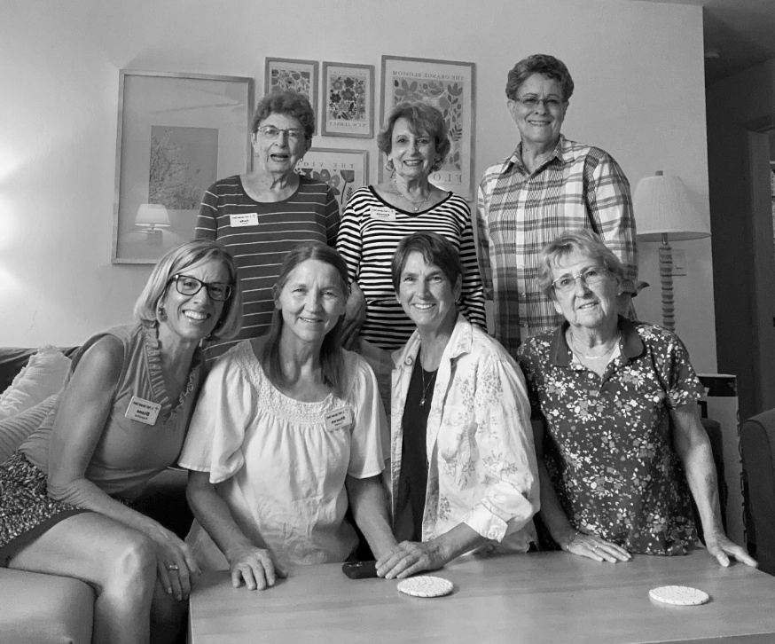
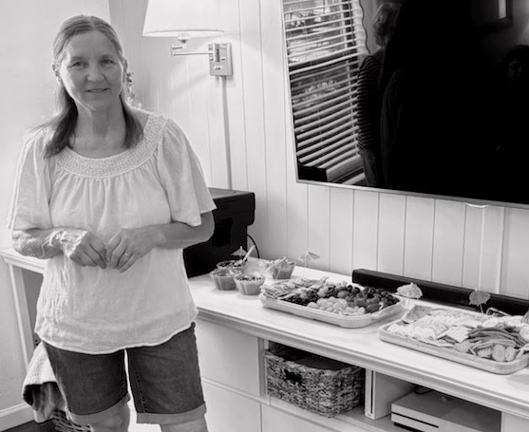

On 6.8.25 at the 9am Pentecost service Fr Tom blessed dresses made for orphans in Tanzania. The Circle of Sisters outreach supports the Tumaini Fund founded by Dr. Susan Wilson. Thank you to Judy Martin, and her sewing team.

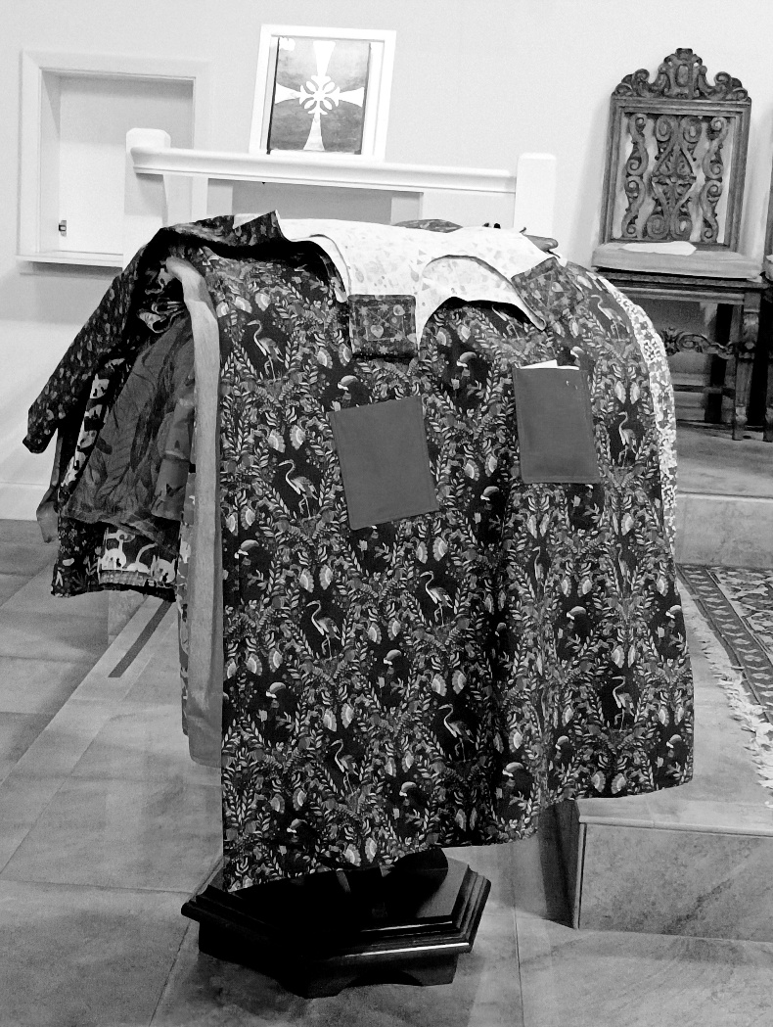

Photo credits: Charlene Connolly. Thank you!

