Welcome to our Sunday Worship
The Fifth Sunday of Easter, Year C
May 18, 2025 9:00 a.m. "Enriching Our Worship”

PRELUDE: The Greatest of These DeCesare

Surely the presence Worship #131

OPENING ACCLAMATION
Celebrant Alleluia. The Lord is risen.
People The Lord is risen indeed. Alleluia

THE COLLECT FOR PURITY
Almighty God, to you all hearts are open, all desires known, and from you no secrets are hid: Cleanse the thoughts of our hearts by the inspiration of your Holy Spirit, that we may perfectly love you, and worthily magnify your holy Name; through Christ our Lord. Amen.

Refrain
Glory to God in the highest, and peace to his people on earth.

Lord God, heavenly King, almighty God and Father, we worship you, we give you thanks, we praise you for your glory.

Refrain
Lord Jesus Christ, only Son of the Father, Lord God, Lamb of God, you take away the sin of the world: have mercy on us; you are seated at the right hand of the Father: receive our prayer.

Refrain
For you alone are the Holy One, you alone are the Lord, you alone are the Most High, Jesus Christ, with the Holy Spirit, in the glory of God the Father. Amen.

Refrain

Celebrant The Lord be with you
People And also with you.
Celebrant Let us pray.

Almighty God, whom truly to know is everlasting life: Grant us so perfectly to know your Son Jesus Christ to be the way, the truth, and the life, that we may steadfastly follow his steps in the way that leads to eternal life; through Jesus Christ your Son our Lord, who lives and reigns with you, in the unity of the Holy Spirit, one God, for ever and ever. Amen.

FIRST READING: Acts 11.1-18
In response to the challenge of the Jewish Christians in Jerusalem Peter testified about his participation in the Gentile mission. Issues such as circumcision prior to baptism and eating unholy foods were obviously very difficult for Jews who had come to believe that Jesus was the true Messiah. The crucial moment for Peter came when the Holy Spirit fell on the assembled household in the home of Cornelius, the Roman army officer in Ceasarea as already told in Acts 10.

Now the apostles and the believers who were in Judea heard that the Gentiles had also accepted the word of God. So when Peter went up to Jerusalem, the circumcised believers criticized him, saying, "Why did you go to uncircumcised men and eat with them?" Then Peter began to explain it to them, step by step, saying, "I was in the city of Joppa praying, and in a trance I saw a vision. There was something like a large sheet coming down from heaven, being lowered by its four corners; and it came close to me. As I looked at it closely I saw four-footed animals, beasts of prey, reptiles, and birds of the air. I also heard a voice saying to me, 'Get up, Peter; kill and eat.' But I replied, 'By no means, Lord; for nothing profane or unclean has ever entered my mouth.' But a second time the voice answered from heaven, 'What God has made clean, you must not call profane.' This happened three times; then everything was pulled up again to heaven. At that very moment three men, sent to me from Caesarea, arrived at the house where we were. The Spirit told me to go with them and not to make a distinction between them and us. These six brothers also accompanied me, and we entered the man's house. He told us how he had seen the angel standing in his house and saying, 'Send to Joppa and bring Simon, who is called Peter; he will give you a message by which you and your entire household will be saved.' And as I began to speak, the Holy Spirit fell upon them just as it had upon us at the beginning. And I remembered the word of the Lord, how he had said, 'John baptized with water, but you will be baptized with the Holy Spirit.' If then God gave them the same gift that he gave us when we believed in the Lord Jesus Christ, who was I that I could hinder God?" When they heard this, they were silenced. And they praised God, saying, "Then God has given even to the Gentiles the repentance that leads to life."

Reader Hear what the Spirit is saying to God’s people.
People Thanks be to God.

Psalm 148 (from The Book of Common Prayer)
All creation is summoned to praise the Lord in this third of five “Hallel psalms” which end the whole Psalter with a resounding “Hallelujah!”

1 Hallelujah! Praise the LORD from the heavens; *
praise him in the heights.
2 Praise him, all you angels of his; *
praise him, all his host.
3 Praise him, sun and moon; *
praise him, all you shining stars.
4 Praise him, heaven of heavens, *
and you waters above the heavens.
5 Let them praise the Name of the LORD; *
for he commanded, and they were created.
6 He made them stand fast for ever and ever; *
he gave them a law which shall not pass away.
7 Praise the LORD from the earth, *
you sea-monsters and all deeps;
8 Fire and hail, snow and fog, *
tempestuous wind, doing his will;
9 Mountains and all hills, *
fruit trees and all cedars;
10 Wild beasts and all cattle, *
creeping things and wingèd birds;
11 Kings of the earth and all peoples, *
princes and all rulers of the world;
12 Young men and maidens, *
old and young together.
13 Let them praise the Name of the LORD, *
for his Name only is exalted, his splendor is over earth and
heaven.
14 He has raised up strength for his people and praise for all his loyal servants, *
the children of Israel, a people who are near him. Hallelujah!

SECOND READING: Revelation 21.1-6
John’s vision included the whole of creation being renewed which reaffirmed God’s coming into the world in Jesus Christ for the single purpose of redeeming the world and reconciling humanity, indeed all creation, to God’s original purpose.

Then I saw a new heaven and a new earth; for the first heaven and the first earth had passed away, and the sea was no more. And I saw the holy city, the new Jerusalem, coming down out of heaven from God, prepared as a bride adorned for her husband. And I heard a loud voice from the throne saying, "See, the home of God is among mortals. He will dwell with them as their God; they will be his peoples, and God himself will be with them; he will wipe every tear from their eyes. Death will be no more; mourning and crying and pain will be no more, for the first things have passed away." And the one who was seated on the throne said, "See, I am making all things new." Also he said, "Write this, for these words are trustworthy and true." Then he said to me, "It is done! I am the Alpha and the Omega, the beginning and the end. To the thirsty I will give water as a gift from the spring of the water of life.”

Reader Hear what the Spirit is saying to God’s people.
People Thanks be to God.

SEQUENCE HYMN: Come, my way, my truth, my life Hymnal #487

GOSPEL: John 13.31-35
At the Last Supper Jesus told his remaining disciples about his glorification, by which he meant his forthcoming death on the cross. This was a theme John had emphasized from the very beginning of his gospel. To John, Jesus’ death was a sacrificial offering to God worthy of God’s holiness and love reflected in the love of the disciples for each other.

Gospeler The Holy Gospel of our Lord Jesus Christ according to John.
People Glory to you, Lord Christ.

When he [Judas] had gone out, Jesus said, "Now the Son of Man has been glorified, and God has been glorified in him. If God has been glorified in him, God will also glorify him in himself and will glorify him at once. Little children, I am with you only a little longer. You will look for me; and as I said to the Jews so now I say to you, 'Where I am going, you cannot come.' I give you a new commandment, that you love one another. Just as I have loved you, you also should love one another. By this everyone will know that you are my disciples, if you have love for one another."

Gospeler The Gospel of the Lord.
People Praise to you, Lord Christ.

SEQUENCE HYMN: Come, my way, my truth, my life Hymnal #487

THE SERMON

THE NICENE CREED
We believe in one God, the Father, the Almighty, maker of heaven and earth, of all that is, seen and unseen.

We believe in one Lord, Jesus Christ, the only Son of God, eternally begotten of the Father, God from God, Light from Light, true God from true God, begotten, not made, of one Being with the Father. Through him all things were made. For us and for our salvation he came down from heaven: by the power of the Holy Spirit he became incarnate from the Virgin Mary, and was made man. For our sake he was crucified under Pontius Pilate; he suffered death and was buried. On the third day he rose again in accordance with the Scriptures; he ascended into heaven and is seated at the right hand of the Father. He will come again in glory to judge the living and the dead, and his kingdom will have no end.

We believe in the Holy Spirit, the Lord, the giver of life, who proceeds from the Father and the Son. With the Father and the Son he is worshiped and glorified. He has spoken through the Prophets. We believe in one holy catholic and apostolic Church. We acknowledge one baptism for the forgiveness of sins. We look for the resurrection of the dead, and the life of the world to come. Amen.

THE PRAYERS OF THE PEOPLE
Let us pray for the Church and for the world. Grant, Almighty God, that all who confess your Name may be united in your truth, live together in your love, and reveal your glory in the world. In the Anglican Cycle of Prayer we pray for The Episcopal Church in Jerusalem & The Middle East
Silence

Lord, in your mercy Hear our prayer.

Guide the people of this land, and of all the nations, in the ways of justice and peace; that we may honor one another and serve the common good.
Silence

Lord, in your mercy Hear our prayer.

Give us all a reverence for the earth as your own creation, that we may use its resources rightly in the service of others and to your honor and glory.
Silence

Lord, in your mercy Hear our prayer.

Bless all whose lives are closely linked with ours, and grant that we may serve Christ in them, and love one another as he loves us. We offer thanksgiving for those celebrating the anniversary of their birth, epscially Mary Grindstaff, Rosanna Lower, Brenda Mosher, Bob Zimmerman, and Wayne Dick; and for those celebrating the anniversary of their marriage.
Silence

Lord, in your mercy Hear our prayer.

Comfort and heal all those who suffer in body, mind, or spirit; give them courage and hope in their troubles, and bring them the joy of your salvation.
Silence

Lord, in your mercy Hear our prayer.

We commend to your mercy all who have died, that your will for them may be fulfilled; and we pray that we may share with all your saints in your eternal kingdom.
Silence

Lord, in your mercy Hear our prayer.

Grant us grace fearlessly to contend against evil and to make no peace with oppression; and, that we may reverently use our freedom, help us to employ it in the maintenance of justice in our communities and among the nations, and nurture victims of violence and warfare throughout your world, to the glory of your Name, through Jesus Christ our Lord, who lives and reigns with you and the Holy Spirit, one God, now and for ever. Amen.

THE PEACE
Celebrant The peace of the Lord be always with you.
People And also with you.

ANNOUNCEMENTS

The Holy Communion

OFFERTORY ANTHEM: I Know that My Redeemer Liveth Handel

DOXOLOGY: Praise God from whom all blessings flow Old 100th

THE GREAT THANKSGIVING: Enriching Our Worship, Prayer 2

Celebrant The Lord be with you.
People And also with you.
Celebrant Lift up your hearts.
People We lift them to the Lord.
Celebrant Let us give thanks to the Lord.
People It is right to give our thanks and praise.

We praise you and we bless you, holy and gracious God, source of life abundant. From before time you made ready the creation. Your Spirit moved over the deep and brought all things into being: sun, moon, and stars; earth, winds, and waters; and every living thing.

You made us in your image, and taught us to walk in your ways. But we rebelled against you, and wandered far away; and yet, as a mother cares for her children, you would not forget us. Time and again you called us to live in the fullness of your love.

And so this day we join with Saints and Angels in the chorus of praise that rings through eternity,
lifting our voices to magnify you as we sing (say):

Sanctus
Holy, holy, holy—- Holy, holy, holy
Lord God of power and might—- Lord God of power and might
Heaven, heaven and earth—- Heaven, heaven and earth
Are full of your glory— Are full of your glory

Refrain
Sing Hosanna—- Sing Hosanna
Sing Hosanna—- Sing Hosanna
Sing Hosanna— Sing Hosanna
Sing Alleluia— Sing Alleluia

Blessed, blessed is he—- Blessed, blessed is he
Who comes in the name of the Lord— Who comes in the name of the Lord
Refrain

Glory and honor and praise to you, holy and living God. To deliver us from the power of sin and death and to reveal the riches of your grace, you looked with favor upon Mary, your willing servant, that she might conceive and bear a son, Jesus the holy child of God. Living among us, Jesus loved us. He broke bread with outcasts and sinners, healed the sick, and proclaimed good news to the poor. He yearned to draw all the world to himself yet we were heedless of his call to walk in love. Then, the time came for him to complete upon the cross the sacrifice of his life, and to be glorified by you.

On the night before he died for us, Jesus was at table with his friends. He took bread, gave thanks to you, broke it, and gave it to them, and said: “Take, eat: This is my Body, which is given for you. Do this for the remembrance of me.”

As supper was ending, Jesus took the cup of wine. Again, he gave thanks to you, gave it to them, and said: “Drink this, all of you: This is my Blood of the new Covenant, which is poured out for you and for all for the forgiveness of sins. Whenever you drink it, do this for the remembrance of me.”

Now gathered at your table, O God of all creation, and remembering Christ, crucified and risen, who was and is and is to come, we offer to you our gifts of bread and wine, and ourselves, a living sacrifice.

Pour out your Spirit upon these gifts that they may be the Body and Blood of Christ. Breathe your Spirit over the whole earth and make us your new creation, the Body of Christ given for the world you have made.

In the fullness of time bring us, with the Blessed Virgin Mary, Blessed Joseph, Blessed Paul, and all your saints, from every tribe and language and people and nation, to feast at the banquet prepared from the foundation of the world.

Through Christ and with Christ and in Christ, in the unity of the Holy Spirit, to you be honor, glory, and praise, for ever and ever.

AMEN. AMEN. AMEN.

THE LORD’S PRAYER Worship #740

DISTRIBUTION OF THE HOLY COMMUNION

COMMUNION HYMN: Come risen Lord, and deign to be our guest Hymnal #305

POST-COMMUNION PRAYER
Let us pray.

Let us pray.
God of abundance, you have fed us with the bread of life and cup of salvation; you have united us with Christ and one another; and you have made us one with all your people in heaven and on earth. Now send us forth in the power of your Spirit, that we may proclaim your redeeming love to the world and continue for ever in the risen life of Christ our Savior. Amen.

BLESSING
And finally my brothers and sisters, live in harmony and with compassion. Show kindness and humility. Return no evil nor slander, but return blessings to all. Bless and do not curse for such is your call in Christ Jesus our Lord. And the blessing of God Almighty, Father, Son, and Holy Spirit shall be with you this day and all the days of your life. Amen.

POST-COMMUNION HYMN: Praise the Lord, Ye Almighty Hymnal #390

Let us pray.
Almighty and everlasting God, make our parish of St Paul's truly a community of prayer and belonging. Raise up in our midst the resources and leadership which will enable us to act upon what you would have us do, in this place and in a ministry of love and concern for others. Open my mind and heart to discern what you would have me do; through Jesus Christ our Lord. Amen.

DISMISSAL
People Thanks be to God. Alleluia. Alleluia.

Welcome visitors!
We are glad you have joined us for worship today. Please join us for coffee and fellowship in Trinity Hall after the service.

Celebrant and Preacher The Rev. Dr. Tom Thoeni
Deacon The Rev. Dr. Mary Abrams
Eucharistic Minister(s) Philip Lindquist, Linda Connelly
Lector Tom Connolly
Intercessor Tom Connolly
Usher(s) Barb & Dave Abernathy

Active Altar Guild Members: Judy Allen, Joan Allison, Diane Augustus, Rose Porembo, Mia Tajawandee, & Cindy Tysiak.

Rector The Rev. Dr. Thomas Thoeni
Deacon The Rev. Dr. Mary Abrams, seasonal
Administrative Assistant Betty Hernandez
Sexton Gary Dickerson
Music Director Jacquie Scaduto

Vestry
Senior Warden Diane Augustus Junior Warden Julio Albino
Clerk Charlene Connolly Treasurer Rose Porembo
Members: Tom Connolly, Mary Lou Dogoloff, Paul Nelson, Jeannie Smith, Murray Smith, Jack LaRose.

3901 Davis Blvd. Naples, FL 34104
239 643-0197 welcome@saintpaulsnaples.org
www.saintpaulsnaples.org

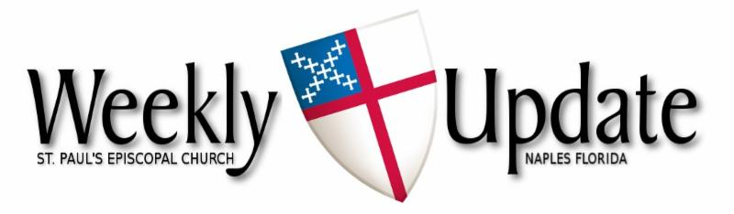
May 18, 2025
The Fifth Sunday of Easter


Aumbry Candle
Throughout May, the aumbrey candle burns

- In loving memory of Millie Olsen & Claire Linquist from Doug & Philip.
- In loving memory of our son, Russel, from the Perry Family.

If you would like to reserve the candle for a loved one, or in memory of a loved one, please call the office at 239-643-0197.

🎶 Wanted: Choir singers (male and female) 🎶
Do you like to sing? We would love to have you join us on Sunday mornings.
You are welcome to come even if you are here for a short time. Our weekly choir practice is held on Monday morning from 11am-12 noon, and we come for rehearsal on Sunday morning at 9:30.
If you would like to join us, please speak to our Music Director, Jacquie Scaduto, at coffee hour, or email her at jacquilt123@gmail.com. Or you can speak to a choir member.
We look forward to seeing new members.

Prayer List
Please pray for Joan Cacchio, Lani Jenkins, Nikki Wall, Richard Broszeit, Lynne LaMarca, Martha Waddell-Gill, Don Kleer, Joyce & Barry Deems, Madeline Fotovich, Mary Grindstaff, Patty Linde, Barry Stone, and Barbara Metcalfe.

Farmers’ Market
The market and stores are now closed for the summer.
They will reopen in the fall. See you soon


This Photo by Unknown Author is licensed under CC BY

The food donations ministry led by Judy Martin is requesting donations of pet food for the months of April, May and June. She will be distributing the donations among the various animal groups in the area. Please contact Judy at 239-784-8485 if you have any questions or particular needs.

*Outreach Committee*
Judy Martin and Jack LaRose are heading up the St. Paul's Outreach Committee. They are in need of 2-3 more people to join them. The committee meets right after church 2 to 3 times per year. They review submissions from the charitable organizations that have reached out to St Paul's for support and decide which ones to contribute to. This is a commitment that does not require a lot of time yet it is very rewarding. Please contact Judy at (239) 784-8485 for more information. Thank you, Diane

If you would like to add someone to the prayer list, email the office at welcome@saintpaulsnaples.org or call the office at (239) 643-0197.

Laundry Love
We encourage you to consider donating to the Laundry Love initiative by contributing to the container in the Narthex. This wonderful program, now led by Steve Augustus, offers a unique opportunity to extend kindness to those in need right here in Naples. If you want to volunteer or have questions, call Steve at 860-490-3178 or email: saugustus@sbcglobal.net. Thank you for your generosity.


Please sign up to bring snacks to fellowship after Sunday Services. Sign up sheets are in Trinity Hall.
Great ideas to bring are breakfast casseroles, bowl of fruit or gluten free foods
Thanks!


May Birthdays

Warren Adams 5/6, Brooke-Lynn Williams 5/8, Norma Pappalardo 5/8, Karen Seller 5/8, Paulette Dickerson 5/12,Gail Cooper 5/14, Deborah Laughlin 5/14, Chuck Lippert 5/17, Amanda DeCastro 5/17, Mary Grindstaff 5/18, Rosanna Lower 5/19, Brenda Mosher 5/24, Wayne Dick 5/25, Roxanne Cunningham 5/27, Cynthia Tyslak 5/29, and Marcia Entner 5/31.


May Wedding Anniversaries

Gerald & Cynthia Tyslak 5/1, Charles & Connie Guensch 5/6, Daniel Fischer 5/6, John R. & Darlene Shoemaker 5/14, Donna Woods 5/17, and William Burfeind 5/27.

Justin’s Place
In the narthex, you will find a dedicated box for donations
Vestry
Sr. Warden – Diane Augustus
Jr. Warden – Julio Albino
Clerk – Charlene Connolly
Treasurer – Rose Porembo
Tom Connolly, Mary Lou Dogoloff, Jack LaRose, Paul Nelson, Jeannie Smith and Murray Smith

Pastoral Emergency:
Fr. Tom’s cell phone: (813) 763-0441

Pastoral Care:
The Rev. Dr. Thomas Thoeni, Rector

Sick? Facing surgery? Recuperating? Please notify the church office for yourself or others.

Office: Betty Hernandez (M-F 9 am-1 pm)
Administrative Assistant (239) 643-0197
Email: welcome@saintpaulsnaples.org

Readings for May 25th

First Reading: Acts 11:1-18
Psalm/Canticle: 148
Second Reading: Revelation 21:1-6

Please go to St. Paul’s Website (www.saintpaulsnaples.org) for links to our online Sunday Services, zoom meetings, and the Sunday bulletin.

St. Paul’s is grateful for your support
You may mail checks to the church, donate via our website: saintpaulsnaples.org, or drop donations on the offering plate on Sunday, or you can scan the QR code to donate to the church.

Scan to donate

Pledge Cards
Pledge cards for 2025 are on the table in the Narthex

Schedule during the week:

MON 5/19 10:00 am Men’s club meeting (LR)
11:00 am Choir practice (CR)
6:30 pm Vestry meeting (TH) – ministries
TUE 5/20 12 noon Tech meeting (L)
WED 5/21 10:30 a.m. Reflect & Connect (L)
6:30 p.m. Bible Study (L)
THU 5/22 8:00 a.m. God’s Gardeners (TH)
5:30 pm Potluck dinner (TH)

Monthly Events and Repeated Gatherings
- Holy Eucharist 9 am Sunday through the summer months

- Bible Study 6:30 pm Wednesdays
- God’s Gardeners 8:00 am every Thursday
- Men’s Meetings 10:00 am every Monday
- Circle of Sisters 3:00 pm 1st Thursday of the month
- Reflect & Connect 10:30 am every Wednesday
- Parish Luncheon 11:30 am 2nd Tuesday of the month
- Potluck Dinners 5:30 pm 3rd Thursday of the month
- Vestry Meeting 6:30 pm 1st Monday of the month
On summer break
- Choir Practice 11:00 am Mondays Resumes soon
- Farmer’s Market 8 am- 12 pm Resumes in November


Thu May 22nd: 5:30 potluck dinner (theme tbd)
Mon. May 26th: MEMORIAL DAY – office closed

SPECIAL MOMENTS

On May 1st, the Circle of Sisters ministry worked together to tidy up the narthex.
Thank you.

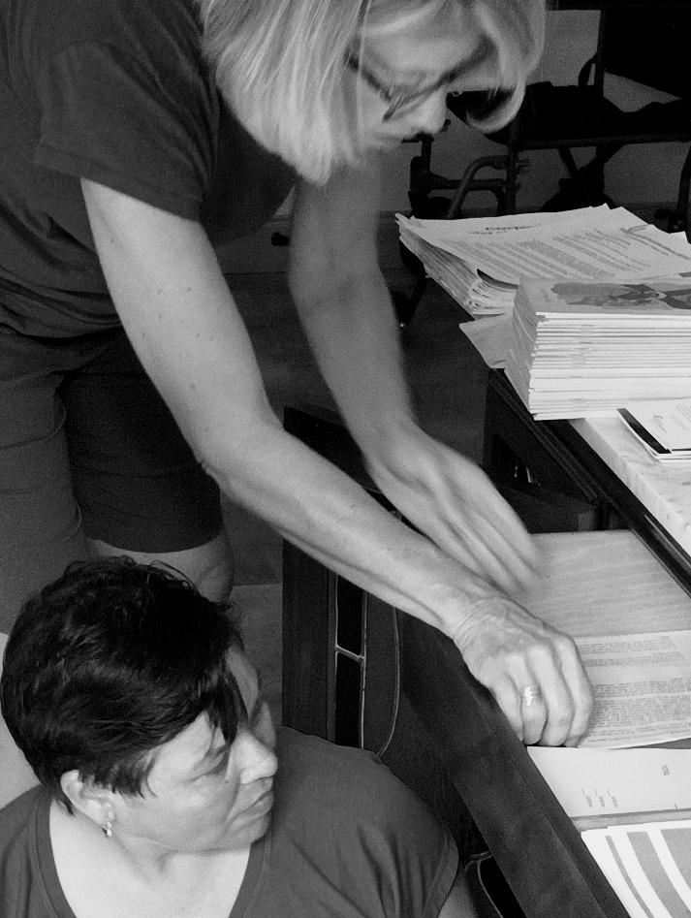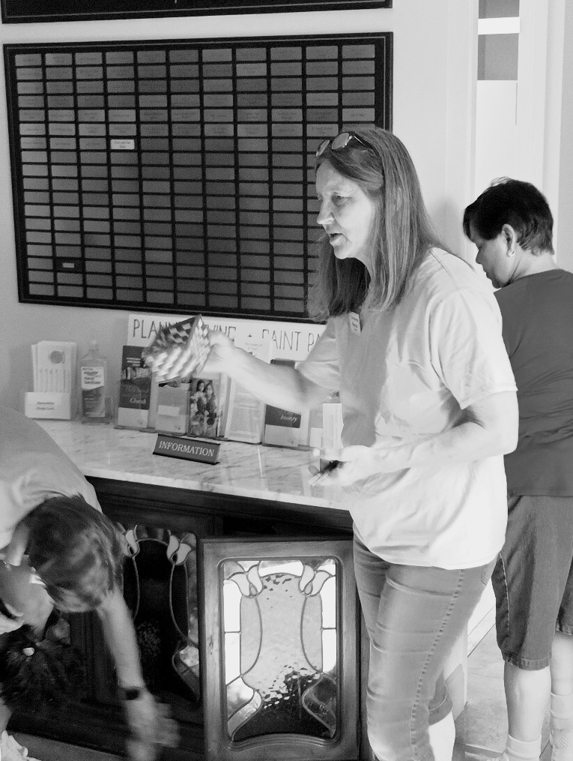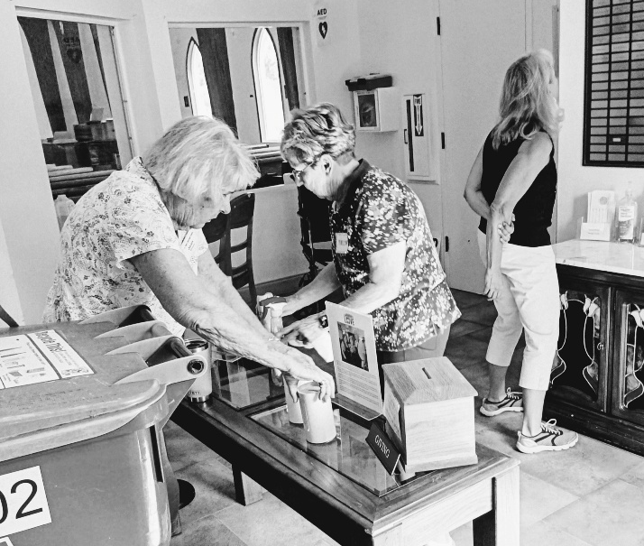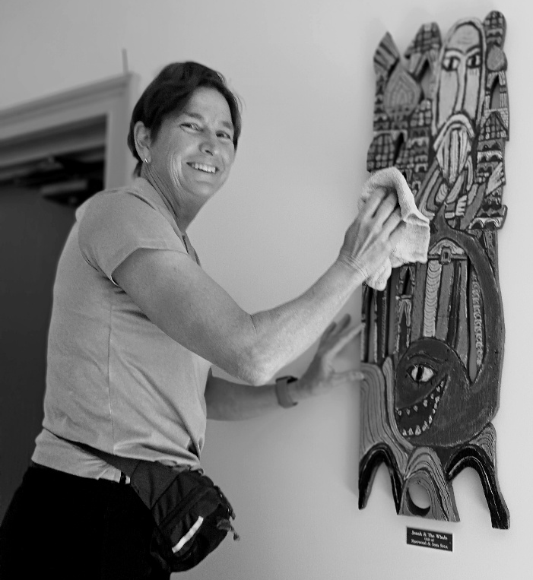

Sunday May 11th Sharing a wonderful Mother’s Day fellowship coffee and extra goodies!

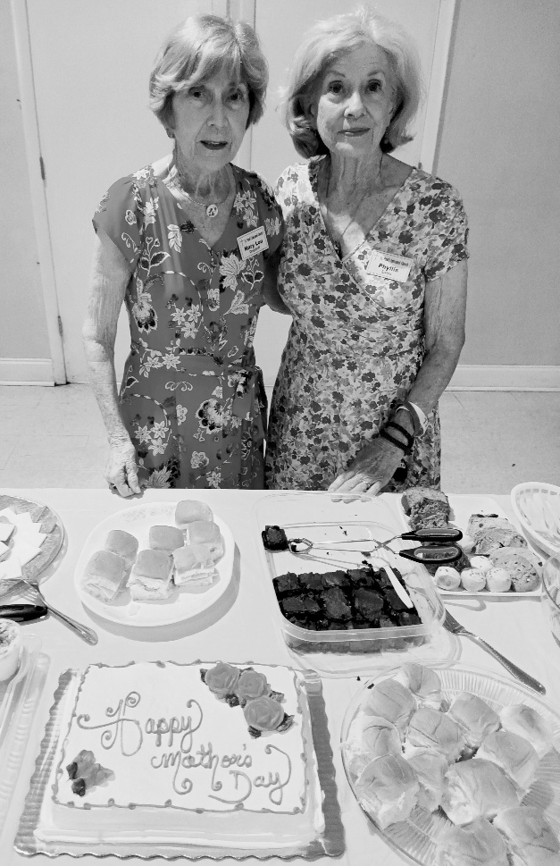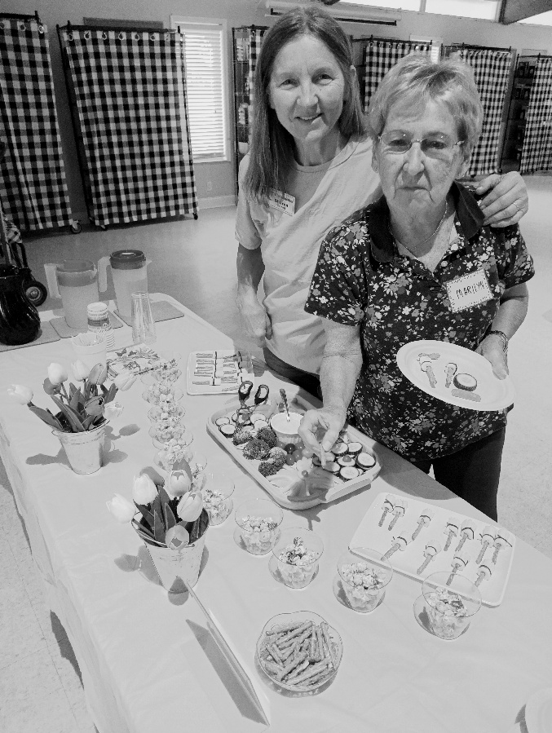
Photo credits: Charlene Connolly – thank you as always

