  - 100th Anniversary of Viking Days Augustana University Alumni Association
MAY 29 – JUNE 11, 2024

2024 ITINERARY PROPOSAL

Celebrating the 100th Anniversary of Viking Days followed by a scenic and historic journey through Norway encompassing Oslo, Bergen, Trondheim, Telemark and the fabulous fjords.

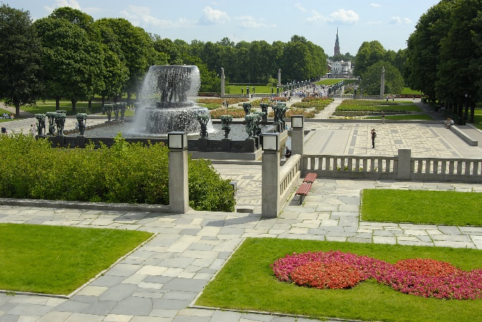

DAY 1 WEDNESDAY, MAY 29, 2024

Mpls/St. Paul – Oslo
Depart the USA on your transatlantic flight. To request alternate dates or for estimated airfare supplements from other US cities, please note on application.

DAY 2 THURSDAY, MAY 30, 2024 [D]

Oslo
Arrive at Oslo Gardermoen Airport. Transfer to hotel in city center. Balance of day free to adjust to time change. Welcome dinner and overnight at the classic Grand Hotel.

DAY 3 FRIDAY, MAY 31, 2024 [B]

Oslo
Sightseeing tour of Oslo includes a visit to Vigeland Sculpture Park, the largest sculpture park in the world by a single artist, boasting over 200 pieces by Norwegian sculptor Gustav Vigeland and a photo stop at Holmenkollen Ski Jump. Afternoon and evening free for shopping and independent explorations. Dinner on own. Overnight at hotel.
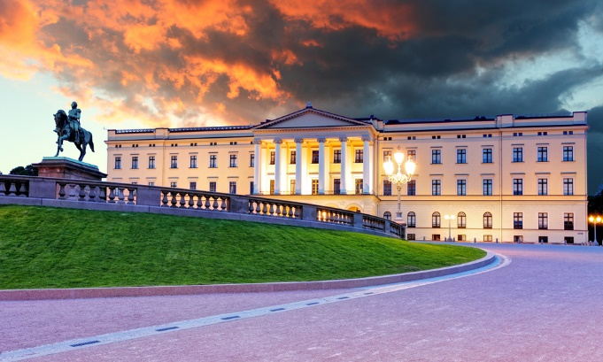

DAY 4 SATURDAY, JUNE 1, 2024 [B]

Oslo
Special events as per own arrangements. Overnight at hotel.

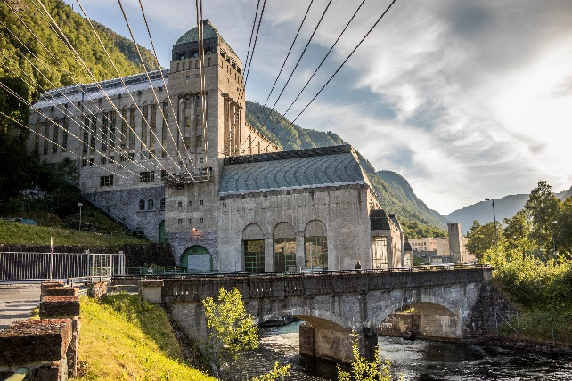
DAY 5 SUNDAY, JUNE 2, 2024 [B,D]

Oslo – Rjukan
Drive to Telemark, an area rich in cultural traditions. Enroute to Rjukan, tour Heddal Stave Church, the largest of the remaining 28 stave churches in Norway. Continue to Vemork, the hydroelectric power plant, where the Nazis produced “heavy water” for their atomic bomb experiments. Learn about the German occupation of Norway during World War II on a tour of the former power plant. Dinner and overnight at Gaustablikk Høyfjellshotell.

DAY 6 MONDAY, JUNE 3, 2024 [B,L,D]

Rjukan – Lofthus

Visit the Hardangervidda National Park Center. Learn about the thousands of wild reindeer roaming the plateau through a variety of interactive exhibits. Lunch. Continue to Hardanger, the heart of Norway’s cherry, apple and pear orchards. Dinner and overnight in fjordview rooms at the charming Ullensvang Hotel situated alongside the spectacular Sørfjord.

DAY 7 TUESDAY, JUNE 4, 2024 [B,L]

Lofthus – Bergen
Cross the Hardangerfjord on Norway’s version of the famed Golden Gate Bridge. Guided tour of a local fruit farm followed by a light lunch and taste of delicious apple pie. Enroute to Bergen stop at Steindalsfossen, one of the most popular waterfalls in Norway. Dinner on own. Overnight at the Opus XVI Hotel, offering guests a taste of the composer Edvard Grieg’s, remarkable life, his relationships and his unique life story.

DAY 8 WEDNESDAY, JUNE 5, 2024 [B,D]

Bergen
Morning sightseeing tour of Bergen includes a visit to Troldhaugen, the home of Norway’s internationally-known composer, the late Edvard Grieg. Tour concludes with a guided walk through the historic Hanseatic Wharf. Balance of afternoon and evening free. Dinner and overnight at hotel.
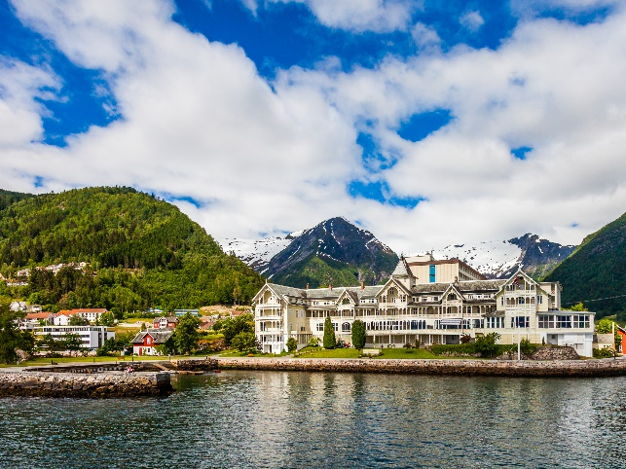

DAY 9 THURSDAY, JUNE 6, 2024 [B,D]

Bergen – Flåm – Balestrand
Drive to Voss. Depart by train on the famed Oslo-Bergen Railway. At Myrdal transfer to the Flåm Line and descend the Flåm Valley, dropping 2800 feet within 13 miles. Cruise the scenic Aurlandfjord and cross the mighty Sognefjord to Balestrand. Dinner and overnight at the historic Kviknes Hotel.

DAY 10 FRIDAY, JUNE 7, 2024 [B,D]

Balestrand – Loen
Scenic drive through the Norwegian fjord country. Opportunity to purchase quality crafts and woven products at Audhild Viken’s Weaving Workshop in Skei. Afternoon excursions to the sparkling Briksdal Glacier. Dinner and overnight at Hotel Alexandra.

DAY 11 SATURDAY, JUNE 8, 2024 [B,D]

Loen – Molde
Depart for the Norwegian Fjord Horse Center in Nordfjordeid, “The Mecca of the Fjord Horse.” The Center is the primary center of research dedicated to this particular breed of horses. Learn about the history of the Norwegian fjord horse. Lunch. Proceed to Molde, the “City of Roses.” Dinner and overnight at Scandic Seilet Hotel or similar.

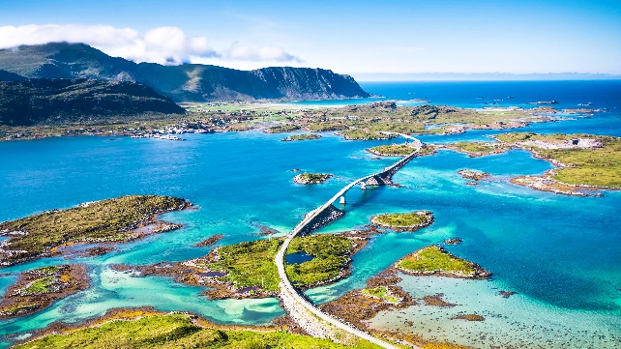
DAY 12 SUNDAY, JUNE 9, 2024 [B,D]

Molde – Trondheim
Drive the Atlantic Ocean Road with the vast and boundless ocean on one side and majestic snow-clad mountain peaks on the other. Visit the fishing village of Bud and tour Ergan Kystfort, a defensive bunker built by the Germans during the occupation of Norway during World War II. Salmon lunch at a local restaurant. Continue to Trondheim for dinner and overnight.

DAY 13 MONDAY, JUNE 10, 2024 [B,D]

Trondheim
Morning sightseeing tour of Trondheim includes a visit to the Nidaros Cathedral, one of the most splendid cathedrals in Scandinavia. Afternoon free. Dinner on own. Farewell dinner and overnight at hotel.

DAY 14 TUESDAY, JUNE 11, 2024 [B]

Trondheim – Depart
Tour ends following breakfast. Transfer to Bergen Flesland Airport for return flight. Longer stays may be requested upon registration for a minimum charge of $250.

MEALS: B=BREAKFAST L=LUNCH D=DINNER

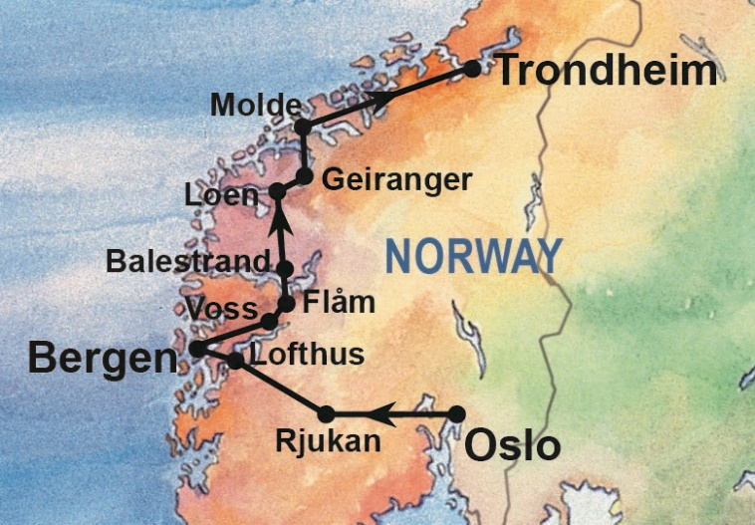

ITINERARY INCLUDES:
- Roundtrip airfare from Mpls / St. Paul, including taxes, fees & fuel surcharge
- 12 nights accommodations, double occupancy, with private facilities
- Daily breakfast [B], 2 lunches [L] and 9 dinners [D]
- 1st-class touring coach, train & ferries per itinerary
- City sightseeing in Oslo, Bergen and Trondheim
- Excursion to Briksdal Glacier
- Entrance fees to all sites including: Heddal Stave Church, Norwegian Industrial Museum, Hardangervidda National Park Center, Troldhaugen, Ergan Kystfort and Nidaros Cathedral
- Luggage handling at hotels for 1 suitcase (subject to availability)
- Tour Director for Days 2 – 14






1-800-437-5302 WWW.BREKKETOURS.COM TOURS@BREKKETOURS.COM

