SHARE YOUR VOICE
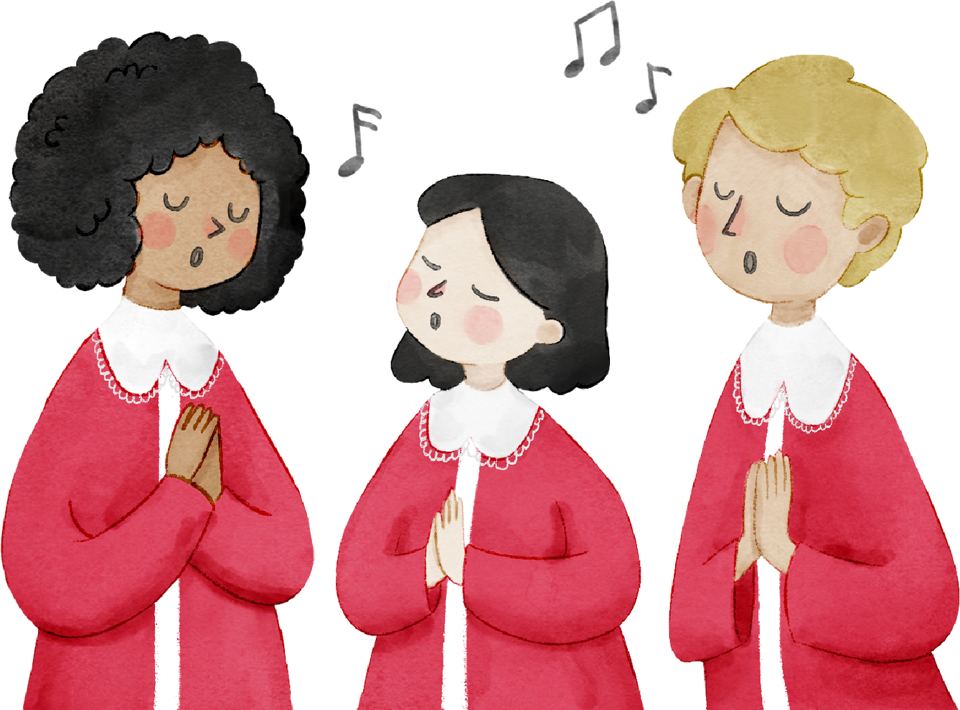
Ohio State Organization Chorus
Calling all who enjoy singing!

Name: Chapter:

Address:

Phone:
Email:

Vocal Part:
Soprano

Soprano 2

Alto

Alto 2

Send registration via email or US Postal Service to: Cheryl Quay 2421 Elmview Drive Lima, OH 45806 419-991-4886 cdquay@wcoil.com
I would be interested in sharing my special musical talent(s) at state convention. I play the musical instrument.
My special musical talent is .

