Hello Family and Friends,
Thank you so much to everyone that has already donated! I wanted to send you an update and let you know how my efforts to get to the top of insert building are going. So far I have raised ($XXX). If I can raise $1,000 I truly will stand on the roof of insert building in downtown insert city and step Over the Edge and rappel insert height feet to the ground! I’m not making this up…check out the event website insert here insert website link

I am not asking you to rappel the building with me but I will need your support to get to the top. I am not only committing to raise awareness for nonprofit by going Over the Edge, but I am also pledging to raise money to fund their vision to help bring all persons with intellectual disabilities into the larger society under conditions whereby they are accepted, respected and given the chance to become useful and productive citizens.

How can you help? By making a 100% tax deductible donation to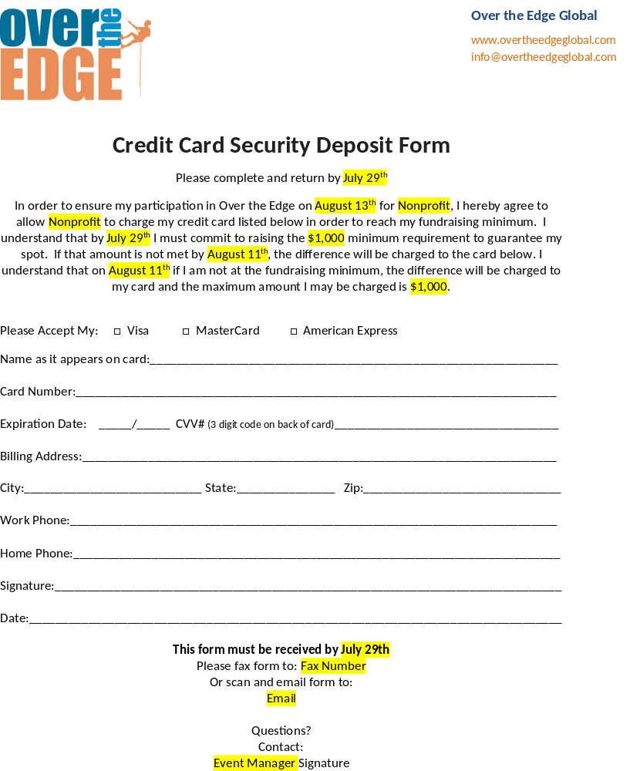 my website here: (insert your website)

You may also send checks or money orders made out to nonprofit:
(Insert your name and address here).
Please help me support the great work that nonprofit is doing. I promise to jump off a building in return!

If you have already donated or want to help even more, please feel free to pass this email along!
Thank you for supporting nonprofit and helping me to go OVER THE EDGE!
Sincerely,
(Your name here)

