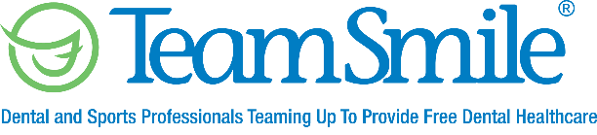

Even though the Center for Disease Control and Prevention (CDC) has lifted many of their COVID 19 restrictions and guidelines, TeamSmile considers itself a medical facility and will still maintain strict guidelines which includes additional Personal Protective Equipment, barriers, and 6ft of separation between areas. TeamSmile will also contact the local Health Department to note any

TeamSmile Phase II program.
- All volunteers, dental and non-dental, will be in proper Personal Protective Equipment.
- The goal of this program is to evaluate the patient, clean the patient’s teeth then work with the patient’s parent/guardian to place him/her in a dental home. If a child has an immediate life threatening need, we will have dentist on hand to address this need.

The TeamSmile Phase II program is a modified program due to COVID 19 restrictions. This program will include:
- Patient will be checked in to our system.
- Patient will then move to a waiting area where education on good brushing habits will take place.
- Patient will move to Patient Examination Area where a comprehensive exam with a dentist will take place. The goal is to evaluate the patient’s overall oral health.
- If no decay is found, the patient will move to our preventative care area where the patient’s teeth will be cleaned and fluoride varnish will be applied to the patient’s teeth. (This area will have barriers around each of the operatories as well as an Extraoral Dental Suction System to remove droplets and Aerosols).
- If decay has been found, the patient will move to another area where a dentist will apply Silver Diamine Fluoride. Silver Diamine Fluoride is a product that will not fix the cavity, it will just stop the cavity from growing larger. Fluoride varnish will be applied after SDF is applied.
- If the patient’s decay is determined to be life threatening, TeamSmile will have dental operatories in place to take care of immediate dental needs. (This area will have barriers around each of the operatories as well as an Extraoral Dental Suction System to remove droplets and Aerosols).
- Once everything is complete, the patient will move to check out, TeamSmile will assist in connecting the patient with a dental home in their community if he/she does not already have a dental home and a dental report card will go home with the patient.
- All patients will also go home with a toothbrush, toothpaste, floss, hand sanitizer and educational information.

