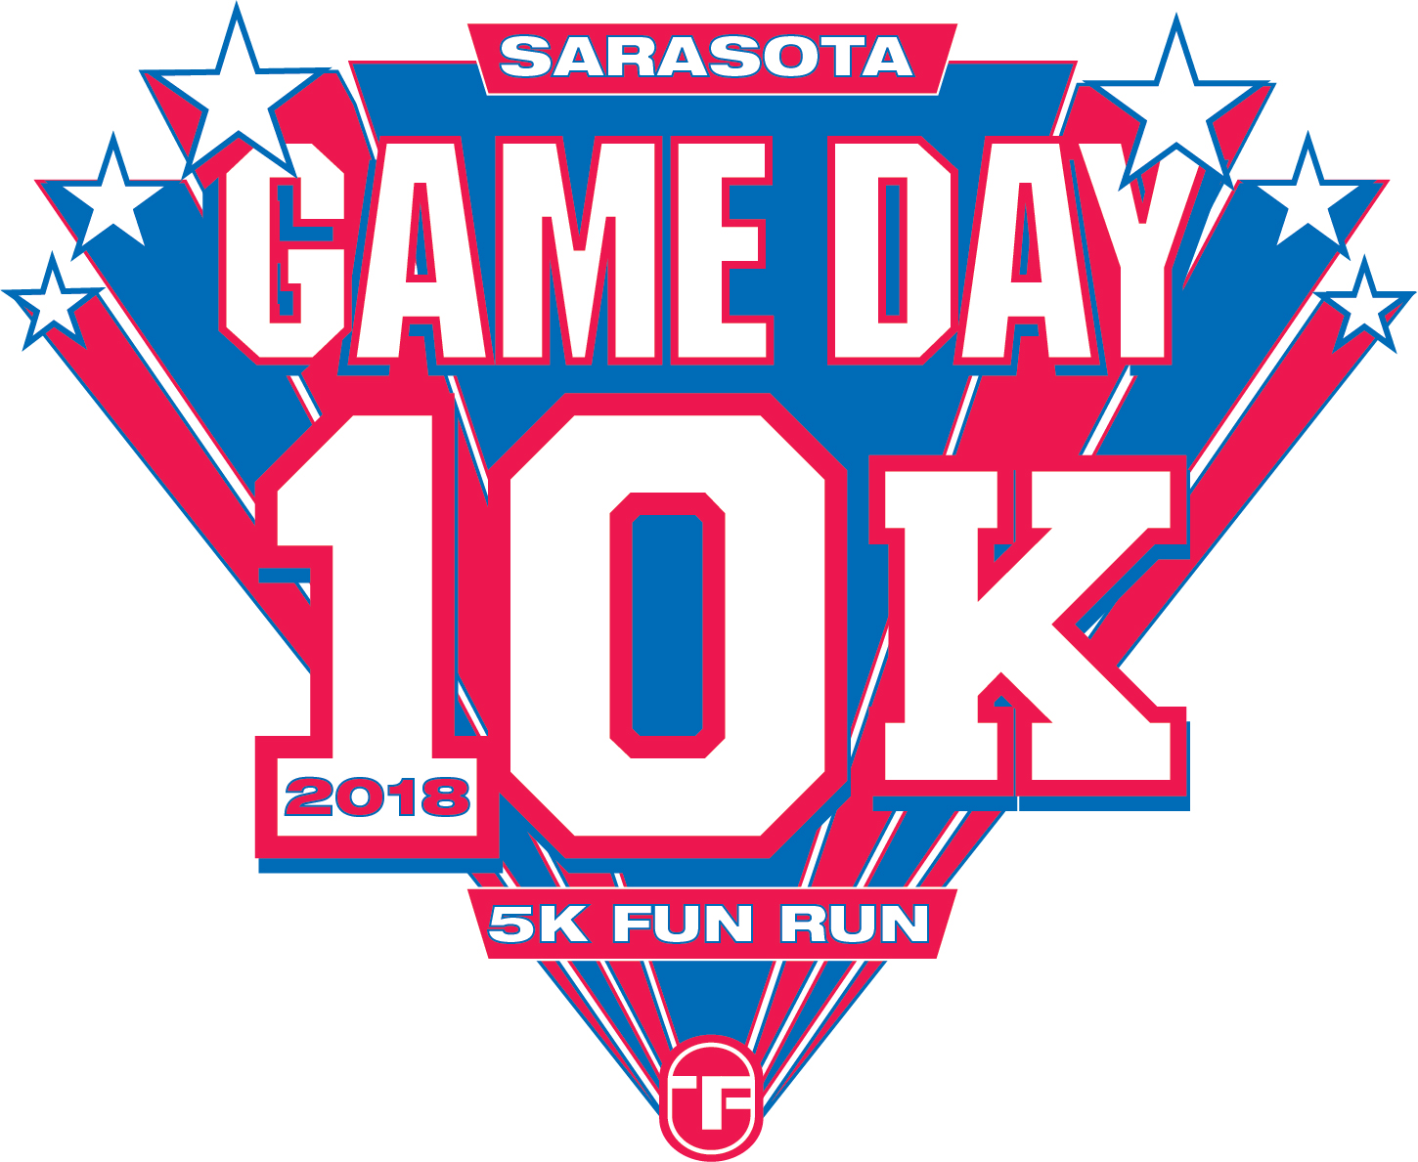

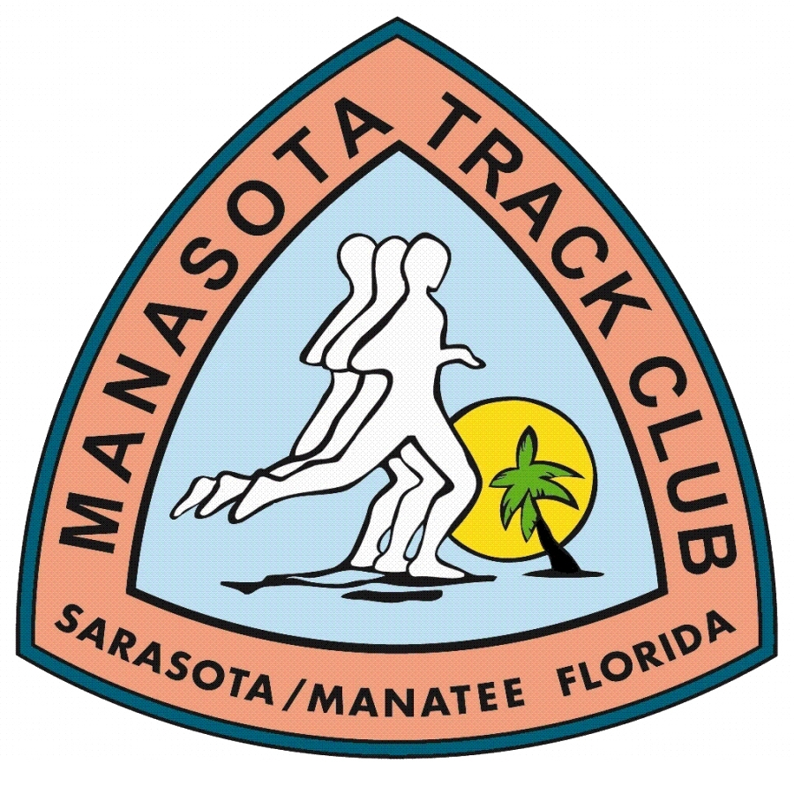

College Game Day 10K & 5K Fun Run Sponsorship Agreement

PLATINUM SPONSORS - $1000 Minimum Contribution GOLD SPONSORS - $500 Minimum Contribution
Recognition at the event as a Major Sponsor Recognition at the event

Name and/or logo printed large on the Race Shirt Name on Race Shirt
Recognition on the GD10K/5K & WPPCGC websites Recognition on the GD10K/5K & WPPCGC websites
Tent/booth space at the event to sell/promote product 1 complimentary GD10K entry (includes race shirt)
Sign or banner allowed at Race site
2 complimentary GD10K entries (includes race shirts)

SILVER SPONSORS - $250 Minimum Contribution BRONZE SPONSORS - $100 Minimum Contribution
Name on Race Shirt Name on Race Shirt
Recognition on GD510K/5K & WPPCGC websites

Non-Cash Sponsorships: You can also achieve the above sponsorship levels by partnering with the GD10K/5K and donating non-cash items to the event. This can be in the form of food or beverages, gift cards and/or merchandise or services that will help defer the expenses of putting on this fitness event.

All sponsors are encouraged to submit promotional items for the race bags.

Checks Payable to: Mail to: Joe and Monica Sweeney – Race Directors
WPPCGC – GD10K 5107 Summerwood Court
Sarasota, FL 34233

Sponsor/Organization Name: _________________________________________________
As you want it to appear on the back of the race shirt

Sponsorship Level/Dollar Amount: $__________________ Check # ___________________

Non-Cash donation: ____________________________________________________________
Please describe non-cash donation

Sponsor’s Name: ________________________________________________________

Full Address: ____________________________________________________________

Phone: ____________________________ Email: ______________________________

What college program would you like to acknowledge? __________________________________

Thank you for your support. Your donation will assist us in raising funds for academic scholarships for the top three college teams and care packages for deployed graduates of West Point and their troops. The West Point Parents Club Gulf Coast is a 501(c) 3 organization. TIN: 59-3417839

