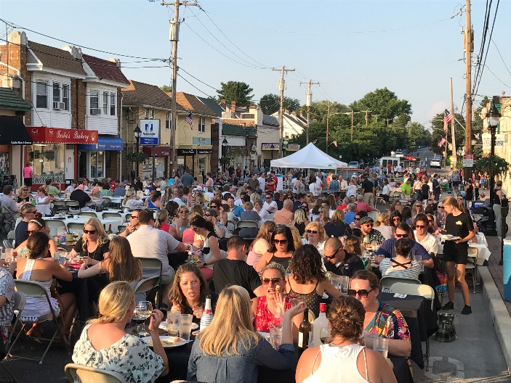
Moonlight Dining on the Boulevard
Tuesday, September 17th 5:00-10:00 PM
Brookline Boulevard, Havertown, PA
Say goodbye to summer with your friends and neighbors on lovely Brookline Boulevard in Havertown! Dine on the street or indoors with fine dining and casual meal options available.
Raindate is Tuesday, September 24th!
FOOD: There will be a variety of dining options at the event, some requiring reservations, some not. Most restaurants will be offering a limited menu to accommodate the anticipated crowd. Most tables will accommodate 6-8 people. Some restaurants may seat smaller groups family-style with other diners. Seatings are time-limited, but we hope you will stay on the Boulevard for dessert, drinks, and socializing after your meal. Please also check out the stores that will remain open that night!
Reservations will not be required at the following restaurants:
Sam's Boardwalk-Style Pizza
Koffmeyer’s Cookies & Ice Cream
Secret Sauce BBQ
Bria & Latella's Deli
Sippy's Bubble Tea
House Cup Coffee Roasters
Limitless Nutrition
Reservations will be required at the following restaurants:
JD McGillucuddy’s – Outdoor seating reservations suggested. Seating times are 5:30, 7:00, & 8:30. No BYOB. Call 485-454-5289 or email Brookline@jmdcgillicuddys.com for reservations.
Sampan Inn – Outdoor seating reservations suggested. No BYOB. Seating times are 5:30, 7:00, & 8:30. Call 610-446-2188 for a reservation.
VIDA – Outdoor seating requires reservations. Seating times are 5:30, 7:00, & 8:30. BYOB. Call (610) 446-8200 for reservations.
Kettle – Outdoor seating requires reservations. Seating times are 5:30, 7:00, & 8:30. BYOB. Call (610) 446-1234 for reservations.

MUSIC: Live music provided by Kelly Music for Life. Michael Kaplan HHS '16 and his band MK and Friends Jazz Quartet will perform two sets.
ALCOHOL: BYOB will be allowed at the event in the enclosed area of the Boulevard only. Do not arrive or leave the event with open containers. Please be mindful that the future of this event depends on it running smoothly, without incident. Please drink responsibly!
PARKING: Brookline Boulevard will be closed at approximately 3:00 pm between Darby Road and the parking lot, with no parking at the street meters after that time. The parking lot will be open for parking throughout the event. If you live close enough to walk, please do so, to allow for others coming from across the Township to use the lot. You might also find available parking at the Skatium or at the Middle and High Schools. Please use a taxi, Lyft, Uber or a designated driver if you plan to drink alcohol.
COST: There is no admission to the event. The Haverford Partnership for Economic Development (HPED) will have information at our tent about Resident Memberships to support events like these and beautification efforts around the Township.

