Summer Sensations Camp
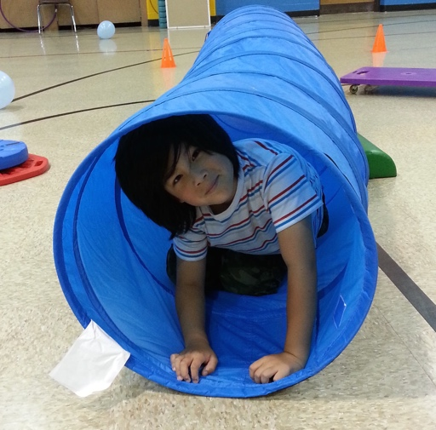
In this fun and engaging camp, kids will explore and participate in a variety of sports, gross motor games, sensory play opportunities, and arts and crafts activities. This camp will help develop core strength, gross motor coordination, eye-hand coordination, and motor planning. Additionally, campers will be introduced to Zones of Regulation and Social Thinking principles to help improve self-regulation, positive peer interactions, and social problem solving sills.
Offered to students grade 1-4.
Group Leaders: Joylynn Holladay, MS, OTR/L and Kate Loughran, MS, OTR/L
Contact Information: joy@sensadv.com
Dates and Time: June 24 to June 28, 9:00 to 12:00
Note: This camp can be paired with our afternoon HW camp for a full day option. Additionally, St. Richard’s offers before and after camp care.

Location: St. Richard’s Episcopal School, 33 E. 33rd Street
Registration: https://www.sresdragons.org/extracurricular/summer-camp

