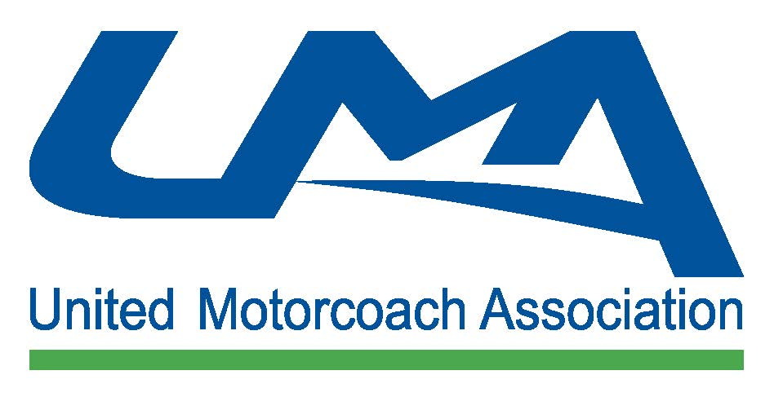
Details of the ASCAP and BMI Licenses 2018

Coverage:
UMA has negotiated special music licensing rates with ASCAP and BMI for its members. This rate is up to 70% off what you would pay going directly through ASCAP or BMI.
- The license covers the performance of the music in the ASCAP and/or BMI repertories on all “Licensed Buses” – that is all United States registered motorcoaches you own or operate that are equipped for the performance of music.
- The license covers audio-visual uses (CD’s, tapes, radio, TV, video*, etc.).
- “ASCAP and or BMI repertories” means all copyrighted musical compositions written or published by ASCAP and BMI members or members of affiliated foreign performing rights societies, including compositions written or published during the term of this Agreement, and which ASCAP and or BMI has the right to license non-dramatic public performances.

*The ASCAP & BMI licenses only apply to the music portion of the video presentation. Video (movie, etc.) require separate licensing, such as that provided by Motorcoach Movies. UMA Members also receive a discount on movie licensing through Motorcoach Movies. For more information, please contact Terri Colyer of Motorcoach Movies at 888.416.2572 or visit www.motorcoachmovies.com

Period, Payment of Fees:
- The license is for the calendar year basis and runs – January 1 to December 31.
- You are now obtaining authorization for performances and paying for calendar year 2018.
- Fees each year will increase according with the Consumer Price Index (CPI-U).
- Checks should be made payable to UMA and mailed with your 2018 paperwork.

JANUARY 1, 2018-DECEMBER 31, 2018 | UMA MEMBER LICENSE FEE
ASCAP | $27.86 per bus equipped for music
BMI | $27.85 per bus equipped for music

Example: Company XYZ has 5 buses equipped for music. Under the ASCAP/BMI licensing agreements, XYZ is responsible for paying $139.30 to ASCAP and $139.25 to BMI for a total of $278.55 in licensing fees. Company XYZ submits a check made in the amount of $278.55 payable to UMA, whereupon UMA will process the necessary paperwork and forward the monies to both societies.

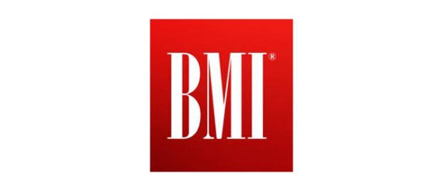

Eligibility:
- A member in good standing of the United Motorcoach Association.
- If you fail to renew your license by not paying fees in any year, you will no longer be eligible to participate in this discounted program. You will then need an individual license at a rate that is more than twice the United Motorcoach Association member rate.
- If you owe fees under any other license agreement with ASCAP or BMI, you must pay any previous balances before you are eligible to participate in this program.
- The 1st quarter payment for ASCAP licensing is March 31, 2018.
- The deadline for 2018 BMI licensing is March 31, 2018.

United Motorcoach Association Member Authorization
2018 ASCAP Licensing Application & Authorization
We represent that we are a member in good standing of the United Motorcoach Association (hereafter referred to as the UMA), and familiar with the terms of the License Agreement between ASCAP and the UMA, hereby consents and agrees to be licensed under the terms and conditions of the License Agreement.

We understand the 2018 ASCAP license fee is $ 27.86 per bus equipped for performance of music or video. For calendar 2018, the number of buses operated by the company and equipped for the performance of music or video is $ 27.86.
Our total 2018 ASCAP license fee is $ ________ (Number of buses X $ 27.86 per bus)
A check in the amount of the total license fee and made payable to the UMA is enclosed.
Return this form with your check payment before 3/31/18 to United Motorcoach Association 113 S. West Street 4th Floor, Alexandria, VA 22314
Date: _______________________________

Name of Licensee Member Organization: ___________________________
Address of Licensee (Street, City, State & Zip):
_____________________________________________________________
______________________________________________________________

Office Number & Email:
_____________________________________________________________
Contact Name:__________________________________________________
Signature: _____________________________________________________

Contact Membership Manager Jocelyn Delacruz @ jdelacruz@uma.org with questions

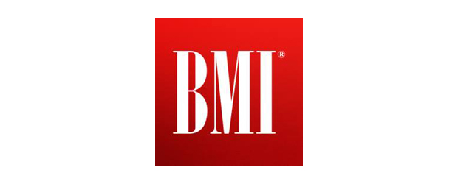
United Motorcoach Association Member Authorization
2018 ASCAP Licensing Application & Authorization
As a member in good standing of the United Motorcoach Association, (hereafter referred to as UMA), we hereby apply for music license from BMI as set forth in the individual agreements between BMI and UMA.

We represent:
1.) We are a member in good standing of UMA; and
2.) That the person signing this Application/Authorization shall be the contact person with whom BMI and UMA may deal as necessary regarding this Application/Authorization and the individual agreements between BMI and UMA.
We further represent that:
1.) Signing one authorization for BMI is only for the mutual convenience of UMA and us;
2.) We are not required by the agreement between BMI and UMA to be a recipient of music licenses from BMI; and 3.) The license from BMI does not permit us to perform music of any other performing rights society, (for example ASCAP).
We understand the 2018 BMI license fee is $27.85 per bus equipped for performance of music or video. For calendar year 2018, the number of buses operated by this company and equipped for the performance or music or video is _______.
Our total 2018 BMI license fee is $ _________ (Number of buses X $ 27.85 per bus)

A check in the amount of the total license fee and made payable to the UMA is enclosed.
Return this form with your check payment before 3/31/18 to United Motorcoach Association 113 S. West Street 4th Floor, Alexandria, VA 22314
Date: _______________________________

Name of Licensee Member Organization: ___________________________
Address of Licensee (Street, City, State & Zip):
_____________________________________________________________
______________________________________________________________

Office Number & Email:
_____________________________________________________________
Contact Name:__________________________________________________
Signature: _____________________________________________________

Contact Membership Manager Jocelyn Delacruz @ jdelacruz@uma.org with questions

