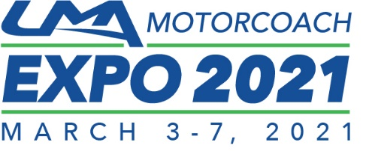
2021 UMA Motorcoach EXPO Pre-Registration
Register for the 2020 UMA Motorcoach EXPO in Nashville by February 15, 2020 to receive the lowest EXPO rate of $295 per person! Please complete one registration form per person and return to UMA.

FIRST NAME LAST NAME email

company phone #

Address

CITY STATE POSTAL CODE

PLEASE LIST ANY SPECIAL NEEDS (DIETARY, PHYSICAL, AUDIO-VISIUAL, TRANSPORTATION, ETC.):

_________________________________________________________________________________________________________________________________

UMA Member
2021 UMA Motorcoach EXPO Operator Fee (per person) $295

Payment Information:

❒ Visa  MasterCard  American Express  Check (UMA, 113 S. West St. 4th Fl., Alexandria, VA 22314)

Credit Card # | Expiration Date
Name on Card | Signature
EXPO-ORL

T

Not a member of UMA? Become one and save on your EXPO registration. Visit www.uma.org or call 1.800.424.8262 to join and learn more about other great benefits UMA membership provides.
Terms: Full registration for the 2021 UMA Motorcoach EXPO in Orlando includes per person: UMA education sessions, UMA trade show floor entrance, breakfasts, lunches, and networking events such as the opening Welcome Reception and the annual Leadership Awards Celebration dinner. By completing this registration form, I give permission to the United Motorcoach Association (UMA) and authorized UMA Motorcoach EXPO vendors to use my information to communicate with me about UMA Motorcoach EXPO and/or other products or services provided by UMA and authorized UMA Motorcoach EXPO vendors. Offer valid only when using this registration form. Regular rate is $450.
Cancellation Policy: There is no refund for cancelling registrations made prior to 2/15/2020 with the special rate.
Photo and Video Release: By attending, you hereby grant UMA, its representatives and employees the right to take photographs and multimedia of you and your property in relation to UMA Motorcoach EXPO. You also authorize UMA to use such images, with or without your name, for any lawful purpose including but not limited to publicity, editorial coverage, print advertising and web content.

To take advantage of this special offer, fax your completed form to UMA at 703.838.2950.

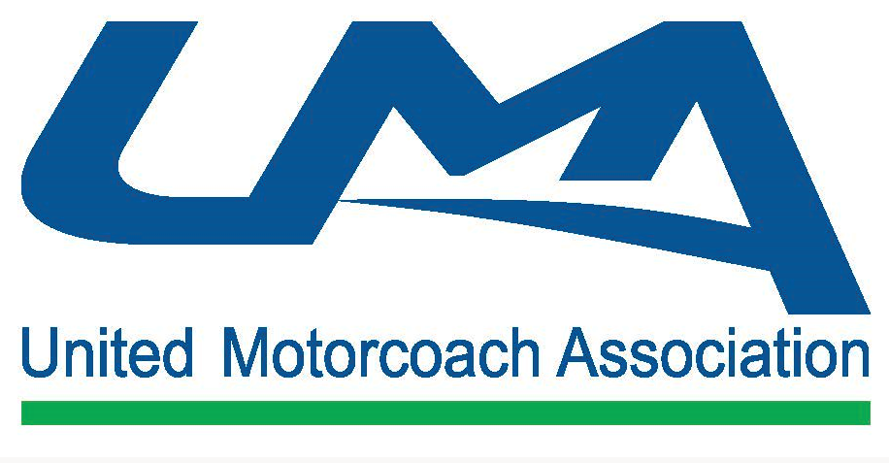
Questions? Contact UMA at 800.424.8262

