Glidden Memories

Compiled and slightly edited by:
Vince DeLisi, Chairman & Registrar
76th Revival AAA Glidden Tour Committee
September 2022

Note – If you would like an electronic version of this document, it is available in Microsoft Word Format, or .pdf if preferred. Our intention is to share it with the editors of Antique Automobile as well as the Bulb Horn over the next couple of weeks. Our hope is that over the years, folks like you will continue to add to this record. Please send any request for copies, or your additions and/or corrections to: vincentdelisi@comcast.net, or via snail mail: Vince DeLisi, 326 East Oak Avenue, Moorestown, NJ 08057 if you wish to have them included in the version that is forwarded to the respective editors.

Don Barlup

My fondest memories of the Glidden Tours are the History and people behind the tours. From James Melton & William Swigart forward the most influential people in our hobby have been Glidden Tourists. That says a lot about what a special tour the Glidden really is. I hope we never lose sight of the history and those who have toured before us.

Duffy Bell

2010 Glidden tour to Holland Michigan!
In the fall of 2010 I joined a group of fellow NJ Region AACA members to go to Holland Michigan for the annual Glidden Tour.
Our itinerary included driving up into Canada, then west around Lake Erie and around Lake Michigan, then back to Holland where we spent the week touring.
I took the trouble to remind everyone that you will need your passports to get back into the US again, then forgot to bring my own! Stupid me. I had to leave the group, turn around and take a different route through Pa and Ohio around the southern end of Lake Erie and Lake Michigan to reach our destination on the west side of Lake Michigan where the city of Holland is located.
This turned out to be an advantage to me because I arrived at the host hotel a full day and a half ahead of the rest of my group from NJ and it gave me the chance to have an exhaust leak in my 40 Buick repaired before the tour started.
On the first morning, as I was leaving the hotel, I was cornered by Dave Zimmerman who wanted to know if I would like to have a passenger along for the ride. Driving alone, as I was, I said yes, I would love to have a passenger.
The passenger turned out to be Pat Swigart, of the W. E Swigart Auto. Museum in Huntington PA. I could not have asked for a better passenger for the whole week. She is an interesting and delightful woman with whom I was able to take an instant liking to. We had many pleasant conversations that made the trip that much more memorable.
We visited the Auburn-Cord-Duesenberg Museum in Auburn Indiana and the. nearby Early Ford V-8 museum.
Later when the New Jersey Region AACA had our annual summer tour to Erie Pa, one of our stops was to the Swigart Auto Museum in Huntington PA.
Chester & Nancy Bradfield

Our first Revival AAA Glidden Tour was in 2002 in Daytona Beach, FL. We took a newly restored 1938 red Studebaker Coupe Express for her maiden trip. We only had 50 miles on it. We met a lot of great people during the week. Near the end of the week, we broke a valve spring. The rest of the week we rode with other people in some great cars including Wayne Hadden's 1930 Studebaker 7 Passenger Touring car. Since then, we have attended many Glidden tours.

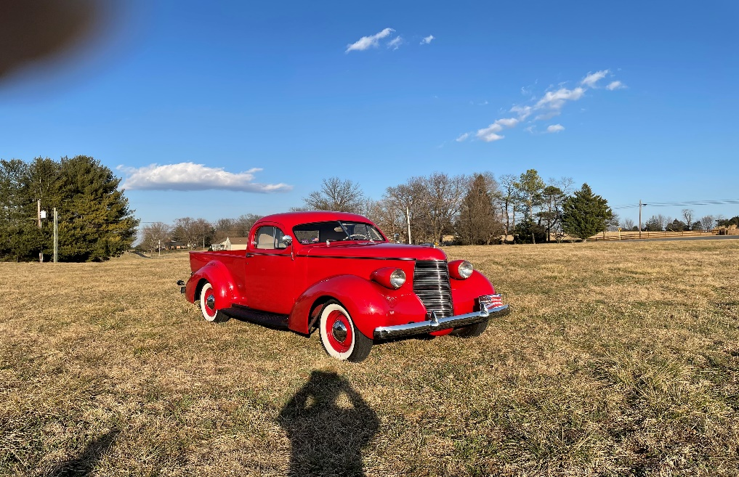

Paul & Inge Dobbin

In 1998 we towed our 1934 Ford Tudor to Bretton Woods, NH from St. Petersburg, FL behind our GMC Motor Home for our second Glidden Tour. On arrival we checked into the designated campground, which was new to us after staying in the county fairgrounds for the prior year's Glidden in Thomasville, Ga. The campground was in full fall colors and also full of Pre WWII cars, many of which we had never seen before. After unhitching and setting up, we ventured out to the Mt. Washington Hotel where the first Glidden Tour started on 1902. We would also begin our 1998 tour from there on Monday. Sunday was a day to sightsee on our own with an opportunity to climb Mt. Washington in the rare sunshine and to meet other Gliddenites and get acquainted.

Monday, we started out and ran out of gas first thing and were rescued by two couples in a 28 Chrysler. We toured the White Mountains and saw the old man of the Mountains before his face fell off. We visited Harman's Country Store in Sugar Hill where we met a guy from Wisconsin who knew the history of our 35 Ford Pickup.

We were scheduled to sail Lake Winnipesaukee from Center Harbor to Wolfeboro on a luncheon cruise on the M/S Mount Washington. Center Harbor was about an hour south of Bretton Woods. We stopped for gas, after fueling up we got up to about 50 MPH and my suicide driver’s door flew open! Bent all three hinges and cracked the safety glass. I was able to strap it partially closed and proceeded to the next town. With the help of a nice garage owner, we managed to close the door on 3 crowbars to bend the hinges back to where I could close and lock it. I used my belt to strap it to the windshield post and we were off again to Center Harbor. That little V8 went really fast and we made it in time to be the last people to board the ship to Wolfeboro. Lunch aboard the ship with 700+ Gliddenites set a record for the most lunches ever served. I think we left more than 300 cars in Center Harbor for the day. When we arrived in Wolfeboro, the M/S Mount Washington was met by dozens of early wooden speedboats in the harbor and a large car collection on the dock. Only time in my life I saw 5 or more 1931 Chrysler Dual Cowl Phaetons all at once. The Gliddenites were not immune to seeing more cars either.

We visited Lancaster, North Conway, North Woodstock, Haverhill & Bath, NH & Clark's Trading Post as well as dozens of covered Bridges in Vermont and New Hampshire in a full fall splendor of perfect fall colors. We were hooked on the Glidden Tours from then on.
On the way home to Florida we visited Camden, Rockport, Owls Head & Kennebunkport, Maine. We even showed our car at Owls Head Transportation Museum Show before heading to the big show at Hershey PA. At Hershey I saw a friend who put me onto a 34 Ford Phaeton in Florida which we went home and bought for the 1999 Glidden Tour. Hooked on Glidden Tours when my knees allow it. Always a fun thing to do.

Debra & Gareth Eich

Our first Glidden Tour was to Brenham, TX and we were sold immediately on the people, the planning and all the events. With each tour we have attended since then, I enjoy how the local communities are involved with coffee stops, lunches and activities. This was so true in Chattanooga, TN, North Conway, NH, Oklahoma City, OK and Saratoga Springs, NY. Seeing the country by old cars is great and meeting the locals even better. We always look forward to our next Glidden Tour.

Steve Fitzgerald

Since I live my life with the motto of: " Life is a journey - Not a destination." I simply enjoy the journey going and coming. Whether it is in a '65 Studebaker a '95 Honda DelSol, a '96 Mercury Sable Wagon, a '56 Studebaker pickup – or - like this trip to Princeton in a 1939 Pontiac. I do not use my trailer to get to a tour and I enjoy the back roads of America. This time I will drive the '39 Pontiac from Grand Junction to Princeton by way of Austin, Texas and Birmingham, Alabama. On the return, I will stop off at the Carlisle Swap Meet. We will arrive in Princeton a few days early to visit places our ancestors lived in the early 1700's. BUT we will soon be off to the Lewis & Clark Tour and after returning to Grand Junction on October 4, we will be off in the Studebaker to the Heritage Tour in Ohio where many of our ancestors lived in the 1800's.

This is a great year now that we can pretty much put Covid behind us.

Walter & Marge Franz

New Jersey Glidden will be Walter’s 44th Glidden and Marge’s 41st.

Most memorable would be our first in Callaway Gardens in 1977. Not only was it exciting, but it was a winner because of the amount of work done by the members.

On all of our tours, we have broken 3 axles, one of which was broken going up Piles Peak!

In 1993, we worked on the Delmarva Glidden Tour. Walter was tour chairman for Friday. It was exceptional because of the number of parties and cars and getting the local businesses to realize what it meant to the participants and the community.

We only missed one Glidden, in 1996.

On all of our Glidden’s, Idaho was the first time that help was need with the car which was provided by the AAA drivers.

Each Glidden has its memories, some special, some not. We have been in 45 States with our car, a 1930 Chevrolet Coach, which has been on 43 tours. We have driven to a good many tours in our earlier years, taking back roads all of the way. We would drive the car if 1,000 miles or less, and trailer if over 1,000 miles.

Lou and Mary Jane Fritz

We have done over 10 Glidden tours and we have done every founder’s tour. Mary Jane’s favorite Glidden tour was 1990 Pikes Peak. It was quite a feat to take our 1926 Chevrolet Touring 10,000 feet up a mountain side, and back down again without losing our brakes. Pikes Peak was closed for the season and the tour chairman got special permission to use the road. They had to plow the road at the higher elevations so that we could get through to the 10,000 feet level. By the time we finished our beautiful 26 Chevy was plenty dirty from the snow.
My favorite tour was our first tour in 1983, only 45 miles from home. Very exciting and we did a lot of prep work so as not to have a failure on the tour. Since that first tour we have completed well over 80 tours. That’s a lot of tour bags I have hanging around.

Robert Giles

Patti Giles and Sheri Roberts in the rumble seat – 2021

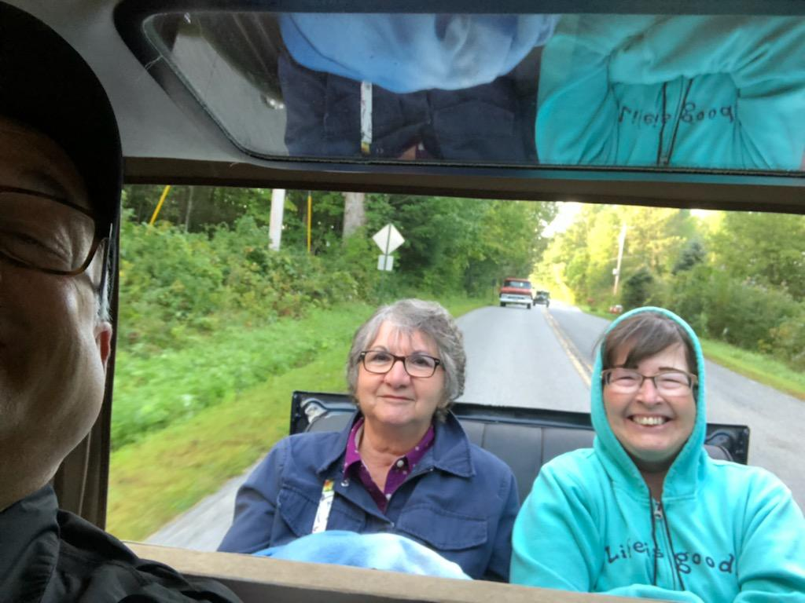

Nancy Huffman and Sharon Kron
On the 2009 Glidden Tour in Golden, Colorado, the Krons, the Huffmans and the Sargents decided to take a suggested scenic alternate route, the "Oh My God Pass", from Idaho Springs to Central City, CO. This was a narrow dirt road, with switchbacks, steep cliffs, drop offs, and no guard rails. When we reached a pull off at the top, Paul spotted a "prehistoric" bone and decided to crawl down the precipice to retrieve it. We watched and held our breath wondering if the next thing on our agenda was going to be calling for a search and rescue mission. Did he retrieve the thing? Of course! Not quite sure what it was-- mountain lion, mountain goat, mastiff, deer, but it made its way home to NY!

Claire Oestreicher

The AAA Centennial Glidden, in Daytona Beach in 2002, was my first, and I felt a bit shy. I quickly learned that Glidden tour participants are the easiest people in the world to talk with. There were always subjects for conversation. Where are you from? What are you driving? How's it running? And on from there. There are no strangers, on a Glidden Tour.

In Branson, Missouri, in 2004, one Model A ran really badly on the first day's trip to Dick's Sporting Goods headquarters. After parking in Dick's lot, other Model A drivers collected enough parts and tools to take the engine apart, replace the head gasket, and have that driver heading home smoothly with the rest of the pack.

On the Altoona, Pennsylvania, tour in 2005, it felt special to honor the victims of Flight 93 at the newly-opened 911 memorial, and to visit a site involved in the 1889 Johnstown Flood. My dad, an amateur telegrapher, had told stories of the telegraphers who stayed at their posts until escaping the floodwaters was impossible. On a less somber note, we visited a small town with an antique mall that hadn't prepared for how much old car fans enjoy antique shops. Several of our ladies pitched in to wrap and bag purchases while the lone cashier rang people up.

As the Gliddenites with the most tours, Steve Gordon was invited to drive onto the arm of Crazy Horse when we visited the South Dakota monument in 2006. Steve's car couldn't make the trip so Bill and Jane Johnson took him up in their '31 Buick. It made for a magnificent cover shot on the next Bulb Horn magazine.

We got to explore a dam over the Mississippi River during the LaCrosse, WI, tour in 2008. We also visited a cranberry farm one day. Upon leaving the facility, our car had a tire problem. Back at the farm, a dozen other drivers helped with a better jack, tools, and friendly supervision. When we returned to the hotel, we were able to help another tourist push his ailing car up onto his trailer. An article I wrote about the Glidden Spirit during those events was published in the Bulb Horn.

Our car didn't like the altitude in Golden, Colorado, in 2009, so we became close personal friends with the AAA driver who rescued the poor Buick several times. At an excursion train parking lot, at about 8,000 ft. altitude, a visitor saw many cars laboring uphill. She commented, "Those old cars don't run very good, do they?" I said they run just fine at home where the altitude is only 550 feet above sea level!

In Holland, Michigan, in 2010, I was able to visit my aunt for what turned out to be the last time. We were also able to veer just a few blocks off the tour route and visit my cousin. The windmill and the car collections were magnificent, but that tour is special to me because it brought me to see relatives I didn't see enough of.

The Flight 93 Memorial was further developed by the time we returned to it on the 2011 Glidden in Cumberland, MD. It was one of many special stops, and so was the legendary Frank Lloyd Wright house, Fallingwater.

The 2012 "Great Texas Trail Drive" in Brenham, Texas, was the first time I edited the "Glidden Gazette." We had a lot of fun that included horses, barbecue, cattle, music, and a demonstration by a crew who disassembled and reassembled a Model T in under an hour.

From relatively level Texas to the Tennessee mountains around Chatanooga in 2013, we had quite different scenery. We stayed at a former train depot, converted to a grand hotel, and some people could even book railroad cars for their accommodation. We could have spent several days at the Coker Tire facility enjoying their cars and shops.

My favorite spot on the Defiance, Ohio, Glidden in 2014 was the little town of Grand Rapids, situated on the Maumee River. The old shops made great backgrounds for car photos, and the riverside park was cool and pretty. I did my second "Gazette" that year.

North Conway, NH, was a fun place to visit in 2016. Mount Washington, the Mt. Washington Grand Hotel, the excursion train, the ride across Lake Winnepesaukee where local boaters greeted us and the automobile gymkhana were all memorable events. I did the "Gazette" there, too.

Hastings, Nebraska, was our destination in 2017. We had lots of open roads to drive through rolling prairie, and saw lots of corn and cattle. The Kool-Aid Man came to our Opening Banquet (Kool-Aid was invented in Hastings). My fourth "Gazette" editorship was there.

We discovered magnificent scenery in Twin Falls, Idaho, in 2018. I had never pictured waterfalls and springs like they had, and there were spectacular rock formations and parks. We also had a great little doughnut truck that provided our coffee stop each morning. That year, I did my fifth "Gazette."

The highlight, for me, of our trip to Rock Hill, SC, in 2019 was the visit to a local high school, where the students were permitted (and for some classes, required) to come view the cars. The interaction between kids and old-car drivers was delightful, as was the special vocal performance put on for us by the school's award-winning chorus.

COVID hit in 2020, so almost everything was cancelled, but the 2021 Glidden, the 75th Revival AAA Glidden Tour, in Saratoga Springs, NY, certainly made up for it. The area had historical buildings, monuments, great scenery, and fine food, all the better appreciated for having been away from touring so long. I enjoyed putting a couple of stories in the "Gazette" about several Gliddenites who helped others with mechanical issues, and about the lake cruise where we danced on the boat while it rained outside.

This trip to Princeton will be my seventeenth Revival AAA Glidden Tour. Each has been unique, each one special. I've met wonderful people, seen beautiful cars, and visited places I never thought I'd see. Being a Glidden Tour participant is one of the greatest privileges in the world!

Nancy & Ray O’Hanlon
On the 2003 Glidden (North Alabama) Tour we had this mishap upon returning from the Jack Daniel’s distillery in Kentucky. The car has made a complete recovery!

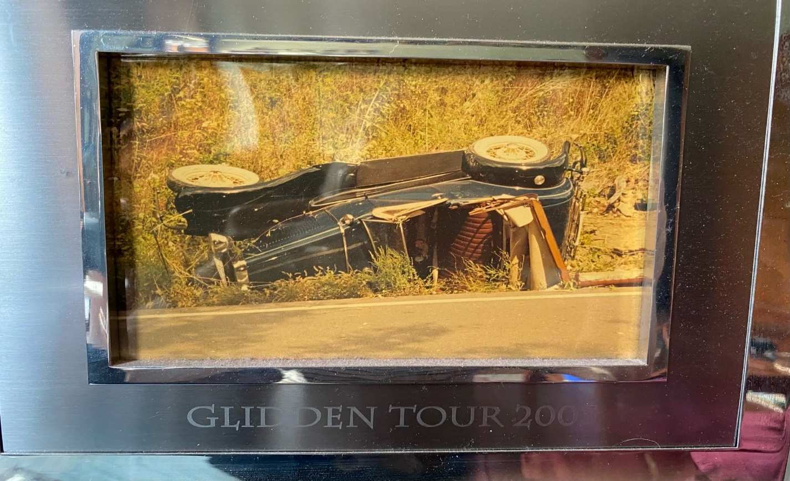

Andrew Poma

I’m from Irvington, New York. This 1912 Buick Model 28 is my tour car which I've owned for about 10 years since I purchased it in Stowe, Vermont. My Buick toured on the 1947 Glidden Tour as well as several others. My wife Marcia and I will be touring the Glidden this year in our proud Buick. Looking forward to saying hello.

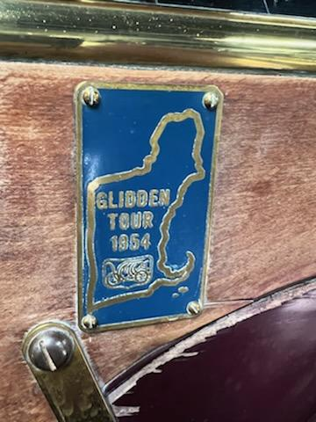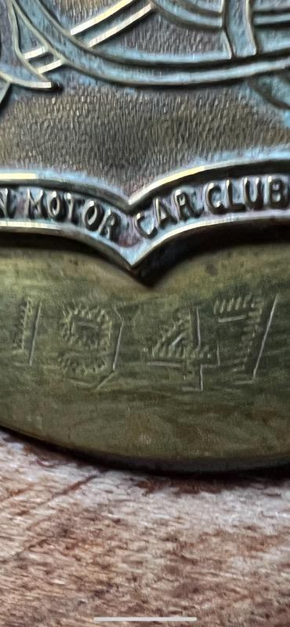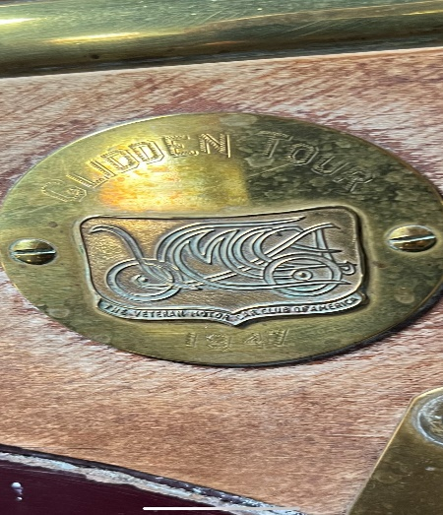
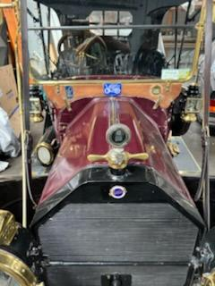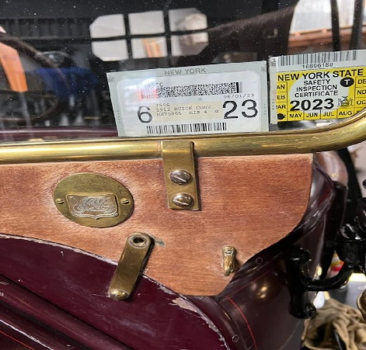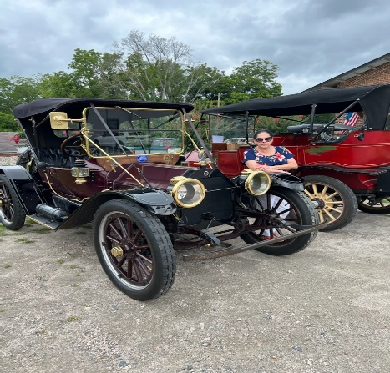

Bill Preston

My first Glidden was in 1995 in Pottstown Pa. I had worked like crazy all summer trying to get our newly restored 1931 Model A Cabriolet sorted out. At 9:30 Friday night sitting on the side of the road tweaking the carb I decided it was done. We got in it Saturday morning at 7, drove the 300 miles to Pottstown with my father-in-law following. His '34 Ford would be swapped out if the A died.

We got to the tour, had a great week, ran like a champ. Friday night at the banquet we received a beautiful lead crystal bowl for the best model A on tour! Got up Saturday, drove 300 miles home and never missed a beat. That was about 1100 miles on a fresh restoration and first-time travelers to our first Glidden!

Shirley Stauffer

Wait, what? You want me to go how far, in a car how old? Are you crazy? This was my reaction back in 2012 when my husband, Ron, started to pressure me to go to the 2012 Glidden Tour in Brenham, Texas. I knew it would be hot and I’m no spring chicken, and what if we had car trouble? He had an answer for everything! First, we wouldn’t have any problems because his trusty 40 Ford was running great, and he had his Leatherman, so if necessary, he could overhaul the engine on the side of the road. He also wanted to visit his friends Jimmy and Connie Carter from Tyler, Texas. I finally relented and the adventures began.

Louise, the 40 Ford, did well but that could be expected since it was riding on a trailer and we arrived after driving 1,000 plus miles. When we arrived, we were welcomed by a pair of lovely cowgirls waving flags on genuine Texas horses. It became a welcome sight that I watched for at each stop. We had a great performance by the Lone Star Cowgirls riding paint horses and carrying Texas flags. It was very patriotic. At registration we all received a white Stetson hat that made us all look like a bunch of good guys in old cars. We began with a tour of the George Bush Presidential Library and Museum located on the campus of Texas A & M University. I think I remember crossing “the Brazos” 14 times!

One day was to be a cowgirl’s day to drive. Of course, we started very early and the fog was as thick as pea soup. Ron’s reaction to this was “you aren’t driving in this” to which I replied, “watch me”. The fog didn’t lift until after we reached our morning coffee break stop and we only made a couple wrong turns, but arrived safely.

Another day, we were in the middle of nowhere, and stopped at a The Lazy Mule Saloon for a break, when Ron spotted a fellow participant with his hood up. He asked the driver, John, if he could help because he claims to be able to fix anything. After working for a good while, and getting advice from several other participants, they decided it was the fuel pump. Ron happened to have a spare one in his truck. He installed it and “problem solved”.
Since we were at a saloon, that called for refreshments. John asked me if I knew what the termite said when he went into the bar. I just gave him a blank look and he chuckled and said, I can't believe you don't know that. After letting a few more people in on it, he finally said "IS THE BARTENDER HERE". I just gave him another blank look and he had to explain it to me. (I think it was the heat).
Ron Stauffer Jimmy & Connie Carter
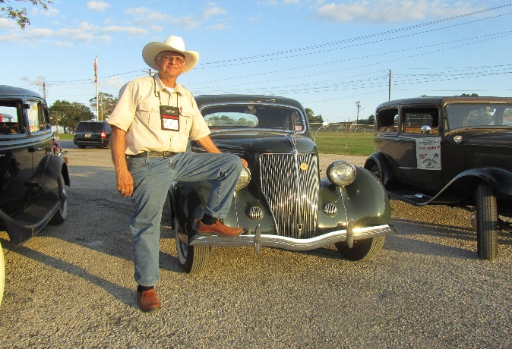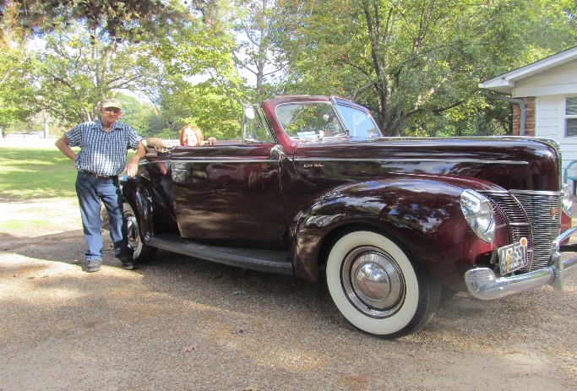

Charles Steffy

My very first AACA tour was the 2007 Glidden Tour in Gettysburg, PA. Having just retired (fortunate enough to retire early) in 2006 I was determined to see what touring was all about. My family has been members of our local Red Rose Antique Auto Club in Lancaster County, PA and over the years I had heard Red Rose members telling many tales of the fun they had on Glidden Tours. There was one small problem. At that time my only prewar car was the 1919 Buick touring that I inherited upon my father's passing. The car was certainly up to the challenge of a week-long tour but I knew that my body was not. Double clutching, minimal suspension and lack of basic comfort features made me decide to search for a better “user friendly” tour car.

My father was a Studebaker dealer in Lititz PA at the very end of Studebaker production. I had several Larks and we were very active in the local chapter of the Studebaker Drivers Club. Another Studebaker club member was Clair Rollman of Bareville, PA about twelve miles from my house. He owned a beautiful 1941 Studebaker Commander Skyway that had been in his family since 1947. He restored it in the early 1980s and it was an AACA Senior car. Alas, Clair succumbed to Alzheimer's and his daughter vowed to keep “Dad's Pride and Joy”. Three years later she had driven it once. Reality set in and it was time to sell the Studebaker. Clair's widow had heard through the grape vine that I was looking for a prewar car. She called me and said “Charlie, you need to buy that Studebaker!” They next night we met with the daughter and son in law and a deal was struck. New tires and a brake system overhaul and we were tour ready!

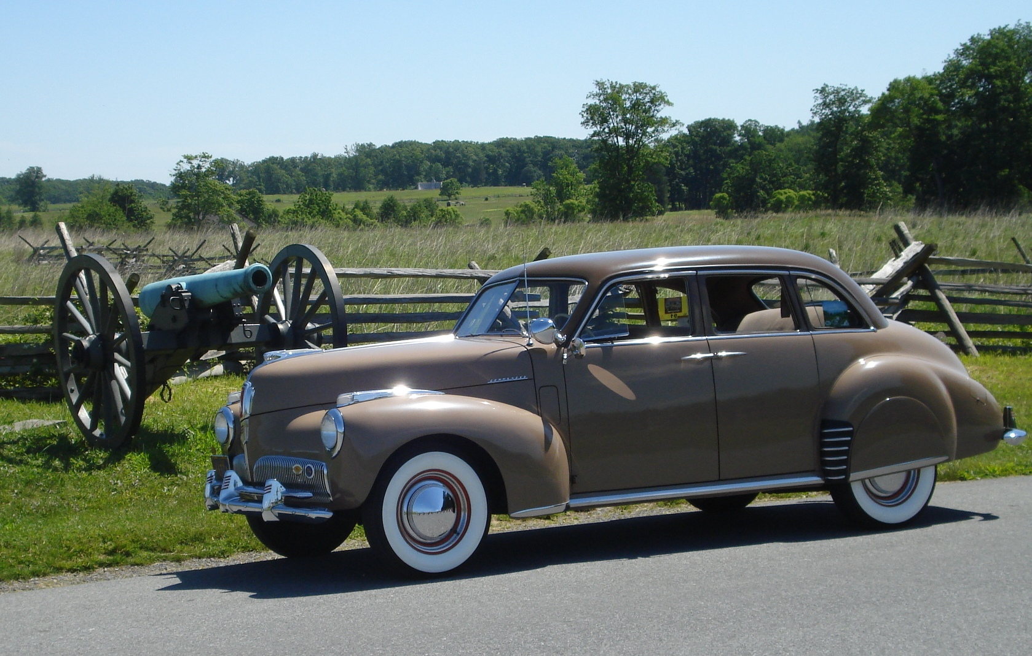
With the 2007 Glidden Tour being only 60 miles from home I thought now is the chance to experience touring. And I am so very glad I did! To see so many wonderful prewar cars out and about on winding back roads, to meet the owners and hear the stories of each car, and to see things that most people never get a chance to see made a big impression on me. They say you never forget your first and that is so true! Now, fifteen years and dozens of tours later I am still enjoying seeing different parts of the country in my trusty 1941 Studebaker Commander! Sad to say that some of my friends from prior tours are no longer with us, but on each tour, I meet new friends and we all look forward to more fun down the road! Below is a picture of our trusty 1941 Studebaker Commander touring the Gettysburg battlefield.

Shelah Turner

My husband Emery Turner and I have been on 30 Glidden Tours together. 2 years ago, my husband died on July 28, 2020. After he passed, I went to the tour in New York last year and am registered this year in New Jersey so this will be my 32nd Glidden Tour!

1991: Was our first tour. It was in the Laurel Highlands at Seven Springs, PA. There where a lot of Model “T”s on this tour and some of the women had to get out of the car and walk or help push the cars up the hills. When you went into the bathrooms the women were really complaining about the hills. We stayed at home and drove 1 hour to get to Glidden Tour and get our Model “A” parked the hotel. At this time, we didn’t have a trailer to haul our Model “A”.

1992: We used a tow bar to get our Model “A” to Lexington, KY, lots of horse farms and horses.

1993: We towed our car to Salisbury, MD. Ate lots of Maryland crabs!

1994: We had to buy a trailer to get to Kerrville, TX, while our son Scott and his wife Rachael flew to San Antonio and rode in our rumble seat. Lots of ranches and cows and we learned to eat Mexican food.

1995: We went to Reading, PA. Our first time to Valley Forge Park!

1996: The Anniversary Tour, we drove to Detroit. We started in Utica, NY and when we got to Erie, PA, the water was up to our running boards so had to find a new route to the hotel.

1997: The Glidden Tour was in Thomasville, Georgia. We wanted to bring two Model “A”s, so we had to make two trips to Georgia. Emery called Steve Gordon and asked him where we could leave our 30 Model “A” Tudor. Steve had us bring it to his home and put it in his garage. Our son Scott, our daughter-in-law Rachael, and grandson Jared were going to ride in it. When the tour was ready to go, Emery and I brought our Model “A” Roadster which we parked in the pecan grove where the hospitality room was located. Our grandson Jared was 1½ years old and he had a little bucket that he and I filled every day with pecans. Our grandson Jared graduated this May from Pharmacy School with a Doctorate in Pharmacy.

1998: Was our trip to Bretton Woods, NH. WOW! WE stayed at the hotel, the food was fantastic, and the music at dinner time was terrific! Emery said that he never saw blueberries that big. We then had a ride up the cable cars. It was very foggy, but when we got back to the hotel in the afternoon, it snowed,

1999: Tour to Virginia. It was a large tour with a lot to see and we drove the Blue Ridge Parkway!

2000: The tour was to Tuscan, Arizona. Was different, one of our dinners was in the air museum and we sat under the airplane wings to eat. We ate with Don and Doris Bluhm who was President of VMCCA at that time.

2001: Tour went to Mackinaw City. We took the boat over to the island and toured it and had a large buffet dinner on the island.

2002: Then we went to Daytona Beach where we drove our cars on the Daytona Beach Speedway.

2003: Next we went to Alabama to see how the cotton gin worked.

2004: We went to Branson, MO, the Music City. Eureka City was this neat city on a hill.

2005: Altona, PA, in our backyard. We were in charge of the Thursday Tour. We went to the Flight 93 Memorial, coal mine rescue 9 and for a boat ride.

2006: Rapid City, SD. Mt Rushmore was terrific, as was the train ride.

2007: Gettysburg, PA, the battlefields and President Eisenhower’s farm.
2008: La Crosse, WI and all of those Cranberries!

2009: Golden, CO, the Georgetown food train ride was nice.

2010: Holland, MI was a good trip, but we were to late for the tulips.

2011: Cumberland, MD train ride, and Frank Lloyd Wright house, Falling Water.

2012: Brenham, TX, rodeos, and Blue Bonnet Ice Cream!

2013: Chattanooga, TN, Trains, Rock City and Lookout Mountain.

2014: Defiance, OH, Nazareth Hall was a neat banquet hall.

2015: Oklahoma City, OK, Cowboy and Heritage Museums were neat.

2016: North Conway, NH, we went back to the hotel at Bretton Woods. It has really changed.

2017: Hastings, Nebraska, Indian show, cow pens, center of the U.S.

2018: Then to beautiful Idaho. The drive to get there was beautiful, mountains, we were up, then down into the valleys. We have always loved going out west. On this tour, our Model “A” broke down and came back to the hotel on the trouble truck.

2019: Rock Hill, SC. It was a good tour. It was the last tour the Emery was on.

2020: No tours due to Covid.

2021: Saratoga Springs, NY. It was a good tour. Hotel was old and had a spa. For me, this was a different tour as it was the first one without Emery. It was my 31st Glidden Tour. The hospitality room was dedicated to Emery. He loved music. He played his fiddle and sang his silly songs for a lot of Glidden Tours. He could pack a room full of people at the Glidden’s to entertain them.

2022: Pray you have a great tour. We still have both of our Model “A”s, the 30 Tudor and the 31 Model “A” Roadster that we always called Emery’s blue Model “A”. The “blue” was on 30 Glidden Tours.

