Upcoming Events at FPCYO
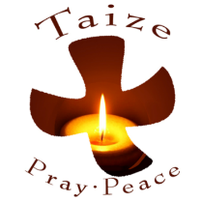
Taizé Worship Service
We will host a Taizé Worship Service on Thursday, March 27 at 7:05 p.m.
Taizé is meditative worship designed to bring all Christian denominations together. Song, silence, and scripture are entwined with the purpose of encouraging peace and reconciliation. Taizé is named for the small town in France where Roger Schütz founded this ecumenical monastic order in 1940. Worship includes Bible readings and texts set to simple tunes, which are then sung repetitively; the music is enhanced by instrumentalists and vocal solos. Attendees will find that Taizé is especially meaningful during Lent since its focus is prayer and introspection.
The sanctuary will lend itself to the beauty of this service as hundreds – yes hundreds – of lighted candles will offer illumination. The simplicity of the music makes it easy enough for all to sing while more experienced singers can fill in various harmonies.
We are inviting other area churches to join us, so please feel free to spread the news yourself and bring any guests with you. All are invited!
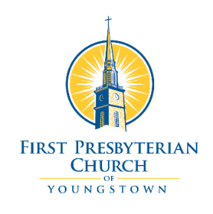

The Schaff Lecture
In partnership with Pittsburgh Theological Seminary, the annual Schaff Lecture will be held on Wednesday, April 23, 2025 at the First Presbyterian Church of Youngstown. We are excited to have Dr. Jennifer Carner, Director of the Preaching in a Post-Christian Age Initiative and Visiting Assistant Professor of Preaching, Pittsburgh Theological Seminary, as our lecturer.
The day will include a clergy workshop, dinner, and evening worship. Please register at https://www.pts.edu/schaff-2025. All fees will be collected at registration.
- 2:00 – 4:00 p.m. Clergy Workshop: The Enduring Power of the Folk Homiletic and Ethic in the Practice of African American Preaching (Registration required) Cost: $10 to cover supplies and materials for the event.
  - Abstract: Since the beginning of Trump's presidency 2.0, the administration has launched an assault on everything that does not support or affirm a monolithic vision of America. Thus, it can be argued that an attack has been launched on African American Thought, History, and Identity. Dr. Carner will make the case that current and past practices in African American preaching, incorporating a Folk Homiletic or Ethic, help communities in crisis fashion hope toward self-preservation and flourishing.
- 4:00 – 5:00 p.m. Light refreshments will be available in the parlor, music will be on offer in the sanctuary, and volunteers will be available to share information on the history of the church.
- 5:00 – 6:30 p.m. Dinner in the Helen Chapel. Seating is limited and registration is required. Meal options are Swiss Steak, Stuffed Chicken, and Eggplant Parmesan. The cost of dinner is $20.
- 6:30 – 8:00 p.m. Community Worship. All are welcome to attend. We are finalizing details on what participation may look like. If you or a group from your church is interested in helping lead or participating in worship, please contact Payne Warner at pastor@fpcyo.org.

Labyrinth at FPCYO
During Lent we will have a Labyrinth out in our Helen Chapel every Sunday through Tuesday when the Church is open (Su 9 a.m. – 1 p.m., M 7:30 a.m. – 4 p.m., and Tu 7:30 a.m. – 7:30 p.m.). It will also be available to walk all of Holy Week (Su 9 a.m. – 1 p.m., MWThF 7:30 a.m. – 4 p.m., Tu 7:30 – 7:30 p.m.). We ask that everyone wear socks (no bare feet and no shoes) to protect the canvas. We will have a basket of clean socks available in case you forget. There will be information about the labyrinth and directions for use available.

