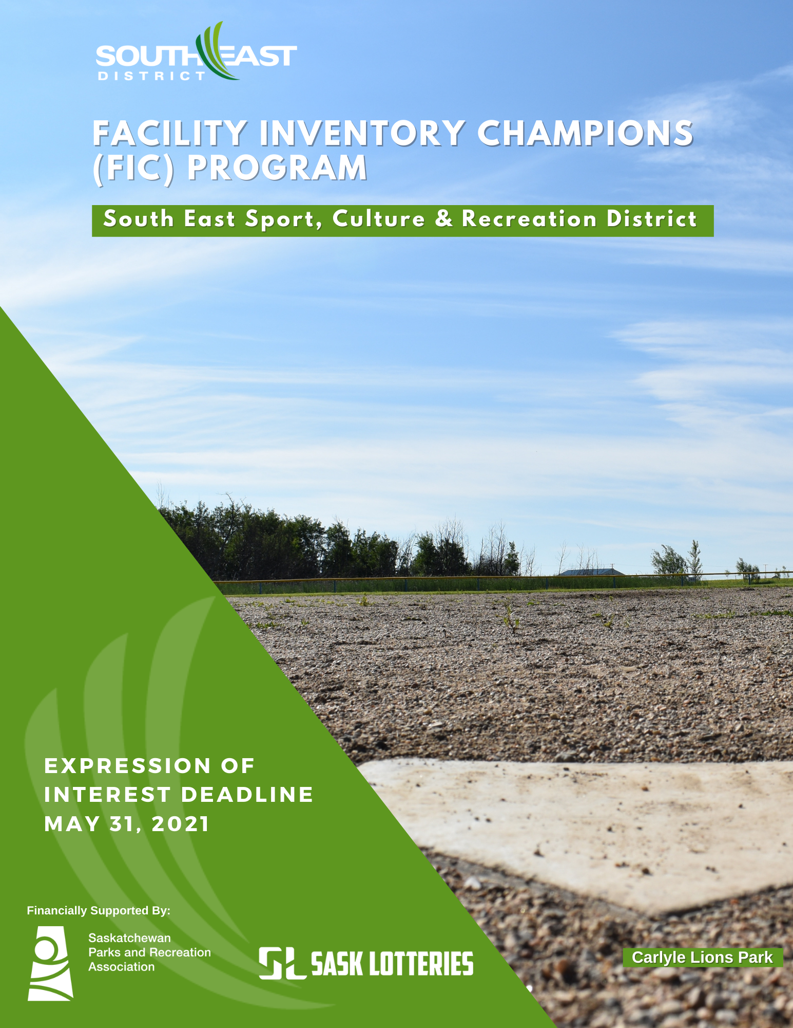

- PROGRAM OVERVIEW
The South East Sport, Culture & Recreation District is pleased to launch the Facility Inventory Champions (FIC) Program which supports small communities that have not traditionally engaged in asset management. Asset management is an important tool, as it helps communities maintain and operate infrastructure in the most effective way so critical services can be provided. This program builds capacity to do long-term planning for recreation infrastructure, so communities can identify priorities and needs and ensure that facilities remain viable and sustainable over the long term.

Recognizing that communities may only require short-term support, this program offers outreach and advisory services to build local capacity to engage in facility inventory activities (what the municipality owns and manages is documented). This is the first step in creating an asset management plan. South east communities have indicated one of the largest barriers to creating facility inventories is a shortage of staff and volunteers with the required knowledge and skills. The program aims to address this issue by creating Facility Inventory Champions.
What is Asset Management?
- Asset management is the way we manage the infrastructure we own. Municipal infrastructure is made up of the physical assets that exist to provide services to communities. Many communities have strategic plans to help guide their development and operations. A strong strategic plan includes components of asset management.
What is a Facility Inventory?
- The infrastructure that you own and manage is documented in a facility inventory, which is the first step to asset management. Inventories document key attributes of each asset including year of construction, type, expected useful life, structural information, building equipment model and serial numbers, photos of building components, and much more.

Recreation and cultural assets can include:
- Outdoor or Indoor Ice Arenas | - Museums
- Parks and Open Spaces | - Community Halls
- Sports Fields/Grounds | - Walking Trails/Community Gardens
- Swimming Pools | - Curling Rinks
- Tennis Courts | - Recreation Centre/Fitness Facility
- Playgrounds | - Golf Course

Why Apply?
*Aging recreation/cultural infrastructure is making it difficult to know what decisions to make for renewal, upgrades, operations, and replacement of facilities. Decision makers are not necessarily making informed decisions about infrastructure costs. Having a clearer picture of the current state of infrastructure can help south east communities make more informed decisions about facility operations, maintenance, and renewal.
*Time and financial resources are challenges to creating asset management plans. Communities simply do not have the tools or knowledge and are not creating these plans. This program helps the community to “kick-start” the asset management process!
- ELIGIBILITY
The following are eligible to apply for funding:
- An Urban or Rural Municipality
- First Nations or Tribal Councils
- Registered community not-for-profit organizations
*Applicants must be located in the south east district geographic area. Check with our office
(phone: 306.842.2188) if you are unsure of eligibility.

- SUPPORTS AND SERVICES
The FIC program offers support for communities interested in developing a Facility Inventory Champion. Education delivery, technical support, and funding will be available over a four-month period to build the community’s internal capacity to better manage their recreation and cultural assets.

South East District, in collaboration with Saskatchewan Parks & Recreation Association (SPRA), will support the successful applicants through the delivery of a four-step program where participants will:
- Learn the basics of asset management and facility inventories (3-hour webinar)
- Participate in a 90-minute online mentorship session to learn how to use the facility inventory tool and resources provided (this may include an additional on-site consultation or virtual meeting/facility tour (two hours) provided by either South East District or SPRA, depending on pandemic restrictions and provincial guidelines).
- Complete an inventory for a minimum of one (1) recreation/cultural facility in the community (i.e. ice arena, pool, hall, park space)
- Understand how to use the inventory tool for future planning and budgeting endeavours.
Participating communities can expect to invest 30-60 hours of total time over a four-month period to complete the program (JUNE 2021 – SEPTEMBER 2021).
Skills and Abilities of Facility Inventory Champions:
- Knowledge of or past experience in performing general labour, maintenance and repair activities on municipal recreational facilities and lands including, but not limited to rinks, playgrounds, sports fields, community centers and halls.
- Knowledge of operation of refrigeration equipment (arenas) and/or pool systems.
- Basic computer skills an asset.
Funding Assistance Available: Applicants will be eligible to receive up to a maximum $1,500 funding assistance to support the work and time of the Facility Inventory Champions (ineligible: permanent staff already employed). Funding shall be used to pay for the expense of a contract fee to conduct the facility inventory, assessment work and for training time.

The funding can also be used to cover the expense of the Champion to take the AM – SK Asset Management Saskatchewan “The Learning Path to Asset Management Readiness” Online Course (https://amsk.thinkific.com/users/checkout/auth).

- OUTCOMES
This pilot will help small communities introduce asset management initiatives into their operations. It will build the internal capacity needed to create facility inventories. The outcomes of the pilot project are to:
  - increase understanding of the importance of asset management with regard to recreation and culture assets.
  - enhance knowledge of local facility planning to make informed facility decisions.
  - provide increased access to resources to enable community to complete facility inventories/assessments.
  - establish a local approach for recreation facility inventories.
- HOW TO PARTICIPATE

1 – Submit the FIC Expression of Interest (EOI)
Communities must submit an EOI to notify the South East District of their interest in participating in the program. Deadline for the EOI is May 31, 2021. EOI’s will be screened by South East District to identify applicants best suited to participate in the program.
South East District will review the applicant’s justification of need and accept program participants on a case-by-case basis. Selection will be made on the perceived need for facility inventory support. Only typed submissions will be accepted. The EOI must include (maximum two (2) pages):
- Name of eligible applicant (Municipality, First Nations)
- Contact Details: Name, Address, Email and Phone
- Identify and describe the assets (facilities) that will be included (minimum of one (1) is required – example: pool and arena)
- Provide background context including the rationale for applying for facility inventory support and the need.
- Indicate if and how much funding you would like to apply for to cover the costs of a contract fee for the inventory work (maximum: $1,500).
- Describe your commitment to provide one or more Champions to participate in the program.

Note: Completion of the EOI does not secure a place as a program community.

2 – Letter of Commitment
Selected applicants will sign a Letter of Commitment (see Appendix 1) which outlines the responsibilities of program participants to engage in activities outlined below in sections 3-5. Upon signing a Letter of Commitment, applicants are formally admitted to the program.

3 – Participate in a Facility Inventory Tool Mentorship Session (online)
The Facility Inventory Champions will be provided with an inventory tool and resources that will enable them to conduct simple facility inventories of the identified buildings. The South East District and SPRA will meet online with each Champion to review these tools and information. This step equips participants with the knowledge of how to create a facility inventory. South East District will be available for questions by phone and email if clarity is needed or questions arise during the inventory process.

4 - Complete Asset Management Learning Activity (online webinar)
Facility Inventory Champions are introduced to asset management basics. The education material has been developed by the Saskatchewan Parks & Recreation Association (SPRA). More than one community may be invited to participate in these learning sessions at any one time. The schedule to be determined with each participating community.
*Note: A minimum of two participants from each community must attend the webinar (one participant must be the Champion).

5 - Conduct Inventory for each Asset/Facility Identified in the EOI
Champions will use the inventory tool and resources provided from the mentorship session to complete the inventory for each asset/facility identified in the EOI (i.e. rink, trail, hall, pool).

- EVALUATION
Program communities will be asked to help the South East District determine the extent to which the FIC program achieved the intended outcomes at the end of the program through completion of a final report form (including evidence of expenses) which is due prior to
October 1, 2021.

Facility Inventory Champions will also be asked to reflect on their participation in the program and provide testimonials for the South East District to use in reviewing and communicating the project’s impact. The findings from the project will help inform future asset management services. This work is funded by the Saskatchewan Lotteries Trust Fund.

- COMMITMENT
Participation offers communities the opportunity to learn more about how asset management can improve planning and decision-making. The South East District requires participants to be fully committed and dedicated to completing each step in the program. Active participation means that communities will dedicate a minimum of one individual/volunteer to the steps of the program over the 4-month schedule (JUNE - SEPTEMBER). Deadline for the completion of inventories and submission of the final report is October 1, 2021.

Each approved applicant will be required to complete a Letter of Commitment (see Appendix 1). This letter formalizes acceptance into the program and establishes the foundational working relationship between the South East District and communities. The Letter of Commitment clarifies the expectations of both parties in relation to the length of time commitment, confidentiality, learning event attendance and completion of the activities identified in this guidebook.

Program communities are responsible for all activities completed by their Facility Inventory Champions. The South East District nor any of its affiliates shall be liable to the community or to any other party for damages to property or injuries to persons caused by, or arising from, any activities associated with this program.

CONTACT US
Questions about this program may be directed to:

Joni Hagen, Executive Director
South East Sport, Culture & Recreation District
Email: ed@southeastdistrict.ca
Phone: 306.842.2188

APPENDIX 1. LETTER OF COMMITMENT (signed upon approval of pilot program)
This Letter of Commitment clarifies the working relationship between the South East Sport, Culture & Recreation District and the _______________________________________________(Community) and the formal acceptance of participation in the Facility Inventory Champions program beginning on ______________________and ending on ______________________.
The South East District commits to:
  - Delivering program supports for a 4-month period in a flexible format
  - Providing information and training to advance facility inventory skills
  - Explaining the purpose of the program and providing the support and encouragement needed to achieve the desired results
  - Assigning you a named staff-person who will provide you with regular support throughout the program
  - Receiving comments and feedback to improve the program
  - Recognizing your commitment in achieving the goals of the program
The Community commits to:
  - Appoint one (or more) individuals to be identified as a Facility Inventory Champion
  - Recognizing the Champion as a significant obligation
  - Committing to spend 30-60 hours to the program, at minimum, over a 4-month period
  - Fulfilling the 4-step program as outlined in the program guidebook
  - Coordinating with the South East District to meet program deliverables
  - Actively participate in all program activities and requests for assistance and feedback
  - Completing a final report form with evidence of expenses prior to October 1, 2021.
  - Responsible for all activities completed by their Facility Inventory Champions. The South East District nor any of its affiliates shall be liable to the community or to any other party for damages to property or injuries to persons caused by, or arising from, any activities associated with this program.
Acknowledgement
☐ I have read and fully agree to this Letter of Commitment and look forward to working with the South East District and advancing facility inventory efforts in our operations through a Facility Inventory Champion.

☐ Our appointed FIC (s) is identified below:
Name: Email: Phone:
Signature: signature indicates endorsement by the applicant organization/community.
______________________________________________________________________________
Name, Title and Date:

https://southeastconnection.sharepoint.com/operations/Capacity Building Programs/2021-22 Capacity Building/Facility Inventory Champions PILOT/FIC Guidebook 21-22.docx

