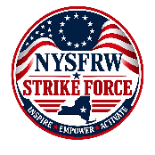
NYSFRW Strike Force

Please complete the following form to participate in the NYSFRW Strike Force. Or, you may complete this online at NYSFRW Strike Force Survey Form or copy and paste https://forms.gle/iMoM46owX667ZYBv8
For questions, please contact Trisha Turner at 585-261-0737 or by email to taturner2@yahoo.com

Full Name:

Address:

Phone Number:

Email Address

County in which you reside:

I am willing to make calls for my candidates: (Circle One):

Yes

No
I am willing to make calls for critical races outside of my district: (Circle One):
Yes
No
Please note questions or comments below:

