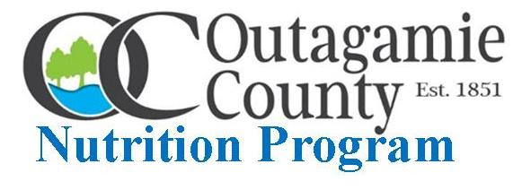
OUTAGAMIE COUNTY RESIDENTS 60 YEARS AND OLDER may order weekly Outagamie County Nutrition Program GRAB N GO MEALS by calling one of the meal site locations below and picking up meals during the designated “pick-up” timeline:
Appleton - Thompson Center on Lourdes 920-858-5619 11:30 AM - NOON Hortonville - Village Municipal Building 920-740-4648 10:00 - 10:30 AM
Kaukauna - Streets, Parks and Recreation Building 920-740-4641 10:30 - 11:00 AM
Seymour - Municipal Building 920-213-3490 10:30 - 11:00 AM
Please call in meal order by Monday 12:00 Noon before Wednesday meal “pick-up”.

January 6th January 27th
HAM AND MACARONI AUGRATIN SLOPPY JOE WITH WHEAT BUN
CHEF’S CHOICE ENTRÉE SCALLOPED POTATOES & HAM
TOMATO BASIL AND CHEF’S CHOICE SOUPS WHITE BEAN CHILI & CHEF’S CHOICE SOUPS
TOSSED CAESAR SALAD WINTER FRUIT SALAD
WHEAT DINNER ROLL WITH BUTTER AND PEANUT BUTTER PEANUT BUTTER BAR
FROSTED YELLOW CAKE MILK CARTON
MILK CARTON

January 13th
HOT SHREDDED BEEF WITH WHEAT BUN
BAKED ZITI WITH MEAT SAUCE
CHEESY BROCCOLI AND CHEF’S CHOICE SOUPS
PINEAPPLE AND MANDARIN ORANGES
CHOCOLATE APPLESAUCE CAKE
MILK CARTON ● CANTEEN provides Nutrition Program GRAB N GO Meals

January 20th
TERIYAKI CHICKEN OVER FRIED RICE
BREAKFAST CASSEROLE
BAKED POTATO AND CHEF’S CHOICE SOUPS
TOSSED SALAD WITH DRESSING
WHEAT DINNER ROLL WITH BUTTER AND PEANUT BUTTER
COOKIE
MILK CARTON

The Outagamie County Nutrition Program is closely monitoring meal service to insure participant, volunteer, staff and food safety during the COVID-19 pandemic and will continue to address food insecurity and malnutrition among Outagamie County older residents.

Remain Healthy and Happy New Year

