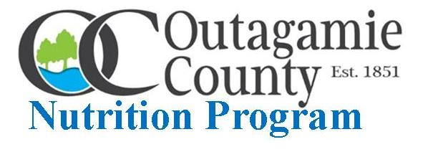
OUTAGAMIE COUNTY RESIDENTS 60 YEARS AND OLDER may order weekly Outagamie County Nutrition Program GRAB N GO MEALS by calling one of the meal site locations below and picking up meals during the designated “pick-up” timeline:
Appleton - Thompson Center on Lourdes 920-858-5619 11:30 AM - NOON Hortonville - Village Municipal Building 920-740-4648 10:00 - 10:30 AM
Kaukauna - Streets, Parks and Recreation Building 920-740-4641 10:30 - 11:00 AM
Seymour - Municipal Building 920-213-3490 10:30 - 11:00 AM
Please call in meal order by Monday 12:00 Noon before Wednesday meal “pick-up”.

February 3rd February 24th
HEARTY TURKEY ALA KING SLOPPY JOE
CHEF’S CHOICE ENTREE HOMEMADE MAC & CHEESE
VEGETABLE BEEF BARLEY & CHEF’S CHOICE SOUPS STUFFED BAKED POTATO & CHEF’S CHOICE SOUP
TOSSED CAESAR SALAD WINTER FRUIT SALAD
WHEAT DINNER ROLL WITH BUTTER & PEANUT BUTTER CINNAMON ALMOND COFFEE CAKE
BANANA CAKE MILK CARTON
MILK CARTON WHEAT BUN FOR SLOPPY JOE

February 10th
HOT SHREDDED TURKEY
MACARONI, TOMATO & BEEF CASSEROLE
CHEESY BROCCOLI & CHEF’S CHOICE SOUPS
PINEAPPLE & MANDARIN ORANGES
WHEAT BUN FOR HOT TURKEY SANDWICH
FROSTED CHOCOLATE CAKE
MILK CARTON
● CANTEEN provides Nutrition Program GRAB N GO Meals
February 17th
CHICKEN POT PIE OVER BISCUIT
HAM & MACARONI AUGRATIN
TOMATO BASIL & CHEF’S CHOICE SOUPS
TOSSED SALAD WITH DRESSING
PARKERHOUSE ROLL WITH BUTTER & PEANUT BUTTER
COOKIE
MILK CARTON
The Outagamie County Nutrition Program is closely monitoring meal service to insure participant, volunteer, staff and food safety during the COVID-19 pandemic and will continue to address food insecurity and malnutrition among Outagamie County older residents.

Thank You and Be Well!

