Peachtree Hills Place Neighbors—

Join the Peachtree Hills Civic Association for some

Sunday, December 5th
5:30-8:30pm
The Georgian Ballroom at PHP
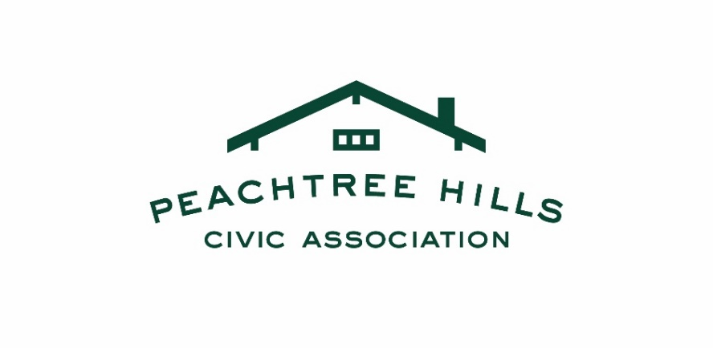
$10 suggested donation for non-members/FREE for members

The Peachtree Hills Civic Association (PHCA) is a neighborhood association with a volunteer Board that works to make Peachtree Hills a safe, fun, welcoming place to live. PHCA has been an active force in maintaining the neighborhood’s desirability, safety, and sense of community. We met a few of you at our recent Octoberfest which was held on the 17th at King’s Circle.
This past year we were responsible for both new entrances signs to the neighborhood as well as new street topper signs. Now that we are transitioning out of the pandemic, we intend to again host many neighborhood events that we hope you’ll attend.

Security is a significant focus of our association. About 80% of our annual dues go directly to our Peachtree Hills Security Patrol. It is made up of three off-duty Atlanta Police officers who patrol our streets 40-45 hours per week. We just added more hours in the evenings to give more presence during the recent spike in crime.

This program is funded solely by neighbors through the PHCA. We depend on our membership to keep it going. We need you! At $200 per year ($170 for those over 65), it’s the best deal in town!

Checks payable to PHCA will work as well. You can drop a check by, or address it to: Justin Williams, Treasurer, 2184 Willow Drive NE. If you have any questions, or issues with the online registration, please contact Betty Hanacek, Membership Co-Chair at bhanacek@bellsouth.net, 404-734-3821.

Please join your neighbors, support your association, and sign up today!
www.peachtreehils.org

