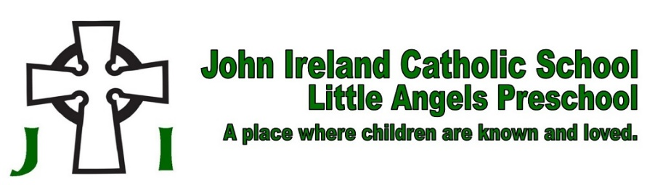
September 22, 2021

Dear Friends of John Ireland,

An amazing $750,000 opportunity has been presented to Catholic schools across the Diocese of New Ulm! Richard Schulze, founder and chairman emeritus of Best Buy Co., Inc., and his foundation, the Schulze Family Foundation, has offered the Diocese of New Ulm a “Challenge Matching Grant” to assist our 13 elementary Catholic schools in enhancing educational excellence as well as growing enrollment.

John Ireland School is excited to report that we have been offered a $25,000 matching grant from the Schulze Family Foundation.

Here’s how it works.
Each Catholic elementary school in the diocese is challenged to raise $25,000. Schools that meet this Challenge would, in return, receive from the Schulze Family Foundation $25,000, which totals $50,000 back to the school.

The diocesan Office of Catholic Schools is being challenged to raise $50,000. If successful, the Schulze Family Foundation will match the $50,000 for a total of $100,000.

This means, combined, Catholic schools in the diocese will receive $750,000 when both the diocese and the 13 Catholic schools meet their Challenge goal!

Matching Grant Guidelines.
Donors to the Challenge Matching Grant must be
- A “new donor” (one who has not financially supported a Catholic school in the diocese)
or
- A previous donor whose donation “exceeds” their largest previous donation to a Catholic school.

Deadline.
- The goal deadline for raising the $25,000 for John Ireland School is set for December 15, 2021.
- All donations must be collected by this date to meet the requirements for the match.

As administrators of Catholic Schools for the Diocese of New Ulm, we already know the incredible things our schools do every day when it comes to Catholic education. But, we are also dreaming about the tremendous opportunities that can happen with an additional $25,000 here at our school.

How will we use the money?
If John Ireland School is successful in its Challenge, the money will be used for:

Part Time Marketing and Development Position
build database, increase social media, reach out to alumni more regularly
Develop 3 Rs Program for Staff
Recruit, Retain, and Reward quality staff as we work on increasing sustainable salaries
Middle School Expansion
add to current funds to offer grades 7-8 at JI
including staff, curriculum and materials, equipment, and modification to current rooms

We are proud of the great tradition of Catholic education here at John Ireland School. This is a place where successful adults and strong leaders are formed. Our schools provide a place where children learn about the value and beauty of the Catholic faith and develop the academic skills to help put them on a trajectory of success. We instill strong values in students and develop hearts committed to faith and service. We are hoping you will partner with us in this worthy mission.

May God bless you for your generosity, and may He help us at John Ireland School continue to provide our children with the outstanding education and faith enrichment they deserve.

In Christ,

Father Craig Timmerman
Ms. Colleen Wenner

