Title: Ethan’s Toys
Description: Ethan’s Toys started 10 years ago with one dad making wooden African wild animals for his 4 year old son. Today 14 year old Ethan carries on the tradition and has engaged his classmates to help in a “Santa’s Worshop” to recreate his childhood and give the toys away to underprivileged children who receive services from Gardner Family Care Corporation in San Jose.

Ethan’s Toys by Dr. Daryn Reicherter,
When my son, Ethan, was very young, I made him toys out of wood. I cut pine with a jigsaw to make African wild animal shapes and I painted them vibrant colors. He loved them and played with them often. He could pretend that he was in on the savanna of Kenya with lions and elephants and zebras. We called them, for obvious reasons, “Ethan’s toys.”
In 2007, Gardner Family Care Company (GFCC) used the Ethan’s Toys idea to make many sets of the animal toys for a Christmas giveaway for financially disadvantaged families. The kids form the GFCC community received gift toys and then they could pretend they were on the savanna of Kenya with lions and elephants and zebras.
Ten years later, Ethan (age 14) said he wanted to try to do a holiday gift giveaway. He said, “When I was two- years- old my dad made me Ethan’s Toys. I really enjoyed playing with them when I was younger. Now I am 14 years old and I want to be able to give back and share these same toys with the kids from the GFCC community. The kids who don’t get as many Christmas presents as I got to have. So we thought it would be nice to bring back the project back to Gardener, 10 years later. I hope that we can produce more toys than before so more kids can have a nice Christmas present. This is our way of sharing our Ethan’s toys with the families of Gardener. I would like to continue this tradition of giving out my toys to the kids, hopefully reaching more and more every year. ”
So we pitched doing the Ethan’s Toys holiday giveaway to GFCC managers, Miguel Valencia and Ann Lilia De Leon. And GFCC is going to do the Ethan’s Toys Holiday Giveaway again, ten years after the first project. We have the old motifs of animals and have even made a few new additions for the tenth anniversary of the initial giveaway.
In the community partnership spirit of GFCC’s, we are working with local high schools’ woodshop programs to cut the many motifs into animal shapes out of pine-wood. GFCC will sand the toy shapes into a “proto-toy.” Then, in the spirit of the holidays, GFCC staff and interested clients, in creative participation, will paint the shapes into the wild animals that will become the beloved toys of children. We intend to turn GFCC and our partners into a “Santa’s workshop,” building as many toy sets as possible between now and the holiday giveaway time.
GFCC staff and clients may participate in the workshop. It is therapeutic to give. The Ethan’s Toys Project allows for people in all parts of collaboration with the GFCC mission to contribute to something fun and creative in the making of the toys. And the present distribution will allow another group of kids have gifts for the holidays that will allow their imaginations to grow. Then they too can pretend they were on the savanna of Kenya with lions and elephants and zebras.
The toy giveaway will take place in December.

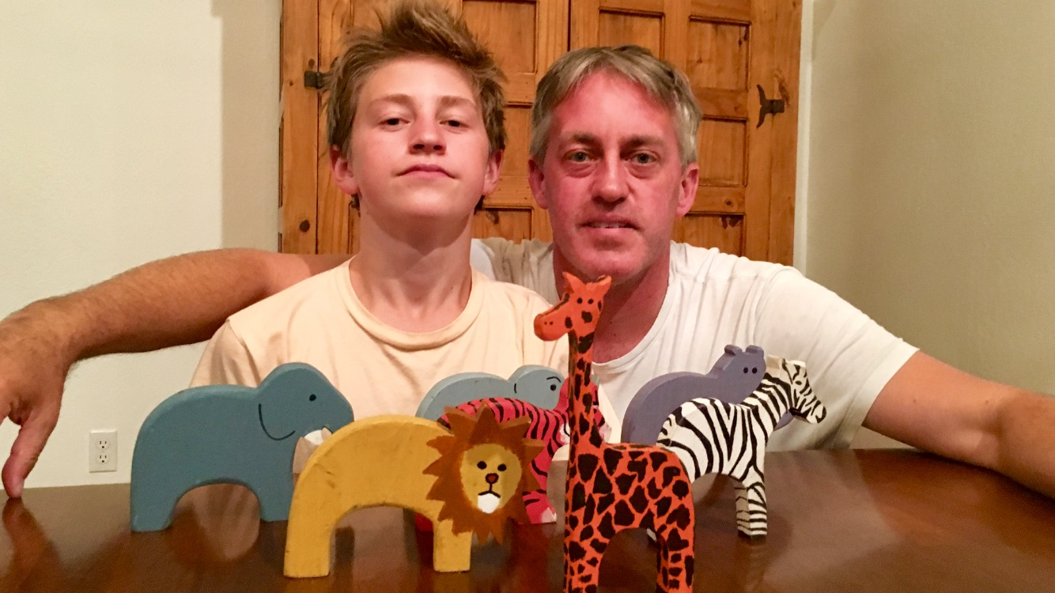
Ethan Reicherter and Daryn Reicherter, M.D. (GFCC Psychiatrist) with “Ethan’s Toys”

