SKINNER WEST CLASSICAL, FINE ARTS & TECHNOLOGY SCHOOL
LOCAL SCHOOL COUNCIL MEETING
January 19, 2021
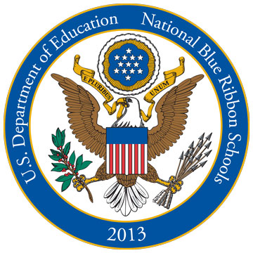
ABBREVIATED PRINCIPAL’S REPORT

VISION: The Mark T. Skinner School’s vision is to be the premier elementary School in metropolitan Chicago for educating special children (Special Education, Classical, and Neighborhood), and to serve as the outstanding model for all such schools.

LRE MANDATE: LRE requires that to the maximum extent appropriate students with disabilities, including students in public or private institutions or other care facilities are educated with students who are non-disabled.

- Thank You- Condolences, kind thoughts, prayers and generosity during my bereavement for the passing of my husband, Nathan Clark

- Congratulations- New LSC Members
  - Parents: Aisha Crump, Fadi Matalka, Matthew Letourneau, Melinda Sgariglia Young, Brett Hughes, Nellie Strong
  - Community: Marla Sedler, Stephanie Majca
  - Teachers: Ramel Werner, Ryan Johnson
  - Non-Teaching Staff: Sheila Howard
We thank all Parent and Community candidates who ran and were willing to serve on Skinner’s LSC.

- Happy Holidays from CNA- Thank you to CNA for their generous check to the school for $10,000.

- We Welcome A Pre-K students & 1 Special Ed Cluster student last week for in person learning.

- NWEA Testing- We tested approx. 190 Superstars for NWEA testing in reading and math in preparation for Selective Enrollment & Academic Center Admissions.

- Hybrid Reopening- We are finalizing plans for re-opening for hybrid learning. Teachers return in person on January 25. Hybrid students on February 1st. Over 570 students have signed up for hybrid learning.

- Parent Informational Virtual Meetings for Hybrid Learning
  - Wed- Jan 27 6:00-6:45 for Kindergarten
  - Thurs- Jan 28 5:30-6:30 1st-4th
  - Thurs- Jan 28 6:30-7:30 5-8
Powerpoint will be sent home to Hybrid families on Tues. Jan 26th , before the informational meetings.

