SKINNER WEST CLASSICAL, FINE ARTS & TECHNOLOGY SCHOOL
LOCAL SCHOOL COUNCIL MEETING
April 13, 2021
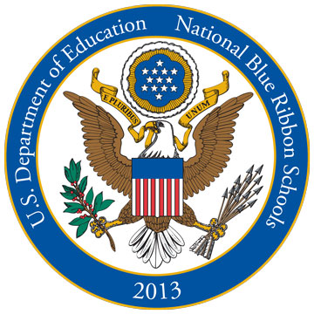
ABBREVIATED PRINCIPAL’S REPORT

VISION: The Mark T. Skinner School’s vision is to be the premier elementary School in metropolitan Chicago for educating special children (Special Education, Classical, and Neighborhood), and to serve as the outstanding model for all such schools.

LRE MANDATE: LRE requires that to the maximum extent appropriate students with disabilities, including students in public or private institutions or other care facilities are educated with students who are non-disabled.

- SCHOOL ACTIVITIES
- Expansion Committee Meeting
- Spring Break
- School Improvement Committee Meeting
- Professional Development
- Parent Sign-Up for 4th Quarter Hybrid Learning
- CPS Weekly Covid Testing for Staff

- PERSONNEL
A. We Welcome: We welcome out new miscellaneous employees- Ms. Karla Jones & Mr. Krage Hervey
B. Retirement: We say goodbye to Jackie Garner, our special education classroom assistant & transportation coordinator for over 29 years of service to Skinner!
C. We Welcome the Return of Skinner Staff:
- Ms. Milroy- Science Teacher
- Ms. Wilhelmina Taylor- Special Ed Classroom Assistant
- Ms. Chen- Mandarin
- Ms. Nancy Nunez- Bilingual Classroom Assistant

- ASSESSMENT SCHEDULE
- IAR Illinois Assessment of Readiness: April 21-May 28 Grades 3-8
- Illinois Science Assessment: Grades 5th-8th April 21-June 11th
- Access Testing for English Learners April 5th-May25th

- Informational Parent Meetings for New Quarter 4 Hybrid Students
  - Kindergarten- Wednesday, April 14th @ 6pm
  - Grades 1-4 – Thursday, April 15th @ 5pm
  - Grades 5-8- Thursday, April 15th @ 6:30pm

- Quarter 4 Hybrid Enrollment- 702 Students!

- Upcoming Dates
  - Friday April 16- Professional Development Day- NO SCHOOL FOR STUDENTS
  - Monday, April 19- Quarter 4 Hybrid Begins
  - Wednesday, April 21- Parent Conference Report Card Pick up Day- NO SCHOOL FOR STUDENTS
  - Thursday, April 29- 8th Grade Graduation Pictures
  - Friday, April 30- Last day for parents to complete “My Voice My School Survey”- Opportunity for parents to share feedback about their school and CPS. Survey link can be found in our enewsletter

