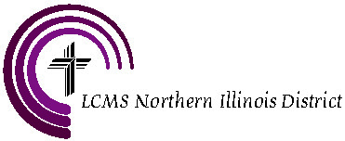

NORTHERN ILLINOIS DISTRICT INVOICE
2301 South Wolf Road
Hillside, Illinois 60162-2298

Due Date: April 15, 2019

For School Year 2018-19

DESCRIPTION | AMOUNT
National Lutheran School Accreditation Fee – Northern Illinois District | $ 125.⁰⁰
TOTAL | $ 125.⁰⁰

Make checks payable to:
The Northern Illinois District

Mail to:
Northern Illinois District, LCMS

2301 South Wolf Road

Hillside, IL 60162

If you have any questions concerning this invoice, contact:
Keith Wilharm, NLSA Consultant
Northern Illinois District, LC-MS
630.279.5979
Keith.Wilharm@nidlcms.org

