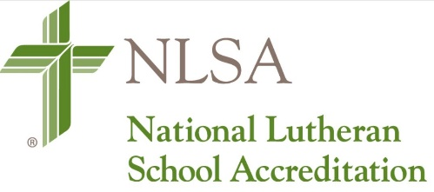

NLSA Reminders
For Schools Receiving Pandemic 2.0 Extension in 2020-21
Note: If you plan on requesting a pandemic extension, but have not yet done so, please apply immediately. Although the deadline isn’t until March 1, 2021, it would be extremely helpful for scheduling purposes to apply now. Contact Keith Wilharm for assistance.

Schools receiving the NLSA Pandemic 2.0 Pandemic Extension are reminded of the following:

- Cumulative Annual Reports are still due April 15, 2021. We realize there will likely be little progress to report, but note what you can. Reports must be on file for continued accreditation.
- Fees must still be paid. The 2020-21 Northern Illinois District Annual Fee ($125, payable to The LCMS Northern Illinois District) is due April 15, 2021. The 2021-22 NLSA Annual Fee ($650 payable to NLSA – LCMS) is due October 1, 2021. You will receive an invoice for each of these fees.
- Do as much work on your Self-study Report as you can handle. Update the parts that need updating: Faculty information, schedules, General Information Section, etc. I’m hoping that schools that have been granted two pandemic extension will be able to host their visits in fall. We currently have 19 schools that will need to host visits next school year.
- Begin rescheduling your visits for 2021-22. E-mail Keith Wilharm to do so (Keith.Wilharm@nidlcms.org).

Keith Wilharm
NLSA Coordinator
LCMS Northern Illinois District
847-529-8614 (Mobile)
630-279-5979 (Home Office)

