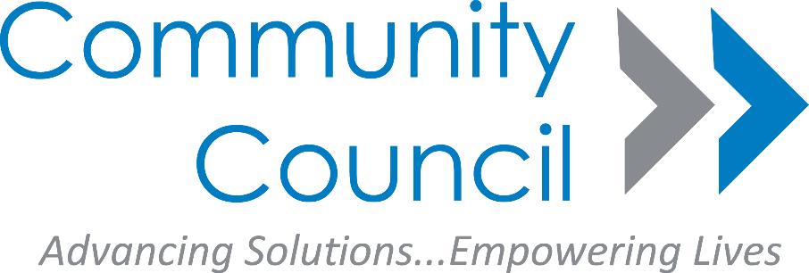

**2018 Benefits Counseling Training Dates:**

**July 19-20, 2018 Medicaid**

**October 4-5, 2018 Medicare/Medicaid**

**9:00AM – 5:00PM**

***\*\*\*Fee: $50.00 (Seniors 60+ Free)\*\*\****

**Submit payment to:**

**Dallas Area Agency on Aging/Benefits Counseling Trainings**

**Attn: Carolyn Toliver**

**1341 W. Mockingbird Ln, Ste. 1000W, Dallas, TX 75247**

The Dallas Area Agency on Aging is a project of the Community Council, sponsored in part by the Health and Human Services Commission

**Location:**

**Meadows Conference Center**

**2900 Live Oak**

**Dallas, TX 75204**

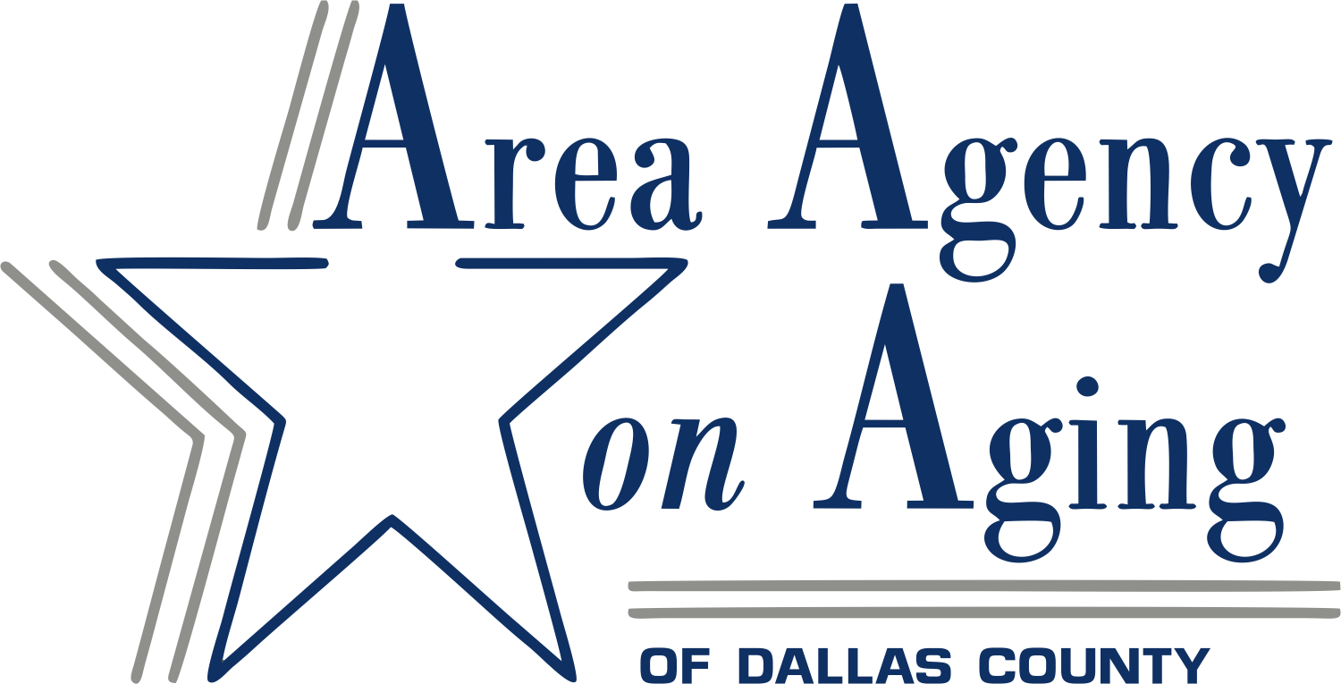

**Benefits Counseling Trainings**

* ***Medicare***
* ***Medicaid***
* ***Social Security***

***Social Work CEU’s 1.00***

**RSVP to Corina Castro**

**214-954-4220 or**

**ccastro@ccadvance.org**