

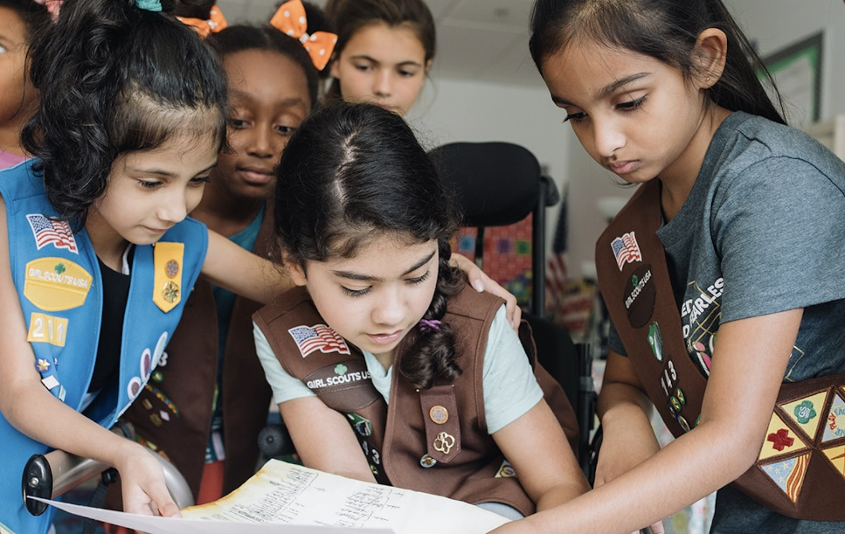
GS
You’re Invited to have fun and make new friends!
Girls K-3 will interact with each other and Girl Scout Staff as they enjoy dancing, crafts, games that encourage creativity and logic, and laughter.
For Unicorn Party dates and registration,
visit: https://bit.ly/32wlonE

For Games for Girls dates and registration,
visit: https://bit.ly/3pu0wr8
Experience an Event.
Start a Troop.
The best way to guarantee your girl finds a troop is by starting your own! We can help you rally together a group of girls based on grade level, location, and school, who are interested in becoming Girl Scouts! Want to Learn More?
Email Cricket.hawkins@gscolorado.org
For more information:
Cricket Hawkins cricket.hawkins@gscolorado.org 970-379-9059 ww.girloutsofcolorado.org/join
Our Badge Series and Fall Clubs are exciting, new virtual ways to engage girls across all age levels. Our Badge Series engages girls in badges and Journeys, translating our traditional Girl Scout program to be accessible virtually and at home. Our Fall Clubs allow girls to enjoy engaging with other girls in a creative environment. Each session, girls will complete an activity and receive ideas to continue to spark their creativity and learning in between sessions.
Questions about our Badge Series or Fall Clubs?
Email GirlExperience@gscolorado.org or visit http://bit.ly/GSCOVirtual
Join a Badge Series or Fall Clubs.
Whether you’re ready to dive in, or looking for a little extra help getting started, Girl Scouts has lots of ways to join the fun!
Begin your Girl Scout adventure today!

