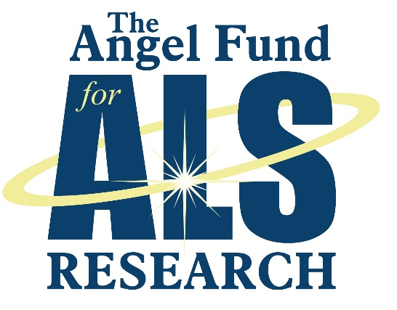

Research Update
Robert H. Brown, Jr., D.Phil., M.D.
UMass Chan Medical School

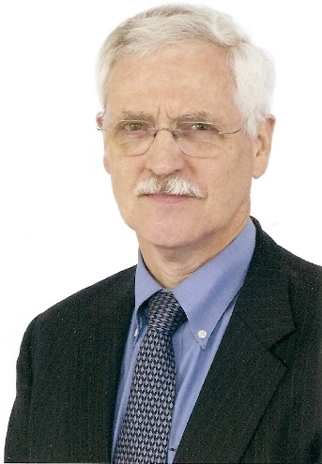
Gene Discovery. A major research goal in our laboratory has been to identify genes whose mutations can trigger ALS. The central premise is that these either are themselves direct targets of therapy or that understanding the genes will define treatable pathways that lead to motor neuron death both in familial and sporadic ALS. The Angel Fund support has been central in our gene discovery program. The
following genes have been identified in the program, combining the investigations of the Brown, Landers, and Bosco laboratories: FUS, profilin-1, TBK1, Tubulin A4A, ERB4, CCNF, NEK1. As well, Bob Brown and John Landers have been members of large consortia that have identified other genes. Three points must be emphasized here. First, John Landers has been an international leader in establishing these consortia and in gene discovery. Second, in the early phases of this program, the Angel Fund was pivotal in purchasing a large robot to accelerate fluid handling for this project, a technology that greatly accelerated the work. And third, Dr. Bosco’s work on the fundamental biology of these mutant genes has been widely acknowledged by ALS teams world-wide.

Gene Suppression. For most of the genes discovered thus far in ALS, the mutations endow the gene
with toxic properties. A major effort of our laboratory has been to identify and implement approaches
to detoxifying these genes. Such studies typically start in petri dishes and mouse models and then, if
appropriate, move to larger animal studies and human trials (in three instances so far). These are multiyear
therapy development programs that require long-term commitment and resources, particularly in
costly, late-phase animal studies. The Angel Fund has been extremely important in such programs.

SOD1. We have developed an approach to suppression mutant SOD1 toxicity using a virus to deliver
a microRNA to the brain and spinal cord. This proved very effective in mice and monkeys and showed
promising pilot results in two patients. In conjunction with Anastasia Khvorova at UMass Chan Medical
School, we have been studying a new type of gene suppression reagent (a “disiRNA”) that shows
unusual potency in suppressing SOD1 in mice.

C9orf72 (UMassChan) Another central activity has been the development of anti-sense
oligonucleotides (ASO) to silence toxicity of the C9orf72 gene, the most commonly mutated ALS gene.
The generosity of the Angel Fund has been the cornerstone of this program. Over the last five years,
working closely with Jonathan Watts, we have moved this therapy from preclinical studies, to monkey
toxicity testing, and to one human. We are preparing now to treat ~15 more C9orf72 ALS people with
this same therapy.

C9orf72 (Wave Lifesciences). We were also privileged to perform pre-clinical work on a new type of
ASO to suppress C9orf72 developed by the company Wave Lifesciences.

FUS. In collaboration with both Jonathan Watts and Neil Shneider, MD, PhD, at Columbia, we have
also developed ASOs to suppress a mutant form of the FUS gene, which triggers very aggressive ALS,
even in children. We intend to move our new anti-FUS ASOs into more efficacy and toxicity trials. If
these are promising we will then progress to human trials,

Animal models. In preclinical development of therapies, it is enormously helpful to have mouse models
for early testing of reagents. We have developed three mouse models for this purpose: a model of
C9orf72 in mice, which recreates the molecular events in humans with C9orf72 ALS but not motor
neuron death. This was all-important in the work leading to the human trial. We have also generated
new models of SOD1 ALS in mice (in which the mutations are put in the mouse’s own SOD1 gene) and a
model of mutations in the TDP43 gene.

Biomarkers. In any disease, it is important to have tests in blood or spinal fluid that indicate the level of
disease activity (such as blood tests used for diagnosing heart attacks). Such biomarkers have been
difficult to develop in ALS. For more than a decade we have focused on a new biomarker: a quantitative
measure of how well motor neurons carry a protein (TTC, a non-toxic derivative of tetanus toxin) from
muscle back to the motor neuron (using retrograde axonal transport). Working with an exceptional
graduate student, Justin Lee, we have just published this assay and shown that, in mice, it is a sensitive
measure of a positive response to a treatment, well before standard tests. We are hopeful that we can
move this toward tests in humans with ALS.

Drug discovery. Prior to our studies of microRNA and ASO to suppress ALS genes, we conducted
searches for drugs that might be beneficial in ALS. One program, conducted jointly with Dr. Robert
Langer at MIT and a graduate student, Seth Townsend, studied nanoparticles for delivery to motor
neurons. Other programs investigated small molecules using high throughput drug screening. These
programs reflected the excellent work of three post-doctoral fellows from the U.K.: Paul Wright, Wendy
Broom, and Carsten Russ.

Stem cells therapies. We have had two broad lines of investigation of stem cell therapy in ALS. First, we
initially probed in our mouse models the use of two types of stem cells (umbilical cord cells, fetal pig
cells), in a program that was possible through the expert surgical technique of a then neurosurgery
resident, Dr. Steven Kalkanis. Second, we have collaborated closely with the Israeli company Brainstorm
to test use of a patients’ own stem cells (from bone marrow) in ALS. In two multi-center human studies
we have seen benefit in terms of improved disease markers in the spinal fluid without a robust clinical
benefit so far (but some very positive anecdotal results from some patients). The company is
considering the next steps in this program.

Mouse drug tests. For the last 20 years, we have pursued many tests of possible therapies in ALS mice.
These studies have benefitted from Angel Fund support of mouse costs and the expense of hiring
mouse technicians. Studies have been performed using classical drugs (arimoclomol, combination antioxidants,
glutathione, BMP-7, mexiletine, procysteine, diethylthiocarbamate, bFGF, penicillamine,
selenium, neurophilins) as well as genetic manipulations and gene-targeting therapies (e.g., gene
suppression as above; suppression of APOE; elimination of sarm1; knock-out of the eNOS gene; caspase
1 inactivation).

Other approaches to ALS biology: Single cell transcriptome analysis. We have been fortunate in the
last 3-4 years to collaborate with Paul Greer, PhD, in the Department of Molecular Medicine to use a
new technique to look at the genes that are expressed in different cell types in ALS mice , as compared
to normal mice. The patterns of differential gene expression as the disease evolves are providing
insight into molecular pathology in ALS. We have already determined that a family of genes that Dr.
Greer studies, the Ms4a genes, are abnormally activated in mouse ALS. This is intriguing, as the same
genes are hyperactive in Alzheimer disease. This project involves two astute graduate students.

Chromosome folding in C9orf72 ALS. For seven years, we have been equally fortunate to collaborate
with Job Dekker, PhD, in Systems Biology to study how large DNA disturbances, such as those caused by
the C9orf72 mutations, may affect properties of whole chromosomes in C9orf72 ALS. Again, this project
has been spear-headed by an exceptional graduate student.

Major Equipment. The generosity of the Angel Fund has extended to purchasing two very expensive
but pivotal equipment items: the fluid handling robot mentioned above and a microscope that permits
use of a laser to cut single cells out of tissue slides, thereby permitting single cell analysis from such
slides.

Publications. It has been our pleasure to acknowledge the funding from the Angel Fund in multiple
publications from our laboratory.

All of us on the UMassChan Medical School ALS team are profoundly grateful to the Angel Fund; we
deeply appreciate the opportunity to work closely with the Angel Fund as we extend research in pursuit
of ALS treatments .

Respectfully submitted,
Robert H. Brown, Jr., D.Phil., M.D.

