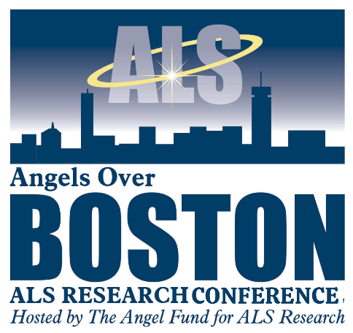

Dear Sponsor,
The Angel Fund for ALS Research invites you to partner with us as a sponsor of Angels Over Boston, an international ALS research conference bringing together leading scientists and clinicians, dedicated to accelerating progress toward effective treatments—and ultimately, a cure—for ALS. The Conference will be held in Boston on July 14 – 16, 2026.
The conference will focus on recent therapeutic approaches to gene suppression therapy in ALS caused by mutations in the C9orf72 gene, the gene most commonly mutated in ALS.
The discussions will be led by world renowned ALS researchers Prof. Robert H. Brown, Jr, DPhil, MD, Director of Neurotherapeutics and Prof. Daryl Bosco, Ph.D., Professor and Associate Vice Chair, Neurology both of UMass Chan Medical School. Researchers and clinicians from the United States, Israel and Germany will join in this two-day conference.
ALS remains a devastating and universally fatal disease, with most patients surviving only three to five years after diagnosis. While the urgency is profound, recent scientific advances offer real and growing hope. Breakthroughs in genetics, biomarkers, and targeted therapies are reshaping the ALS research landscape—progress made possible only through sustained investment and collaboration.
The urgency behind this work is deeply human.
Every ALS diagnosis marks the beginning of an unrelenting race against time. Patients gradually lose the ability to walk, speak, swallow, and breathe—while their minds remain fully intact. Families often describe the heartbreak of watching a loved one fade physically while remaining emotionally present, aware, and engaged. For them, research is not abstract; it represents time, dignity, and the possibility of a future that looks different from the past.
Angels Over Boston is necessary because patients and families cannot wait. The conference accelerates the exchange of ideas that may lead to earlier diagnosis, slower disease progression, and more effective therapies. By bringing together academic researchers and clinician-scientists, the conference helps shorten the path from discovery to patient impact.

Your sponsorship will directly help underwrite conference costs, ensuring that resources are focused on science—not logistics—and that financial barriers never limit participation by leading investigators or early-career researchers whose ideas may shape the next breakthrough.
For more than 25 years, The Angel Fund for ALS Research has invested in bold, high-impact science with one goal in mind: changing outcomes for patients and families living with ALS. A Lead sponsorship of Angels Over Boston continues that legacy—transforming generosity into momentum, and hope into measurable progress.
We would be honored to discuss this opportunity with you and explore how your philanthropic goals align with this mission-critical event. Thank you for your commitment to advancing ALS research. The sponsorship level information is enclosed. Please feel free to reach out to me at theangelfundals@gmail.com or my cell, 617-823-1084. We hope that you will Step Up to Cure ALS with us.
With sincere gratitude,

Ann Hadley, Chief Development Officer
The Angel Fund for ALS Research

THE ANGEL FUND FOR ALS RESEARCH - 649 Main Street, Wakefield, MA 01880 - THEANGELFUND.ORG

