• 2 days onboard Rocky Mountaineer in SilverLeaf Service
• Eight nights’ hotel accommodation
• All breakfasts
• Gourmet meals and unlimited beverages onboard
Rocky Mountaineer
• National Parks Pass
• Sightseeing tour of Banff region
• Banff Gondola and Minnewanka Cruise
• Tour of Yoho National Park
• All tours and transfers specified in the itinerary
• Luggage handling / porterage at the hotels and train stations
• Prepaid gratuities for onboard Hosts

• Airfare
• Travel insurance
• Other meals not mentioned in the itinerary
Pricing:
DATES | DOUBLE | SINGLE
May 21st – 29th 2027 | USD 6,309.99* | USD 9,425.15*
*Pricing is per person including tax.
Terms & conditions apply.

EXCLUSIONS
INCLUSIONS
Travel by Tatten
FIRST PASSAGE TO THE WEST DISCOVERY - WESTBOUND
CALGARY – BANFF – LAKE LOUISE – KAMLOOPS – VANCOUVER

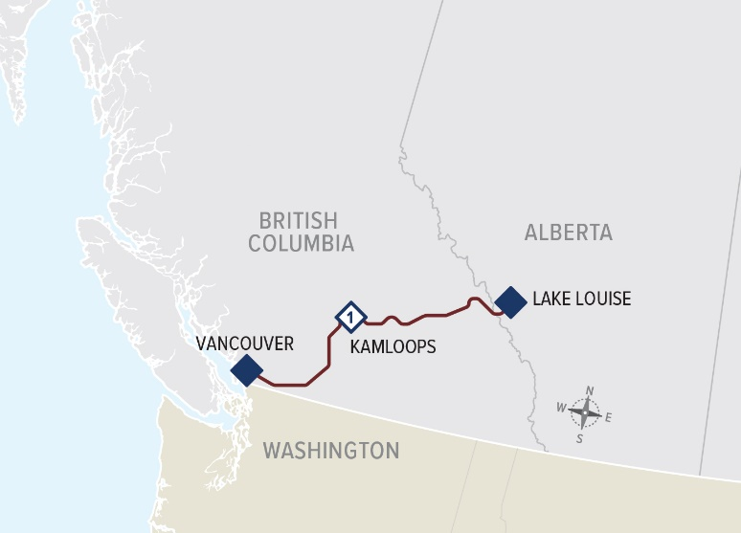

Linda Tatten, CTC
Travel by Tatten
508-485-5723 (direct) |508-460-1816 (mobile)
LTatten@globaltravelcollection.com

www.TravelbyTatten.com
www.Facebook.com/travelbytatten

DAY 6 LAKE LOUISE TO KAMLOOPS
SILVERLEAF. KAMLOOPS HOTEL TBC.

Travel onboard Rocky Mountaineer from the mountain town of Lake Louise to Kamloops, in the heart of the BC Interior. Enjoy the spectacular array of scenery as you travel between the glacier and snow-capped peaks of the Canadian Rockies, over mountain passes and through remarkable tunnels, along rocky lakeshores and across the ranchlands of the Interior. Today’s highlights include the Continental Divide, the Spiral Tunnels, Kicking Horse Canyon, Rogers Pass, and Craigellachie, where the last spike of the Canadian Pacific Railway was driven. Breakfast & lunch included onboard. (B, L)

DAY 7 KAMLOOPS TO VANCOUVER
SILVERLEAF. Sutton Place Hotel
Your journey continues west towards the Pacific Ocean and the coastal city of Vancouver. You will again see dramatic changes in scenery, from the desert-like environment of the Interior, through winding river canyons and pristine forests, to the Coast and Cascade Mountains and the lush green fields of the Fraser Valley. Highlights include the steep slopes and rock sheds along the Thompson River and the rushing waters of Hell’s Gate in the Fraser Canyon. Breakfast & lunch included onboard. (B, L)
DAY 8 VANCOUVER
Sutton Place Hotel

Explore Vancouver on your own. (B)

DAY 9 VANCOUVER
Check out of your hotel and your vacation with us comes to an end.
(B)


DAY 1 CALGARY
Delta Calgary Downtown
Arrive in Calgary and spend the remainder of the day on your own to explore. Affectionately known as “Cowtown,” Calgary exudes a youthful vitality as well as frontier spirit. Just east of the Rockies, it’s a dynamic city with an ever-changing list of attractions.

DAY 2 CALGARY TO BANFF
Moose Hotel & Suites

Enjoy a motorcoach tour exploring the many places of interest around Banff. The highlights of today include Banff Gondola, Cruse on Minnewanka Lake, the Hoodoos rock formations, Surprise Corner and Bow Falls. (B)

DAY 3 BANFF
Moose Hotel & Suites

Enjoy the day in Banff with free time to relax or book activities at your leisure. (B)

DAY 4 BANFF TO LAKE LOUISE
Fairmont Chateau Lake Louise

Enjoy a full-day sightseeing tour and learn about the natural forces that have shaped the appearance of the lakes and streams found in this area of the Rocky Mountains. Highlights include Lake Louise, Yoho National Park, the Spiral Tunnels, Emerald Lake and Natural Bridge.
Lunch at the Emerald Lake Lodge is included.

DAY 5 LAKE LOUISE
Fairmont Chateau Lake Louise

Enjoy a day of leisure to explore Lake Louise on your own. (B)

RAIL ROUTE MAP
ITINERARY 9 DAYS / 8 NIGHTS

