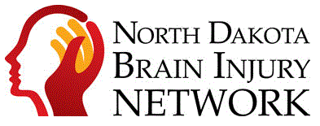
The North Dakota Brain Injury Network held their annual Concussion Symposium on September 13th. This event consisted of 6 different health care professionals presenting on topics related to brain injuries. Carma and Jed from our office virtually attended the symposium, and they shared some key takeaways they believe everyone should be aware of.
Adolescent females have overtaken adolescent males in high-risk behavior (e.g. drinking, drug use, physically dangerous activity, etc.) This is coupled with the fact that females usually have longer recovery periods for head injuries than males. The reason behind this isn’t completely understood yet, but some theories include biological/hormonal differences, and possibly females having a higher rate of honest reporting of lingering symptoms.
A big risk factor with brain injury is people not being able to correctly analyze safety issues. An example of this is someone who is recovering from a concussion could decide to go on a long walk, even though they have been having balance issues and may fall and hit their head again. This doesn’t even have to be someone that recently suffered a brain injury. Sometimes people that seem to lack “common sense” may have suffered a brain injury years, or even decades in the past, and that still interferes with their decision making.
There have been links found between brain injuries and seemingly unrelated body parts. The science is still new, but the two major systems that seem to play a big role are the parasympathetic nervous system, and gut health. Some new recovery therapies are being tested, and the results have been mostly positive so far.
The most striking visual representation given during the symposium can be seen below. The image on the far right is a PET scan of a normal functioning brain. The one in the middle is of a brain that is in a coma. The one on the left is of someone with a mild concussion. This person is still conscious and showing very mild symptoms.
These scans are showing the rate of glucose metabolism, which is basically how effectively each brain is using energy. The brain with a mild concussion is showing similar rates of energy conversion as the brain that is in a coma. While this is only one way to measure brain activity, it does show that there is a real, physical difference in brains that have suffered a recent concussion, even if we cannot see it outwardly.
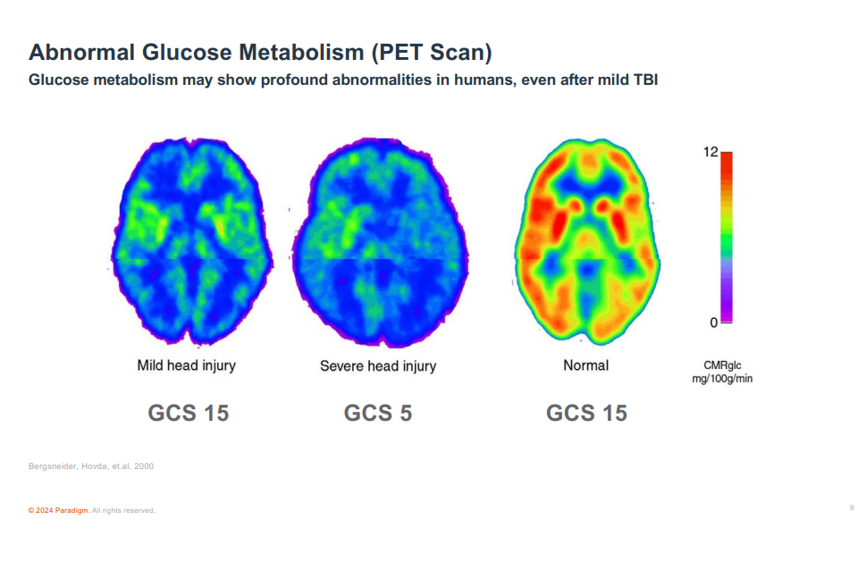
The North Dakota Brain Injury Network is based out of the University of North Dakota School of Medicine on the UND Campus, but it covers the entire state, offering help and resources to healthcare professionals, brain injury survivors and family and caregivers to those with brain injuries. For more information on their services, please reach out to them with the contact information below or at their website at : www.ndbin.org

North Dakota Brain Injury Network
School of Medicine & Health Sciences
1301 N. Columbia Road, Stop 9037
Grand Forks, ND 58202-9037
Phone: (855) 866-1884
Fax: (701) 777-1431
Email: info@ndbin.org

