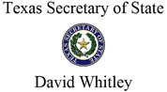

  FOR IMMEDIATE RELEASE
  May 21, 2019
  Contact: Sam Taylor
  STaylor@sos.texas.gov
  512-463-6116

Secretary Whitley Convenes First Border Trade Advisory Committee Meeting Of 2019
"By collaborating to overcome common challenges, we can ensure this committee can make progress toward an even more prosperous economic future for our border communities and for the State of Texas as a whole"

AUSTIN, TX – Texas Secretary of State David Whitley today convened the first Border Trade Advisory Committee (BTAC) meeting of 2019, bringing together stakeholders from throughout the Texas-Mexico border region to advance initiatives to address challenges related to international trade with Mexico. In his capacity as Texas' Border Commerce Coordinator, Secretary Whitley works closely in conjunction with the Texas Department of Transportation (TxDOT) and Committee members to discuss strategies for better facilitating cross-border trade, including improving transportation infrastructure, cargo processing, and coordination with public officials in Mexico.
Secretary Whitley began by introducing his vision for the Committee, emphasizing the need for border stakeholders to speak with one voice to address the challenges that affect public entities, businesses, and individuals who rely on robust trade between Texas and Mexico.
"Relationships matter, and the relationships in this room will ensure this committee has an impact, working together," Secretary Whitley said. "Communicating with our local, state, federal, and international counterparts is extremely important, and by collaborating to overcome common challenges, we can ensure this committee can make progress toward an even more prosperous economic future for our border communities and for the State of Texas as a whole."
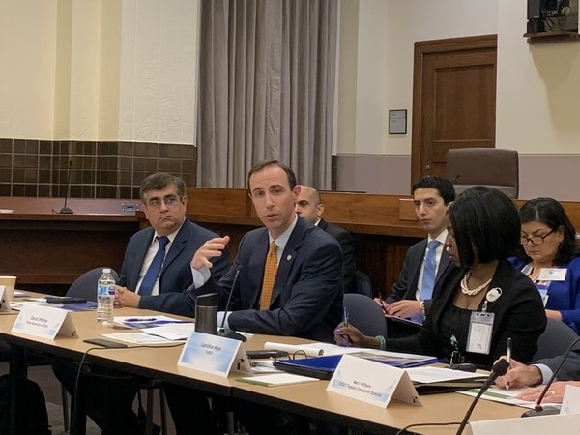
(Secretary Whitley convenes the first Border Trade Advisory Committee meeting of 2019 in Austin, Office of the Texas Secretary of State, 5/21/2019)

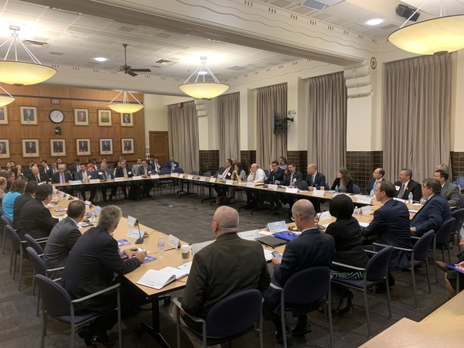
(Office of the Texas Secretary of State, 5/21/2019)
After reviewing BTAC activities and accomplishments in 2018, the Committee engaged in a group discussion on the Texas-Mexico Border Transportation Master Plan, including feedback provided to TxDOT on its recent listening tours throughout the border region. The Master Plan, expected to be completed in 2020, is designed to identify transportation infrastructure challenges, solicit feedback from stakeholders throughout the border region, and implement long-term strategies for continuing to facilitate cross-border trade. The committee reviewed extensive input gathered at TxDOT's public meetings and identified areas in which local, state, and U.S. and Mexican federal officials can coordinate to improve efficiency in the movement of freight, goods, and people at Texas' 28 ports of entry.
Secretary Whitley concluded the meeting by leading an open discussion among Committee members and representatives from the Mexican states of Coahuila and Nuevo Leon. As a result of the feedback collected, Secretary Whitley agreed to communicate the Committee's recommendations on addressing delays at border crossings to the Texas Transportation Commission so that Texas can develop strategies to continue facilitating robust cross-border commercial exchange.
Learn more about the Border Trade Advisory Committee.

