Free Vaping Prevention Resources:
- FDA-Free posters to order or download like the one shown below: https://digitalmedia.hhs.gov/tobacco/print_materials/search?language=eng&page=1&tag=Prevention
  - 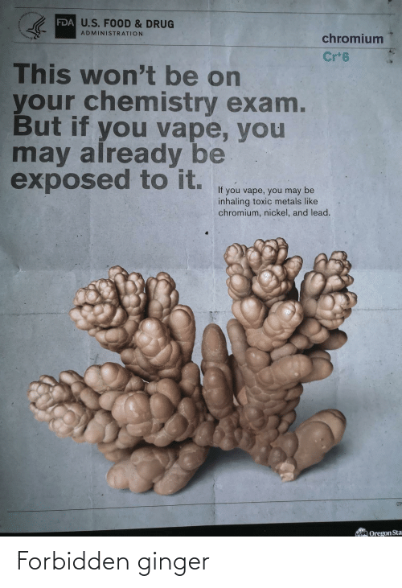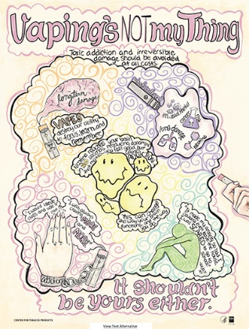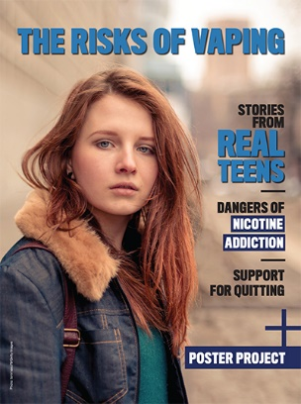
- Mass DPH: https://massclearinghouse.ehs.state.ma.us/category/Vaping.html (Free Image to Download)
  - 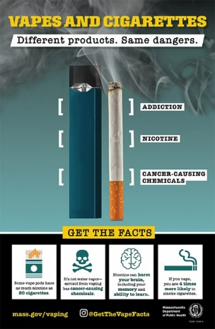
- Stanford Toolkit Factsheet Visuals: https://med.stanford.edu/tobaccopreventiontoolkit/take-and-teach/toolkit-factsheets.html
CT Clearinghouse Free Resources:
- Videos to Borrow: vaping specific educational videos such as “Vaping and viruses video recording: your lungs, your life” by Human Relations Media, Inc. 2020.
- Posters: Vaping is Addictive (limit of one poster of up to ten posters)
- Pamphlets: such as “Wake Up: There’s a Lot the E-cig industry isn’t Telling Us about Vaping” and “Vaping: Don’t Get Taken In.”
- Request specific materials here: https://www.ctclearinghouse.org/pamphlet-poster-directory/ or email directly here: https://www.ctclearinghouse.org/contact-form/
Here are short PSA’s from Rescue Change:
- Behind The Haze videos, Chemical Warfare and Defenseless

CT Department of Public Health:
- https://portal.ct.gov/dph/Health-Education-Management--Surveillance/Tobacco/Tobacco-Use-Prevention--Control-Program
- https://portal.ct.gov/DPH/Health-Education-Management--Surveillance/Tobacco/Vaping
Cessation: contact Victoria Adams for additional youth cessation materials adamsv2@southernct.edu
Vaping Prevention Curriculum:
- Truth Initiative: https://truthinitiative.org/curriculum
- Stanford Medicine’s Tobacco Prevention Toolkit: https://med.stanford.edu/tobaccopreventiontoolkit.html

